**PRACTICAL 1**

1. **AIM:** To study about the architecture of a desktop computer and an IBM 360 server.
2. Desktop Computer

**THE STUDY PART:**

1. Common Specifications
2. Processor - dual core 2.4 GHz+ (i5 or i7 series Intel processor or equivalent AMD)
3. RAM – 8 GB
4. Hard Drive - 256 GB or larger solid state hard drive
5. Graphics Card - any with DisplayPort/HDMI or DVI support - desktop only
6. Wireless (for laptops) - 802.11ac (WPA2 support required)
7. Monitor - 23" widescreen LCD with DisplayPort/HDMI or DVI support - desktop only
8. Operating System - Windows 10 Home or Professional editions, or Apple OS X 10.12.3
9. Backup Device - External hard drive and/or USB Flash Drive

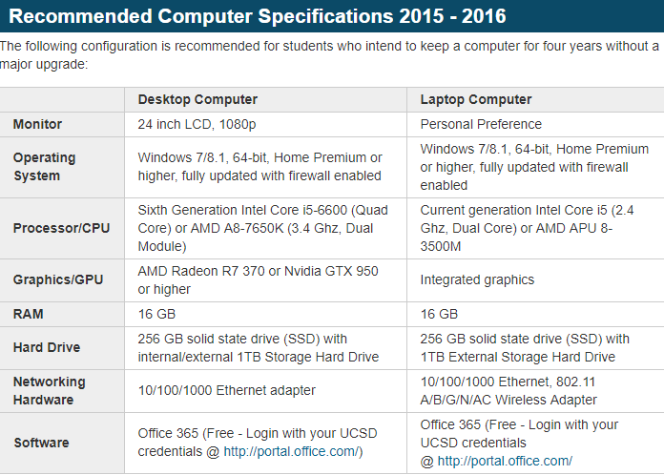

Parts of the desktop PC

1. **The Cabinet**

A computer cabinet is an enclosure with fitted, fixed or removable side panels and doors. The cabinet contains a computer rack for mounting computers or other electronic equipment. Cabinets come in a variety of sizes, colors and styles and may contain baffles and fans to facilitate cooling and minimize recycled and bypass airflow.

A computer case, also known as a computer chassis, tower, system unit, cabinet, base unit, or simply case, is the enclosure that contains most of the components of a computer (usually excluding the display, keyboard and mouse).

Cases are usually constructed from steel (often SECC—Steel, electrogalvanized, cold-rolled, coil) or [aluminium](https://en.wikipedia.org/wiki/Aluminium" \o "Aluminium). Plastic is sometimes used, and other materials such as glass, wood and even Lego bricks have appeared in home-built cases.

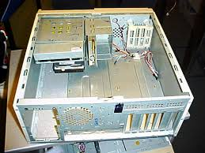

1. **The Motherboard**

A motherboard (sometimes alternatively known as the mainboard, system board, baseboard, planar board or logic board, or colloquially, a mobo) is the main [printed circuit board](https://en.wikipedia.org/wiki/Printed_circuit_board) (PCB) found in general purpose [microcomputers](https://en.wikipedia.org/wiki/Microcomputer) and other expandable systems. It holds and allows communication between many of the crucial electronic components of a system, such as the [central processing unit](https://en.wikipedia.org/wiki/Central_processing_unit) (CPU) and [memory](https://en.wikipedia.org/wiki/Computer_memory), and provides connectors for other [peripherals](https://en.wikipedia.org/wiki/Peripherals). Unlike a [backplane](https://en.wikipedia.org/wiki/Backplane), a motherboard usually contains significant sub-systems such as the central processor, the chipset's input/output and memory controllers, interface connectors, and other components integrated for general purpose use.

Motherboard specifically refers to a [PCB](https://en.wikipedia.org/wiki/Printed_circuit_board) with expansion capability and as the name suggests, this board is often referred to as the "mother" of all components attached to it, which often include [peripherals](https://en.wikipedia.org/wiki/Peripheral), interface cards, and [daughtercards](https://en.wikipedia.org/wiki/Daughtercard" \o "Daughtercard): [sound cards](https://en.wikipedia.org/wiki/Sound_card), [video cards](https://en.wikipedia.org/wiki/Video_card), [network cards](https://en.wikipedia.org/wiki/Network_card), [hard drives](https://en.wikipedia.org/wiki/Hard_drive), or other forms of persistent storage; [TV tuner cards](https://en.wikipedia.org/wiki/TV_tuner_card), cards providing extra [USB](https://en.wikipedia.org/wiki/USB) or [FireWire](https://en.wikipedia.org/wiki/Firewire) slots and a variety of other custom components.

Similarly, the term mainboard is applied to devices with a single board and no additional expansions or capability, such as controlling boards in laser printers, televisions, washing machines and other [embedded systems](https://en.wikipedia.org/wiki/Embedded_system) with limited expansion abilities.

A motherboard is one of the most essential parts of a computer system. It holds together many of the crucial components of a computer, including the central processing unit (CPU), memory and connectors for input and output devices. The base of a motherboard consists of a very firm sheet of non-conductive material, typically some sort of rigid plastic. Thin layers of copper or aluminum foil, referred to as *traces*, are printed onto this sheet. These traces are very narrow and form the circuits between the various components. In addition to circuits, a motherboard contains a number of sockets and slots to connect the other components.

Motherboard connects the various parts of a computer system together. Here are some of the typical parts:

* A CPU socket - the actual CPU is directly soldered onto the socket. Since high speed CPUs generate a lot of heat, there are heat sinks and mounting points for fans right next to the CPU socket.
* A power connector to distribute power to the CPU and other components.
* Slots for the system's main memory, typically in the form of DRAM chips.
* A chip forms an interface between the CPU, the main memory and other components. On many types of motherboards, this is referred to as the Northbridge. This chip also contains a large heat sink.
* A second chip controls the input and output (I/O) functions. It is not connected directly to the CPU but to the Northbridge. This I/O controller is referred to as the Southbridge. The Northbridge and Southbridge combined are referred to as the *chipset*.
* Several connectors, which provide the physical interface between input and output devices and the motherboard. The Southbridge handles these connections.
* Slots for one or more hard drives to store files. The most common types of connections are Integrated Drive Electronics (IDE) and Serial Advanced Technology Attachment (SATA).
* A read-only memory (ROM) chip, which contains the firmware, or startup instructions for the computer system. This is also called the BIOS.
* A slot for a video or graphics card. There are a number of different types of slots, including the Accelerated Graphics Port (AGP) and Peripheral Component Interconnect Express (PCIe).
* Additional slots to connect hardware in the form of Peripheral Component Interconnect (PCI) slots.

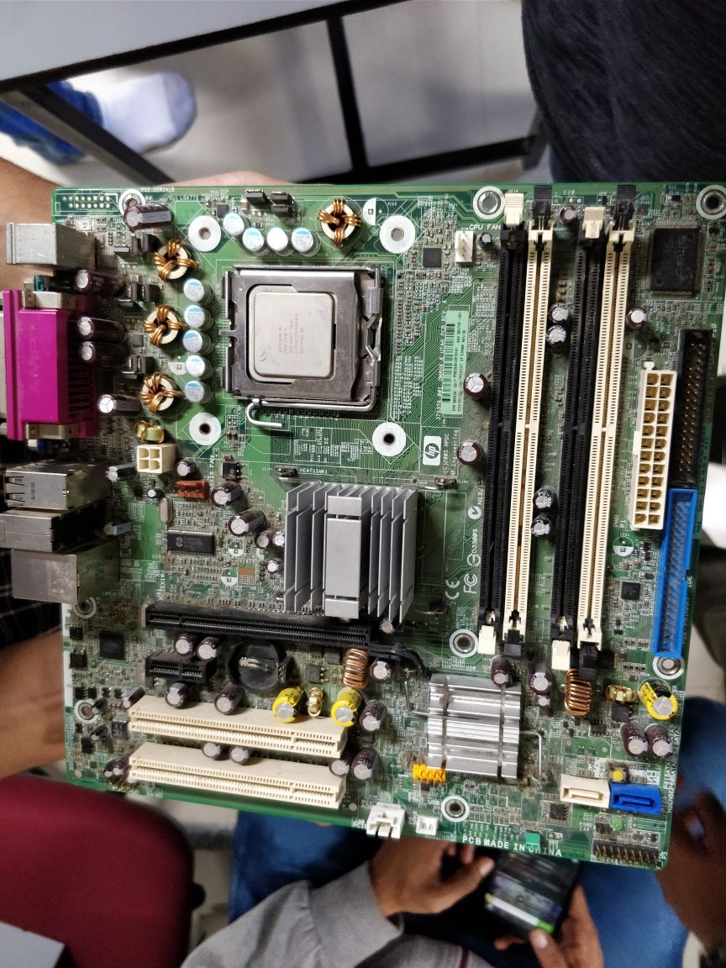

1. The Processor

A **microprocessor**, sometimes called a logic chip, is a **computer** processor on a microchip. The **microprocessor** contains all, or most of, the central processing unit (CPU) **functions** and is the "engine" that goes into motion when you turn your **computer** on.

the major processor models released by Intel.

* Pentium 1, 2, 3, 4
* Celeron
* Pentium M and Celeron M for mobile devices
* Pentium Dual Core
* Core Solo
* Core Duo
* Core 2 Duo
* Core 2 Quad
* Core i3, i5, i7

1st Generation Intel Processors – Nehalem

### 2nd Generation Intel Processors – Sandy Bridge

### 3rd Generation Intel Processors – Ivy Bridge

### 4th Generation Intel Processors – Haswell

### The next generations-Skylate

Most pcs today use **Intel** microprocessors and **Amd and Nvidia** for gaming

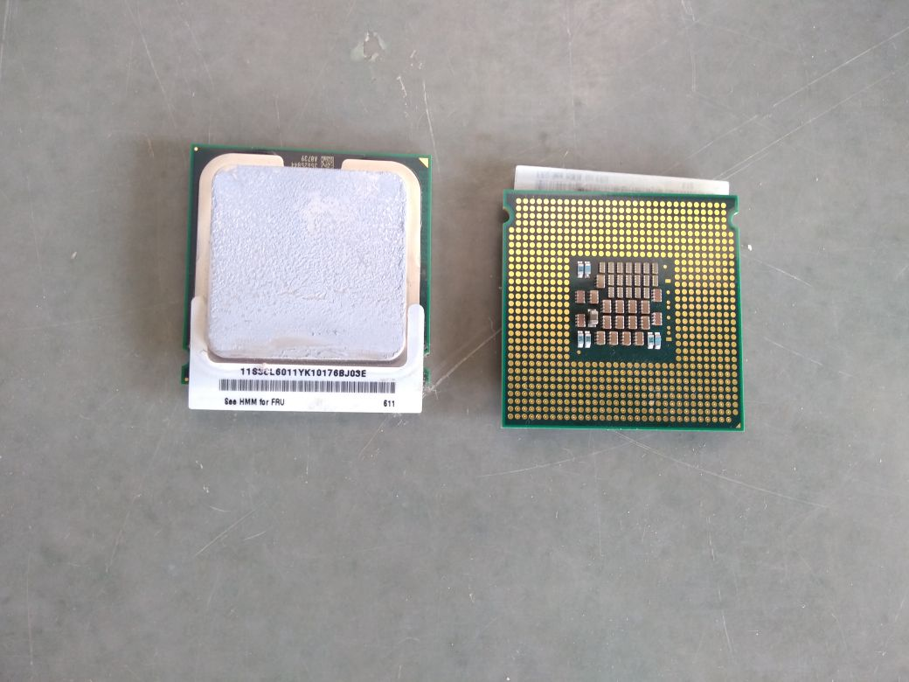

1. RAM (Random Access Memory)

**RAM** is considered volatile memory, which means that the stored information is lost when there is no power. So, **RAM** is used by the central processing unit (CPU) when a computer is running to store information that it needs to be used very quickly, but it does not store any information permanently.

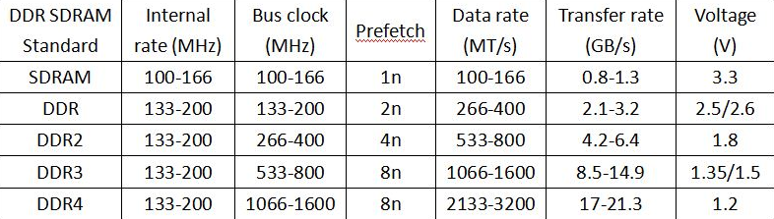

The common RAMs today comes in variant of 8GB and 16GB

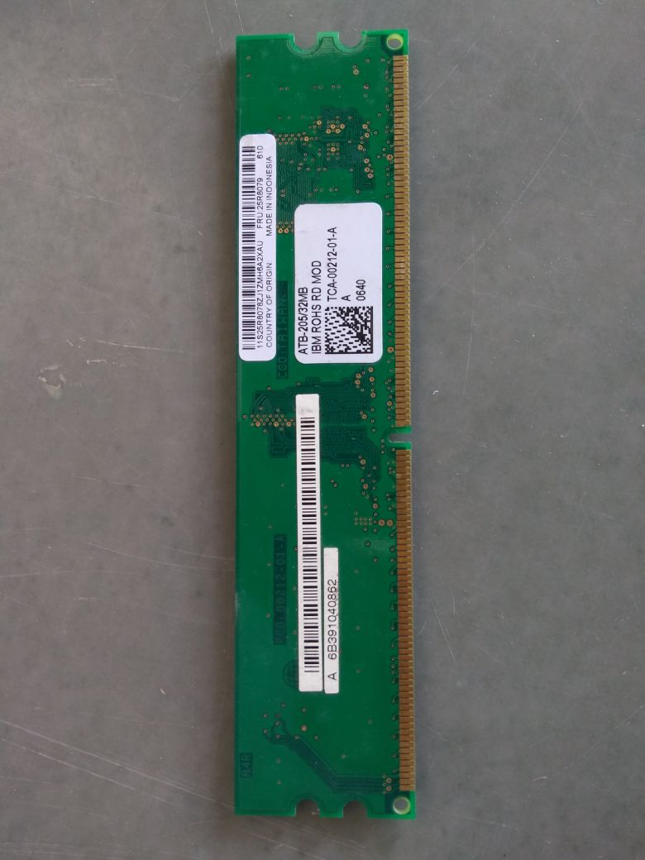

1. Hard Disk

**Hard Disk** Drives (**HDD**) **Hard disk** drives have been the dominant type of storage since the early days of computers. A **hard disk drive** consists of a rigid disc made with non-magnetic material, which is coated with a thin layer of magnetic material. Data is stored by magnetizing this thin film.

Most Hard disk drives today comes in variant of 512GB, 1TB, 2TB.

**Storage capacity.** HDDs come in all sizes, capping out at 16TB per drive due to physical limitations. On the other hand, SSDs are much smaller and have reached as high as 60TB. Even so, consumer-level SSDs are rarely larger than 1TB as of this writing.

**Transfer speeds.** The performance of a consumer-level HDD is determined by many factors, but revolutions per minute (RPMs) is an important one. Higher RPMs means faster transferring of data to and from the drive.

**Cache space.** When a hard disk needs to transfer data from one section of the drive to another, it utilizes a special area of embedded memory called the *cache* or *buffer*.

A larger cache enables the data to transfer faster because more information can be stored at one time. Modern HDDs can have cache sizes ranging from 8MB to 256MB.

**Access times.** Traditional HDDs have a couple of other factors that impact performance, such as the time it takes for the reader to position itself to read data from or write data to the drive.

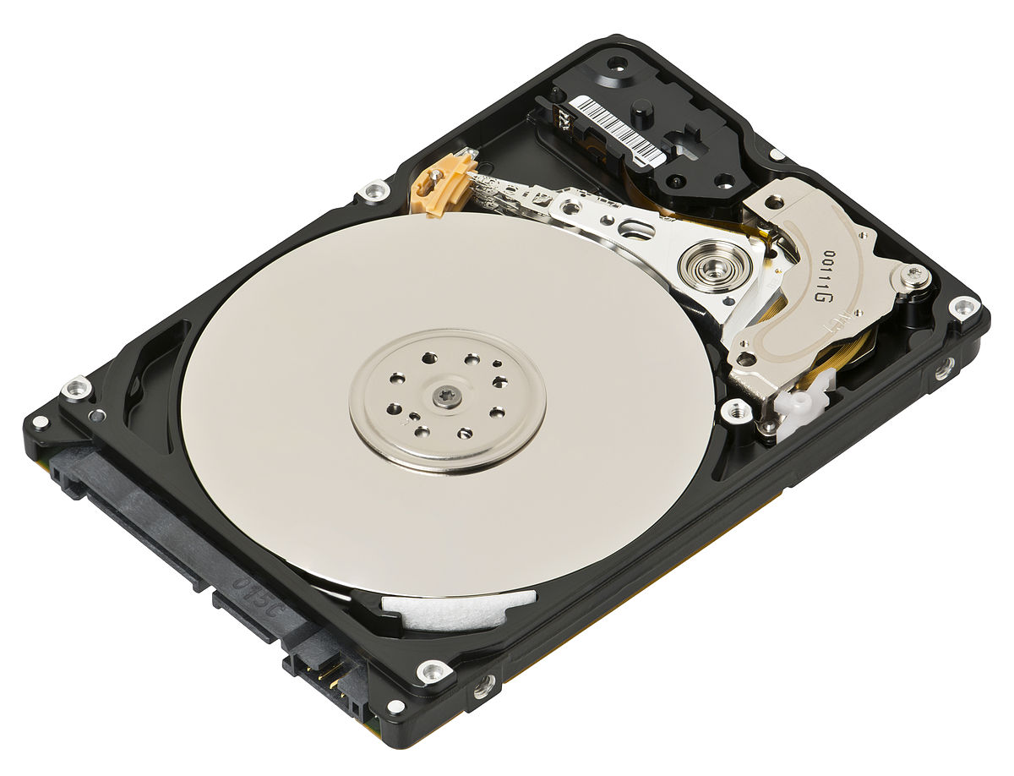

1. Floppy disk drive

**Floppy disks** are read and written by a **floppy disk drive** (FDD). **Floppy disks**, initially as 8-inch (200 mm) media and later in 5¼-inch (133 mm) and 3½-inch (90 mm) sizes, were a ubiquitous form of data storage and exchange from the mid-1970s into the first years of the 21st century.

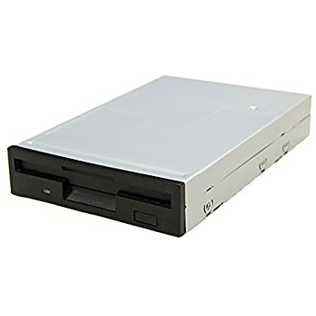

1. CD/DVD Drive(Optical Disk Drive)

An **optical** disk **drive** (ODD) uses a laser light to read data from or write data to an **optical** disc. These include **CDs**, **DVDs**, and Blu-ray discs. This allows you to play music or watch movies using pre-recorded discs

In [computing](https://en.wikipedia.org/wiki/Computing), an **optical disc drive** (**ODD**) is a [disk drive](https://en.wikipedia.org/wiki/Disk_drive) that uses [laser](https://en.wikipedia.org/wiki/Laser) light or electromagnetic waves within or near the visible [light spectrum](https://en.wikipedia.org/wiki/Light_spectrum) as part of the process of reading or writing data to or from [optical discs](https://en.wikipedia.org/wiki/Optical_disc). Some drives can only read from certain discs, but recent drives can both read and record, also called burners or writers. [Compact discs](https://en.wikipedia.org/wiki/Compact_disc), [DVDs](https://en.wikipedia.org/wiki/DVD), and [Blu-ray](https://en.wikipedia.org/wiki/Blu-ray) discs are common types of optical media which can be read and recorded by such drives. Optical disc drives that are no longer in production include CD-ROM drive, CD writer drive, combo (CD-RW/DVD-ROM) drive, and DVD writer drive supporting certain recordable and rewritable DVD formats (such as DVD-R(W) only, DVD+R(W) only, DVD-RAM only, and all DVD formats except DVD-R DL). As of 2015, DVD writer drive supporting all existing recordable and rewritable DVD formats is the most common for desktop PCs and laptops. There are also the DVD-ROM drive, BD-ROM drive, Blu-ray Disc combo (BD-ROM/DVD±RW/CD-RW) drive, and Blu-ray Disc writer drive.

Disc recording is restricted to storing files playable on consumer appliances ([films](https://en.wikipedia.org/wiki/Film), music, etc.), relatively small volumes of data (e.g. a standard DVD holds 4.7 [gigabytes](https://en.wikipedia.org/wiki/Gigabyte)) for local use, and data for distribution, but only on a small scale; mass-producing large numbers of identical discs is cheaper and faster than individual recording.

Optical discs are used to [back up](https://en.wikipedia.org/wiki/Backup) relatively small volumes of data, but backing up of entire hard drives, which as of 2015 typically contain many hundreds of gigabytes or even multiple terabytes, is less practical. Large backups are often instead made on external hard drives, as their price has dropped to a level making this viable; in professional environments magnetic [tape drives](https://en.wikipedia.org/wiki/Tape_drive) are also used.

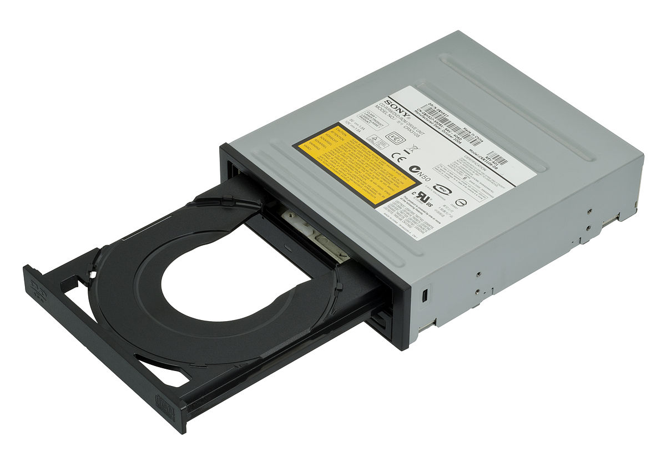

1. Graphics Card or Video card

A video **card** connects to the motherboard of a computer system and generates output images to display. Video **cards** are also referred to as **graphics cards**. Video **cards** include a processing unit, memory, a cooling mechanism and connections to a display device.

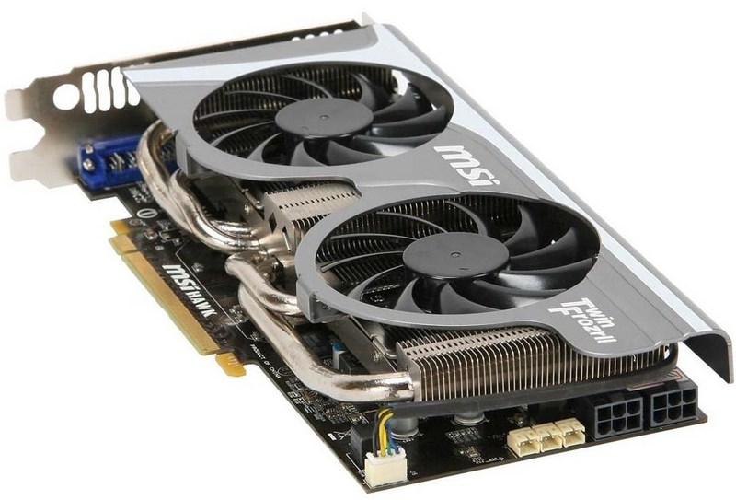

1. SMPS

**SMPS** stands for Switch-Mode-Power-Supply. They are used in many places in a computer. In a modern computer, there is a **SMPS** that takes rectified AC input from the wall, performs power factor correction and then converts the output into one or more lower voltage DC outputs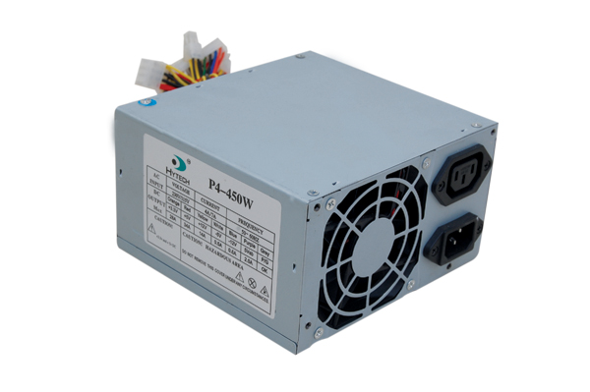

1. Cooling Fan

Used to cool the CPU (central processing unit) heatsink. Effective **cooling** of a concentrated heat source such as a large-scale integrated circuit requires a heatsink, which may be cooled by a **fan**; use of a **fan** alone will not prevent overheating of the small chip.

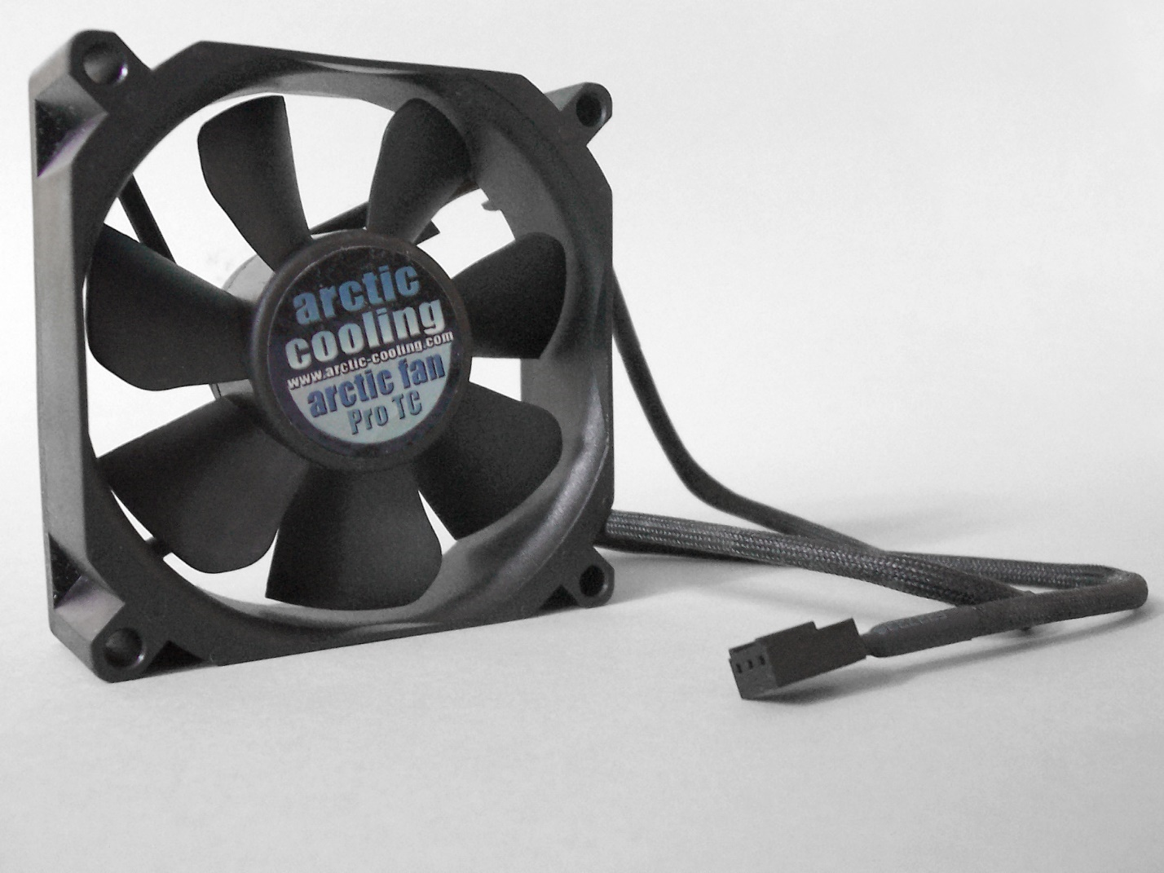

1. Heat sink (The fan above the processor)

The **CPU fan** is critically necessary to ventilate the heat generated from the components, and actively cools the **processor** by bringing in cooler air before the heat damages the computer components. Cooling **fans** for the **CPU** are available in different sizes and is usually sold with an aluminum or copper heat sink **fan**.

Active heat sinks utilize the [power supply](https://www.computerhope.com/jargon/p/ps.htm) and are usually a fan type or some other peltier cooling device. If you are looking to purchase an active heat sink, we recommend purchasing fans with ball-bearing motors that often last much longer than sleeve bearings. Sometimes these types of heat sinks are referred to as an HSF, which is short for heat sink and fan.

Passive heat sinks are 100% reliable, as they have no mechanical components. Passive heat sinks are made of an aluminum-finned radiator that dissipates heat through convection. For passive heat sinks to work to their full capacity, there should be a steady airflow moving across the fins. The above picture is an example of a heat sink that is both active and passive.

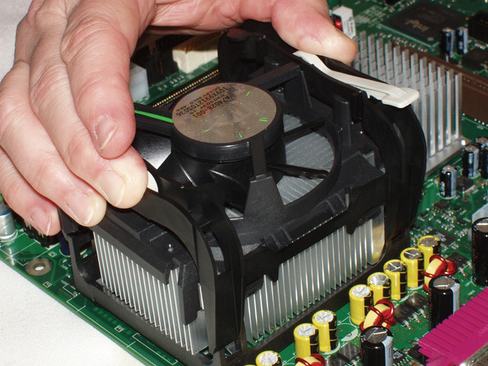

**THE PRACTICAL PART:**

* Assembling the CPU

1. ***Prepare the Mainboard (motherboard).****If you want to assemble the well-liked device, you should use Intel i3,i5,i7 Mainboard.*
2. ***Mount the CPU in the socket of the Mainboard.****You must choose the correct CPU for your motherboard, and install it according to its instructions.****Be careful not to install the CPU in wrong. Not only would your computer not work, it could short-circuit and damage your motherboard.***
3. ***Connect the CPU cooler to the Mainboard*** *exact above the processor****.***
4. ***Attach the RAM(memory) modules in the corresponding slots.****the motherboard should have rows of slots that have 2 or 3 sections that are different lengths. Make sure the pins on the RAM cards line up with the pins on the motherboard connector.****Don't get the RAM slots mixed up with PCI slots. The PCI slots are usually wider.***
5. ***Open the case and mount the power supply which is M-ATX type.****Make sure to connect all the connections to the drives and the motherboard*
6. ***Attach the Mainboard back plate to the case and check the Mainboard mounting positions.****The motherboard's instructions should tell the position of the motherboard.*
7. ***Suitably position the Mainboard in the case. All the physical connector slots on the motherboard should be fit on CPU case.***
8. ***Mount the Hard disk and connect it to the power supply and the motherboard.*** *There should be separate connections for the power supply and the motherboard. In SATA Hard disk case, should remove the jumper.*
9. ***Connect the SATA connectors to the hard drives , PATA with the CD-Drive and the USB connectors and the case switches to the motherboard.****The case and motherboard's instructions should tell where to connect the cables*
10. ***Connect the 20 or 24 pin ATX connector and the 4-pin power supply control connector to the motherboard.***
11. ***Mount the DVD-ROM drive.****After connecting the ATA cable to the device, hook it up to the power supply.*
12. ***Connect front usb,front audio,on off switch line to cpu.***
13. ***Finally, select a compatible operating system, and follow the instructions to install.***

***CONCLUSION: learnt to assemble parts of computer.***

Part II:IBM 360 Server

**AIM:** Parts of the IBM 360

1. The cabinet

The cabinet is the place where all the processing parts and drives are fixed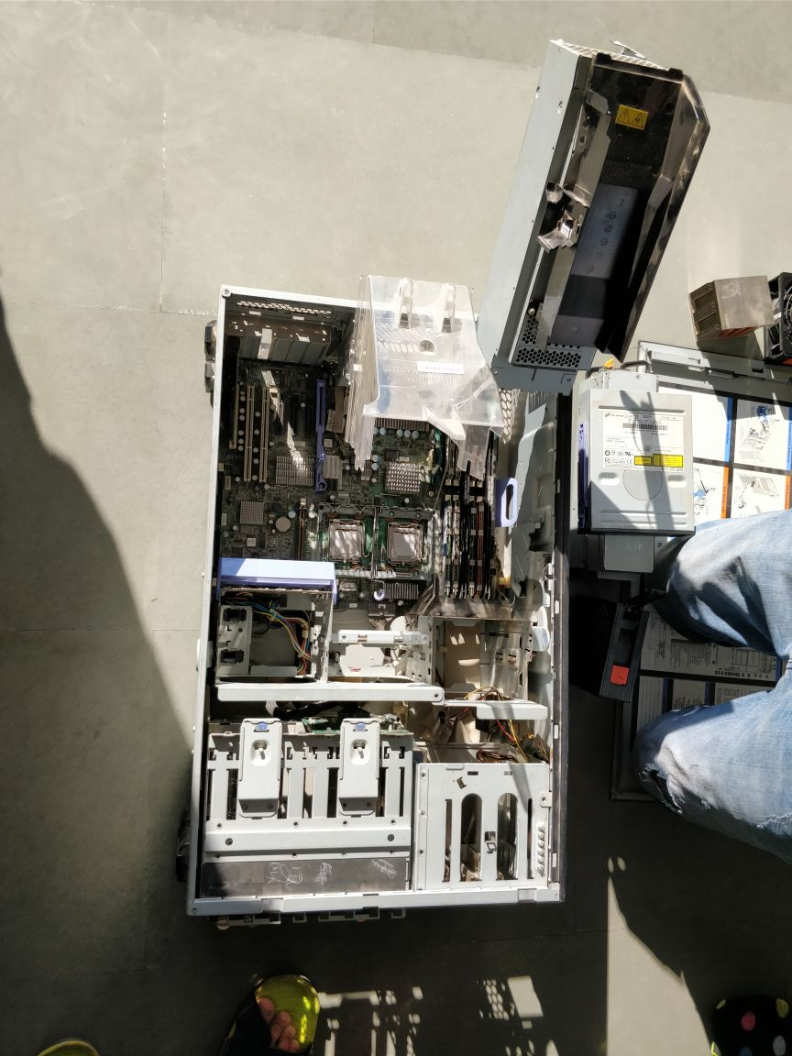

1. MotherBoard

The Motherboard is where all core parts are inserted such as microprocessors, RAM . Sound Cards, Video Cards

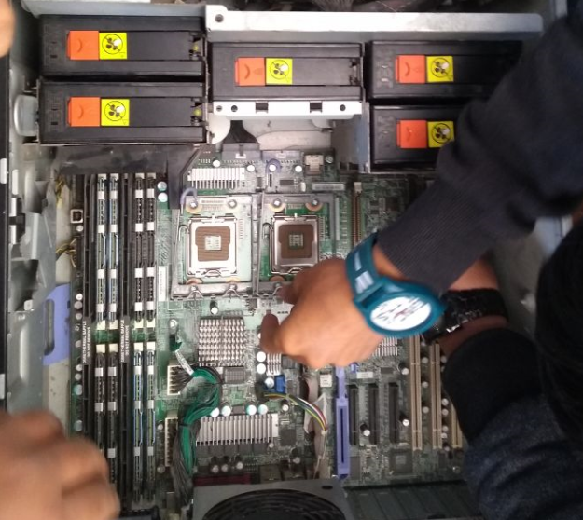

1. Microprocessor

A **microprocessor**, sometimes called a logic chip, is a **computer** processor on a microchip. The **microprocessor** contains all, or most of, the central processing unit (CPU) **functions** and is the "engine" that goes into motion when you turn your **Computer** on.

Basically the IBM motherboard contains 2 processor slots where intel xeon processors are installed.

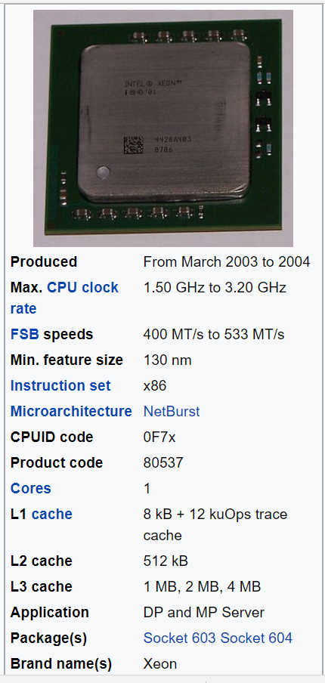

1. Heat Sink

The Heat Sink are used to cool the processors as they throw the hot air away from them.

In IBM 360 there are 2 Heat Sinks for 2 Processors

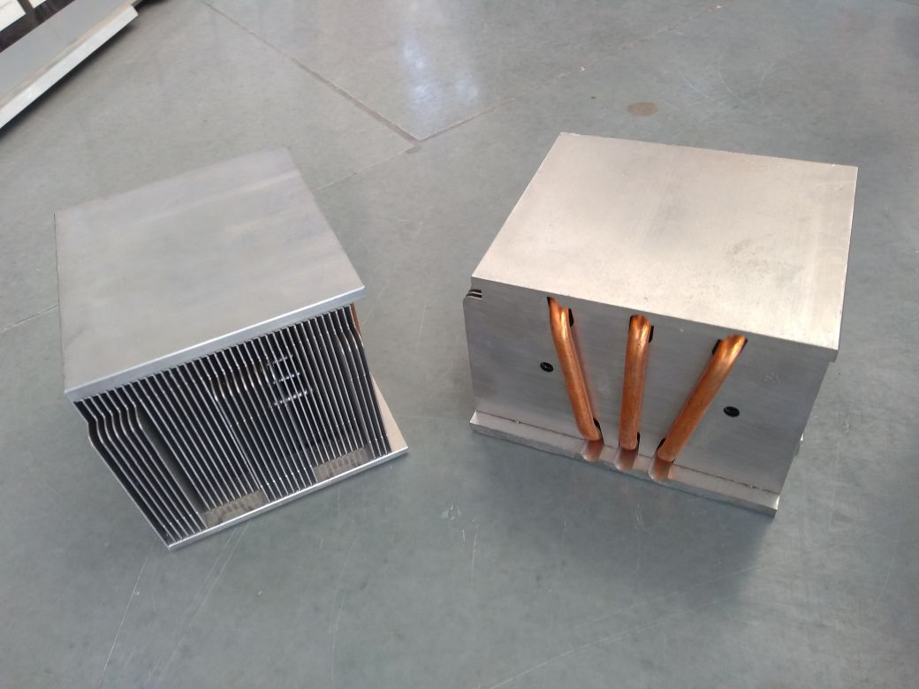

1. RAM

RAM is the primary memory which stores all ready to run processes.IBM 360 contains 8 RAM Slots

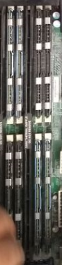

1. Cooling Fans

The cooling fans are used to provide good air circulation in the cabinet and hence cooling the machine

There are 6 cooling fans in IBM 360

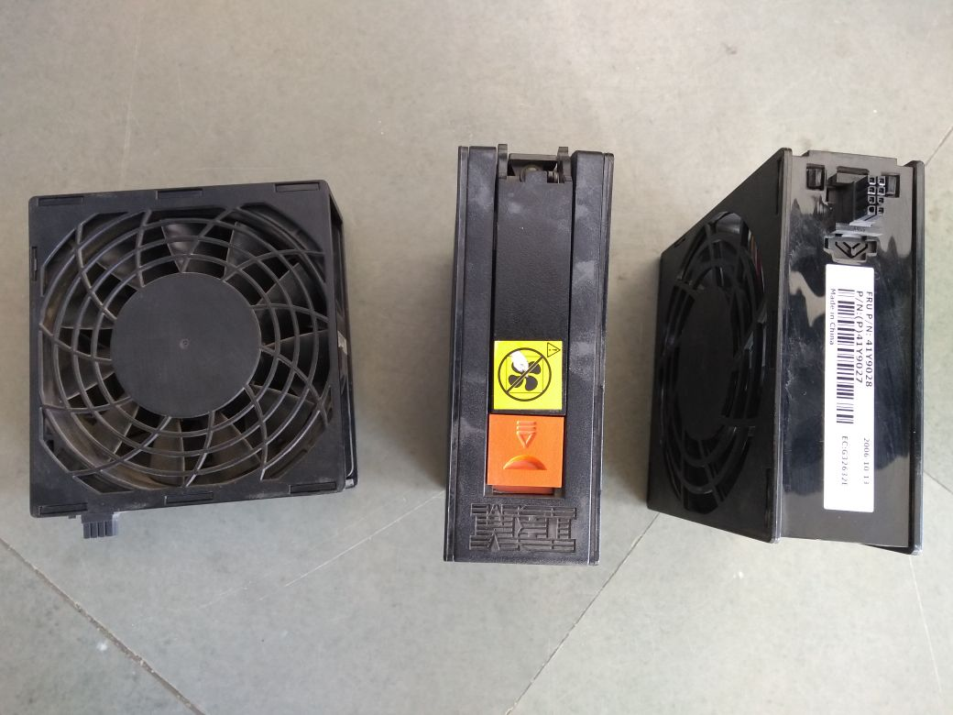

1. SMPS

The basic function of SMPS is to convert the AC current in to DC current so that the machine can operate

IBM 360 has 2 cuboid shaped SMPS.

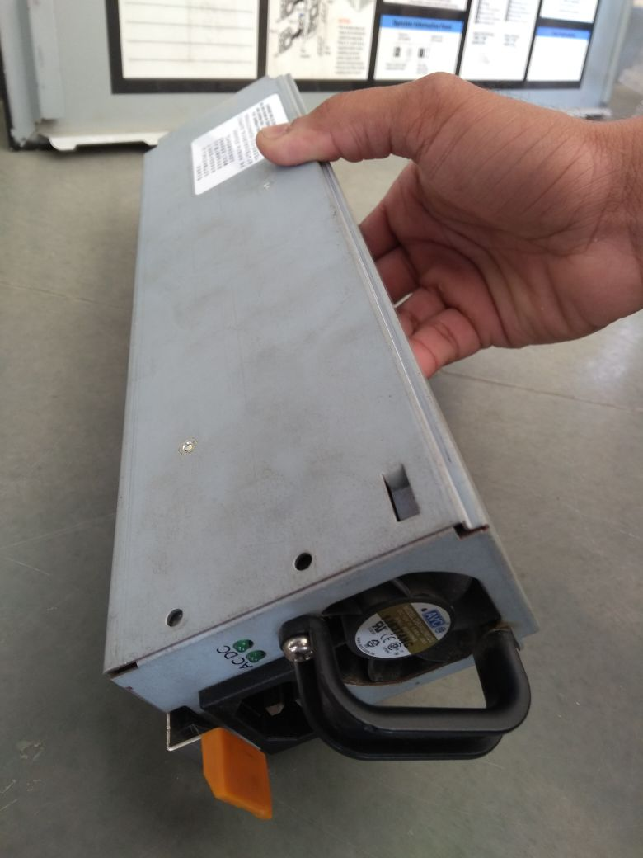

**SPECIFICATIONS OF IBM 360**

**Physical Specifications**

xSeries 360

8686-1RQ

Processor Xeon MP

Int. speed 2.0 GHz

Ext. speed 400 MHz

Number standard 1

Maximum 4

L3 Cache (full speed) 1 MB

Memory (PC1600 DDR) 1 GB ECC

DIMMs 2 x 512 MB

DIMM sockets 8

Capacity 16 GB(9)

Video SVGA

Memory 8 MB

SCSI Controller Ultra160

Channels 1

Connector Int. 1

Connector Ext. 0

HDD 0

Total bays 5

5.25-inch slim 1

3.5-inch slim 1

Hot-swap 3

Accessible 5

Internal capacity 220.2 GB(10)

Bays available 3

5.25-inch slim 0

3.5-inch slim 0

Hot-swap 3

PCI Slots 6

64-bit/66 MHz 4

64-bit/133 MHz 1

or

64-bit/100 MHz 2

Slots available 6

Management proc. Standard

Ethernet Controller 10/100 Mbps

CD-ROM (IDE) 24x-10x

Diskette drive 1.44 MB

Power supply 370 W

Number standard 1

Hot-swap Yes

Redundant power Optional

Auto restart Yes

**THE PRACTICAL PART:**

1. Assembling the IBM 360
2. Most of the Steps of assembling this server is almost same as the CPU but this is a **No-screw Architecture** and hence there are no screws in this machines
3. First you have to put the motherboard so that it fit insides the main cabinet.
4. Now, put the 2 processors on the motherboard so that it fits properly according to the notch. Be careful while putting them as they might get damaged if put wrong.
5. Now put the 2 heat sinks above the processors and fit their power cables on the mother board.
6. Insert the RAMs on the motherboard according to the noches so that they fit properly.
7. Put all the 6 cooling fans at their places 1 on the left side and 5 in the center of the cabinet.
8. Put the two SMPS on the slot in the front side of the server.
9. Now cover all the parts with the triangular plastic glass cases as show in the picture below
10. Close the lid of the cabinet.

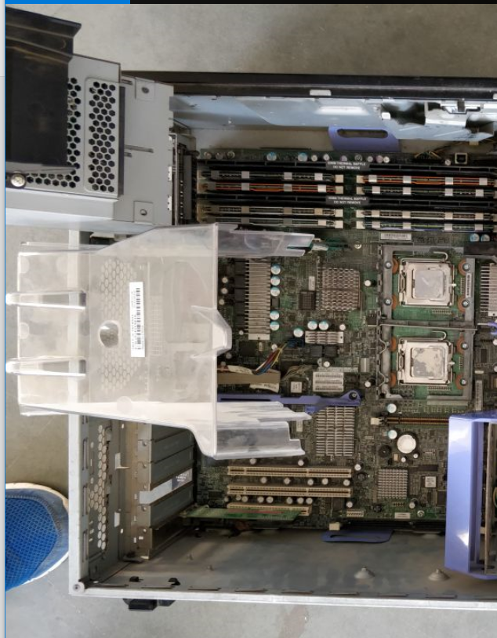

**PRACTICAL 3**

**3. AIM:** To study about the architecture of a processors.

**Introduction:**

A microprocessor -- also known as a CPU or central processing unit -- is a complete computation engine that is fabricated on a single chip. The first microprocessor was the Intel 4004, introduced in 1971. The 4004 was not very powerful -- all it could do was add and subtract, and it could only do that 4 bits at a time. But it was amazing that everything was on one chip. Prior to the 4004, engineers built computers either from collections of chips or from discrete components (transistors wired one at a time). The 4004 powered one of the first portable electronic calculators.

If you have ever wondered what the microprocessor in your computer is doing, or if you have ever wondered about the differences between types of microprocessors, then read on. In this article, you will learn how fairly simple digital logic techniques allow a computer to do its job, whether its playing a game or spell checking a document!

The first microprocessor to make it into a home computer was the Intel 8080, a complete 8-bit computer on one chip, introduced in 1974. The first microprocessor to make a real splash in the market was the Intel 8088, introduced in 1979 and incorporated into the IBM PC (which first appeared around 1982). If you are familiar with the PC market and its history, you know that the PC market moved from the 8088 to the 80286 to the 80386 to the 80486 to the Pentium to the Pentium II to the Pentium III to the Pentium 4. All of these microprocessors are made by Intel and all of them are improvements on the basic design of the 8088. The Pentium 4 can execute any piece of code that ran on the original 8088, but it does it about 5,000 times faster! Since 2004, Intel has introduced microprocessors with multiple cores and millions more transistors. But even these microprocessors follow the same general rules as earlier chips.

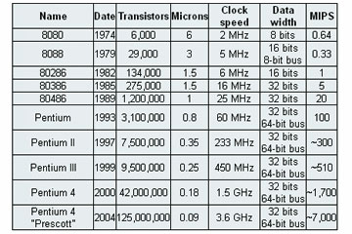

* **Transistors** is the number of transistors on the chip. You can see that the number of transistors on a single chip has risen steadily over the years.
* **Microns** is the width, in microns, of the smallest wire on the chip. For comparison, a human hair is 100 microns thick. As the feature size on the chip goes down, the number of transistors rises.
* **Clock speed** is the maximum rate that the chip can be clocked at. Clock speed will make more sense in the next section.
* **Data Width** is the width of the ALU. An 8-bit ALU can add/subtract/multiply/etc. two 8-bit numbers, while a 32-bit ALU can manipulate 32-bit numbers. An 8-bit ALU would have to execute four instructions to add two 32-bit numbers, while a 32-bit ALU can do it in one instruction. In many cases, the external data bus is the same width as the ALU, but not always. The 8088 had a 16-bit ALU and an 8-bit bus, while the modern Pentiums fetch data 64 bits at a time for their 32-bit ALUs.
* **MIPS** stands for "millions of instructions per second" and is a rough measure of the performance of a CPU. Modern CPUs can do so many different things that MIPS ratings lose a lot of their meaning, but you can get a general sense of the relative power of the CPUs from this column.

**Microprocessor Instructions**

Humans are not particularly good at remembering bit patterns, so a set of short words are defined to represent the different bit patterns. This collection of words is called the **assembly language** of the processor. An **assembler** can translate the words into their bit patterns very easily, and then the output of the assembler is placed in memory for the microprocessor to execute.Here's the set of assembly language instructions that the designer might create for the simple microprocessor in our example:

* **LOADA mem** - Load register A from memory address
* **LOADB mem** - Load register B from memory address
* **CONB con** - Load a constant value into register B
* **SAVEB mem** - Save register B to memory address
* **SAVEC mem** - Save register C to memory address
* **ADD** - Add A and B and store the result in C
* **SUB** - Subtract A and B and store the result in C
* **MUL** - Multiply A and B and store the result in C
* **DIV** - Divide A and B and store the result in C
* **COM** - Compare A and B and store the result in test
* **JUMP addr** - Jump to an address
* **JEQ addr** - Jump, if equal, to address
* **JNEQ** addr - Jump, if not equal, to address
* **JG addr** - Jump, if greater than, to address
* **JGE addr** - Jump, if greater than or equal, to address
* **JL addr** - Jump, if less than, to address
* **JLE addr** - Jump, if less than or equal, to address
* **STOP** - Stop execution

**64-bit Microprocessors**

Sixty-four-bit processors have been with us since 1992, and in the 21st century they have started to become mainstream. Both Intel and AMD have introduced 64-bit chips, and the Mac G5 sports a 64-bit processor. Sixty-four-bit processors have 64-bit ALUs, 64-bit registers, 64-bit buses and so on.

One reason why the world needs 64-bit processors is because of their enlarged address spaces. Thirty-two-bit chips are often constrained to a maximum of 2 GB or 4 GB of RAM access. That sounds like a lot, given that most home computers currently use only 256 MB to 512 MB of RAM. However, a 4-GB limit can be a severe problem for server machines and machines running large databases. And even home machines will start bumping up against the 2 GB or 4 GB limit pretty soon if current trends continue. A 64-bit chip has none of these constraints because a 64-bit RAM address space is essentially infinite for the foreseeable future -- 2^64 bytes of RAM is something on the order of a billion gigabytes of RAM.

With a 64-bit address bus and wide, high-speed data buses on the motherboard, 64-bit machines also offer faster I/O (input/output) speeds to things like hard disk drives and video cards. These features can greatly increase system performance.

Servers can definitely benefit from 64 bits, but what about normal users? Beyond the RAM solution, it is not clear that a 64-bit chip offers "normal users" any real, tangible benefits at the moment. They can process data (very complex data features lots of real numbers) faster. People doing video editing and people doing photographic editing on very large images benefit from this kind of computing power. High-end games will also benefit, once they are re-coded to take advantage of 64-bit features. But the average user who is reading e-mail, browsing the Web and editing Word documents is not really using the processor in that way.

**Why are there limits on CPU speed?**

There are two things that limit a chip's speed:

* Transmission delays on the chip
* Heat build-up on the chip

Transmission delays occur in the wires that connect things together on a chip. The "wires" on a chip are incredibly small aluminum or copper strips etched onto the silicon. A chip is nothing more than a collection of transistors and wires that hook them together, and a transistor is nothing but an on/off switch. When a switch changes its state from on to off or off to on, it has to either charge up or drain the wire that connects the transistor to the next transistor down the line. Imagine that a transistor is currently "on." The wire it is driving is filled with electrons. When the switch changes to "off," it has to drain off those electrons, and that takes time. The bigger the wire, the longer it takes.

As the size of the wires has gotten smaller over the years, the time required to change states has gotten smaller, too. But there is some limit -- charging and draining the wires takes time. That limit imposes a speed limit on the chip.

There is also a minimum amount of time that a transistor takes to flip states. Transistors are chained together in strings, so the transistor delays add up. On a complex chip like the G5, there are likely to be longer chains, and the length of the longest chain limits the maximum speed­ of the entire chip.

Finally, there is heat. Every time the transistors in a gate change state, they leak a little electricity. This electricity creates heat. As transistor sizes shrink, the amount of wasted current (and therefore heat) has declined, but there is still heat being created. The faster a chip goes, the more heat it generates. Heat build-up puts another limit on speed.

You can try to run your chip at a faster speed -- doing that is called overclocking. On many chips (especially certain models of the Celeron, it works very well. Sometimes, you have to cool the chip artificially to overclock it. Other times, you cannot overclock it at all because you immediately bump into transmission delays.

Differences between Pentium and Celeron Processor

Here are the most important similarities and differences between the Pentium 4 and the Celeron chips coming out today:

* Core - The Celeron chip is based on a Pentium 4 core.
* Cache - Celeron chips have less cache memory than Pentium 4 chips do. A Celeron might have 128 kilobytes of L2 cache, while a Pentium 4 can have four times that. The amount of L2 cache memory can have a big effect on performance.
* Clock speed - Intel manufactures the Pentium 4 chips to run at a higher clock speed than Celeron chips. The fastest Pentium 4 might be 60 percent faster than the fastest Celeron.
* Bus speed - There are differences in the maximum bus speeds that the processors allow. Pentium 4s tend to be about 30 percent faster than Celerons.­

**Intel’s Microprocessor Road Map(generations)**

1. 8086

First x86 processor; initially a temporary substitute for the iAPX 432 to compete with Motorola, Zilog, and National Semiconductor and to top the successful Z80.

1. 186

Included a DMA controller, interrupt controller, timers, and chip select logic.

1. 286

First x86 processor with protected mode.

1. i386

First 32-bit x86 processor.

1. i486

Intel's second-generation of 32-bit x86 processors, included built in floating point unit and pipelining.

1. P5

Original Pentium microprocessors.

1. P6

Used in Pentium Pro, Pentium II, Pentium II Xeon, Pentium III, and Pentium III Xeon microprocessors.

1. Pentium M

Updated version of Pentium III's P6 microarchitecture designed from the ground up for mobile computing.

1. Enhanced Pentium M

Updated, dual core version of the Pentium M microarchitecture used in Core microprocessors.

1. NetBurst

Used in Pentium 4, Pentium D, and some Xeon microprocessors. Commonly referred to as P7 although its internal name was P68 (P7 was used for Itanium). Later revisions were the first to feature Intel's x86-64 architecture.

1. Core

Reengineered P6-based microarchitecture used in Core 2 and Xeon microprocessors, built on a 65 nm process.

1. Penryn

45 nm shrink of the Core microarchitecture with larger cache, higher FSB and clock speeds, and SSE4.1 instructions.

1. Nehalem

Released November 17, 2008, built on a 45 nm process and used in the Core i7, Core i5, Core i3 microprocessors. Incorporates the memory controller into the CPU die.

1. Westmere

32 nm shrink of the Nehalem microarchitecture with several new features.

1. Sandy Bridge

Released January 9, 2011, built on a 32 nm process and used in the Core i7, Core i5, Core i3 second generation microprocessors, and in Pentium B9XX and Celeron B8XX series. Formerly called Gesher but renamed in 2007.

1. Ivy Bridge

22 nm shrink of the Sandy Bridge microarchitecture released April 28, 2012.

1. Haswell

New 22 nm microarchitecture, released June 3, 2013.

1. Broadwell

14 nm shrink of the Haswell microarchitecture, expected in 2014. Formerly called Rockwell.

1. Skylake

Future Intel microarchitecture, based on a 14 nm process.

1. Cannonlake

10 nm shrink of the Skylake microarchitecture. Formerly called Skymont.

1. Larrabee

Multi-core in-order x86-64 updated version of P5 microarchitecture, with wide SIMD vector units and texture sampling hardware for use in graphics. Cores derived from this microarchitecture are called MIC (Many Integrated Core).

1. Bonnell

45 nm, low-power, in-order microarchitecture for use in Atom processors.

1. Saltwell

32 nm shrink of the Bonnell microarchitecture.

1. Silvermont

22 nm, out-of-order microarchitecture for use in Atom processors.

1. Airmont

14 nm shrink of the Silvermont microarchitecture.

1. Goldmont

14 nm Atom microarchitecture

**AMD’s Microprocessor Road Map(generations)**

1. AMD K5 - AMD's first original microarchitecture. The K5 was based on the AMD Am29000 micro architecture with the addition of an x86 decoder. Although the design was similar in idea to a Pentium Pro, the actual performance was more like that of a Pentium.
2. AMD K6 - The K6 was not based on the K5 and was instead based on the Nx686 processor that was being designed by NexGen when that company was bought by AMD. The K6 was generally pin-compatible with the Intel Pentium (unlike NexGen's existing processors).
3. AMD K6-2 - An improved K6 with the addition of the 3DNow! SIMD instructions.
4. AMD K6-III - A further improved K6 with three levels of cache – 64 KB L1, 256 KB full-speed on-die L2, and a variable (up to 2 MB) L3.
5. AMD K7 Athlon - Microarchitecture of the AMD Athlon and Athlon XP microprocessors. Was a very advanced design for its day?
6. AMD K8 Hammer - Also called SledgeHammer, the K8s central processor unit is based on the K7 but was extended to 64 bits, added an integrated memory controller, HyperTransport communication fabric, L2 cache sizes up to 1 MB (1128 KB total cache), and SSE2. Later K8 added SSE3. The K8 was the first mainstream Windows-compatible 64-bit microprocessor and was released April 22, 2003. K8 replaced the traditional front side bus with a HyperTransport communication fabric. Also known as AMD Family 15.
7. AMD K10 Barcelona Family 10h microarchitecture - The Family 10h microarchitecture, called K10 popularly, is an architecture which is based on the K8 microarchitecture. Shared Level 3 Cache, 128-bit floating point units, AMD-V Nested Paging virtualization, and HyperTransport 3.0 are introduced in the Family 10h microarchitecture. Barcelona was the first design which implemented it.
8. AMD Turion X2 Ultra Family 11h microarchitecture - The Family 11h microarchitecture is a mixture of elements of both K8 and K10 to address the requirements for lower power consumption of the notebook market. It was marketed as the Turion X2 Ultra. It was later superseded by entirely K10-based notebook CPU designs.
9. Llano Family 12h microarchitecture - The Family 12h microarchitecture is an evolution of the K10 design featuring a 1 MB L2 cache per core, no L3 cache, improvements to the hardware prefetcher, a redesigned memory controller, power-saving improvements including clock gating, and Onion and Garlic interfaces for interfacing with an on-die GPU. It was used in first generation AMD Fusion A10, A8, A6, A4 and E2 CPUs.
10. AMD Bobcat Family 14h microarchitecture - The Family 14h microarchitecture, codenamed Bobcat, is a new distinct line from the original AMD64 microarchitectures, which is aimed in the 1 W to 10 W power category; the microprocessor core is in fact a very simplified x86 core. Ontario and Zacate were the first designs which implemented it.
11. AMD Bulldozer Family 15h microarchitecture - The Family 15h microarchitecture, codenamed Bulldozer, is the latest successor of the Family 10h microarchitecture by way of Fusion Family 12h. Bulldozer is designed for processors in the 10 W to 220 W category, implementing XOP, FMA4 and CVT16 instruction sets. Orochi was the first design which implemented it.
12. Family 16h microarchitecture Jaguar - Successor to Bobcat. Kabini and Temash. Puma - Successor to Jaguar. Beema and Mullins.

intel 8085 

* The Intel 8085 is an 8-bit microprocessor introduced by Intel in 1977.
* It was binary-compatible with the more-famous Intel 8080 but required less supporting hardware, thus allowing simpler and less expensive microcomputer systems to be built.

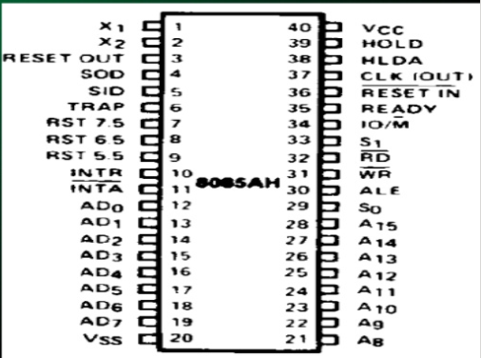

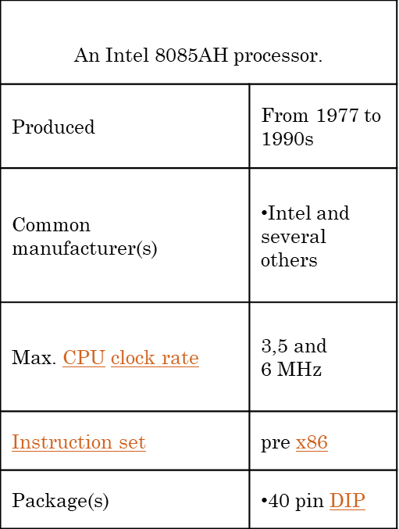

intel 8086

* The 8086 is a 16-bit microprocessor chip designed by Intel, which gave rise to the x86 architecture; development work on the 8086 design started in the spring of 1976 and the chip was introduced to the market in the summer of 1978.
* The Intel 8088, released in 1979, was a slightly modified chip with an external 8-bit data bus (allowing the use of cheaper and fewer supporting logic chips and is notable as the processor used in the original IBM PC.

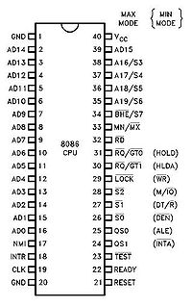

1. What are the components of a processor?

* **Control Unit**- fetches, decodes, executes instructions.
* **Arithmetic & Logic Unit**- performs arithmetic and logical operations on data.
* **Registers**- fast, on-chip memory inside the CPU, dedicated or general purpose.
* **Internal Clock**- derived directly or indirectly from the system clock
* **Internal Buses**- to connect the components
* **Logic Gates**- to control the flow of information

2. List and describe the types of processors are used in the modern

computer?

There are two primary manufacturers of [computer](https://www.ebay.com/sch/i.html?_nkw=computer" \o "Link added by VigLink" \t "_blank)microprocessors. Intel and Advanced Micro Devices(AMD) lead the market in terms of speed and quality. Intel's desktop CPUs include Celeron, Pentium and Core. AMD's desktop processors include Sempron, Athlon and Phenom. Intel makes Celeron M, Pentium M and Core mobile processors for notebooks. AMD makes mobile versions of its Sempron and Athlon, as well as the Turion mobile processor which comes in Ultra and Dual-Core versions. Both companies make both single-core and multi-core processors.

3. List the features of the Intel Core processors.

## Features and Performance



### Get Unprecedented Power and Responsiveness

Now everyday computer tasks can happen faster. Edit photos and videos seamlessly. Move between programs and windows quickly. Multi-task easily. Better still, all that performance comes with up to 10 hours of battery life1 5, so you can take your computer wherever you go without worrying about cords and plug points.



### Make Your Computer an Entertainment Center

Get an amazing entertainment hub—stream 4K UHD videos, power virtual reality, and play the most demanding games. With 4x more pixels on screen than traditional HD, you can enjoy sharp, lifelike visuals, complex shading, and fast frame rates—all with virtually no stuttering, buffering, or lags. And be ready for revolutionary immersive experiences yet to come.



### Easy to Use, Hard to Break Into

Built-in security6 adds a critical layer of protection to make password logins, browsing, and online payments safe6 and simple. You can log on with a look, your voice, or your fingerprint for rock-solid security6 that’s fast and hassle free. Store passwords, personal information, and auto-fill information with one master password. Plus touch screen, voice commands, and stylus options offer natural and intuitive interactions.

4. What is a Co- Processor?

A coprocessor is a special set of [circuit](http://searchcio-midmarket.techtarget.com/definition/circuit) s in a [microprocessor](http://searchcio-midmarket.techtarget.com/definition/microprocessor) [chip](http://searchcio-midmarket.techtarget.com/definition/chip) that is designed to manipulate numbers or perform some other specialized function more quickly than the basic microprocessor circuits could perform the same task. A coprocessor offloads specialized processing operations, thereby reducing the burden on the basic microprocessor circuitry and allowing it to work at optimum speed.

5. Which are the possible configurations in a multiprocessor environment?

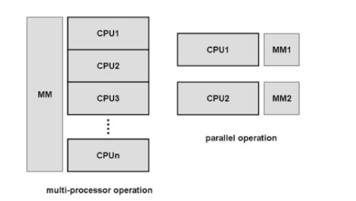

6. What is pipelining? State the advantages of pipeline architecture

In computers, a pipeline is the continuous and somewhat overlapped movement of [instruction](http://searchcio-midmarket.techtarget.com/definition/instruction) to the [processor](http://searchcio-midmarket.techtarget.com/definition/processor)or in the arithmetic steps taken by the processor to perform an instruction. Pipelining is the use of a pipeline. Without a pipeline, a computer processor gets the first instruction from memory, performs the operation it calls for, and then goes to get the next instruction from memory, and so forth. While fetching (getting) the instruction, the arithmetic part of the processor is idle. It must wait until it gets the next instruction. With pipelining, the computer architecture allows the next instructions to be fetched while the processor is performing arithmetic operations, holding them in a [buffer](http://searchcio-midmarket.techtarget.com/definition/buffer) close to the processor until each instruction operation can be performed. The staging of instruction fetching is continuous. The result is an increase in the number of instructions that can be performed during a given time period.

The only major advantage is **performance improvement**. By pipelining instructions, you are able to pump in more instructions and so, you get a significant improvement in processor speed. This happens because you are able to execute parts of instructions in parallel to parts of other instructions. Consider the case when you are trying to execute 3 instructions, each of cycle length 3. In the case of pipelined execution, you will be able to get them all done in 5 cycles. If you are executing them without pipelining, it will take you 9 CPU cycles to complete them all.

7. How is synchronization between different operations of a processor

achieved?

A single processor or [uniprocessor system](https://en.wikipedia.org/wiki/Uniprocessor_system) could disable [interrupts](https://en.wikipedia.org/wiki/Interrupt) by executing currently running code without [preemption](https://en.wikipedia.org/wiki/Preemption_(computing)), which is very inefficient on [multiprocessor](https://en.wikipedia.org/wiki/Multiprocessing) systems.[[4]](https://en.wikipedia.org/wiki/Synchronization_(computer_science)#cite_note-Wiley2014-4) "The key ability we require to implement synchronization in a multiprocessor is a set of hardware primitives with the ability to atomically read and modify a memory location. Without such a capability, the cost of building basic synchronization primitives will be too high and will increase as the processor count increases. There are a number of alternative formulations of the basic hardware primitives, all of which provide the ability to atomically read and modify a location, together with some way to tell if the read and write were performed atomically. These hardware primitives are the basic building blocks that are used to build a wide variety of user-level synchronization operations, including things such as [locks](https://en.wikipedia.org/wiki/Lock_(computer_science)) and [barriers](https://en.wikipedia.org/wiki/Barrier_(computer_science)). In general, architects do not expect users to employ the basic hardware primitives, but instead expect that the primitives will be used by system programmers to build a synchronization library, a process that is often complex and tricky."[[5]](https://en.wikipedia.org/wiki/Synchronization_(computer_science)#cite_note-Morgan2011-5) Many modern hardware provides special atomic hardware instructions by either [test-and-set](https://en.wikipedia.org/wiki/Test-and-set) the memory word or [compare-and-swap](https://en.wikipedia.org/wiki/Compare-and-swap)contents of two memory words.

8. What are superscalar processors? How can we achieve superscalar

architecture?

A **superscalar processor** is a [CPU](https://en.wikipedia.org/wiki/Central_processing_unit) that implements a form of [parallelism](https://en.wikipedia.org/wiki/Parallel_computer) called [instruction-level parallelism](https://en.wikipedia.org/wiki/Instruction-level_parallelism) within a single processor. In contrast to a [scalar processor](https://en.wikipedia.org/wiki/Scalar_processor) that can execute at most one single instruction per clock cycle, a superscalar processor can execute more than one instruction during a clock cycle by simultaneously dispatching multiple instructions to different [execution units](https://en.wikipedia.org/wiki/Execution_unit) on the processor. It therefore allows for more [throughput](https://en.wikipedia.org/wiki/Throughput) (the number of instructions that can be executed in a unit of time) than would otherwise be possible at a given [clock rate](https://en.wikipedia.org/wiki/Clock_rate). Each execution unit is not a separate processor (or a core if the processor is a [multi-core processor](https://en.wikipedia.org/wiki/Multi-core_processor)), but an execution resource within a single CPU such as an [arithmetic logic unit](https://en.wikipedia.org/wiki/Arithmetic_logic_unit).

In [Flynn's taxonomy](https://en.wikipedia.org/wiki/Flynn%27s_taxonomy), a single-core superscalar processor is classified as an [SISD](https://en.wikipedia.org/wiki/SISD) processor (Single Instruction stream, Single Data stream), though many superscalar processors support short vector operations and so could be classified as [SIMD](https://en.wikipedia.org/wiki/SIMD) (Single Instruction stream, Multiple Data streams). A [multi-core](https://en.wikipedia.org/wiki/Multi-core) superscalar processor is classified as an [MIMD](https://en.wikipedia.org/wiki/MIMD) processor (Multiple Instruction streams, Multiple Data streams).

While a superscalar CPU is typically also [pipelined](https://en.wikipedia.org/wiki/Instruction_pipeline), superscalar and pipelining execution are considered different performance enhancement techniques. The former executes multiple instructions in parallel by using multiple execution units, whereas the latter executes multiple instructions in the same execution unit in parallel by dividing the execution unit into different phases.

The superscalar technique is traditionally associated with several identifying characteristics (within a given CPU):

* Instructions are issued from a sequential instruction stream
* The CPU dynamically checks for [data dependencies](https://en.wikipedia.org/wiki/Data_dependencies) between instructions at run time (versus software checking at [compile time](https://en.wikipedia.org/wiki/Compile_time))
* The CPU can execute multiple instructions per clock cycle

Superscalar architecture is a method of parallel computing used in many processors. In a superscalar computer, the central processing unit (CPU) manages multiple instruction pipelines to execute several instructions concurrently during a clock cycle. This is achieved by feeding the different pipelines through a number of execution units within the processor. To successfully implement a superscalar architecture, the CPU's instruction fetching mechanism must intelligently retrieve and delegate instructions. Otherwise, pipeline stalls may occur, resulting in execution units that are often idle.

9. Differentiate between a microprocessor and a microcontroller.

1. Key difference in both of them is presence of external peripheral, where microcontrollers have RAM, ROM, EEPROM embedded in it while we have to use external circuits in case of microprocessors.

2. As all the peripheral of microcontroller are on single chip it is compact while microprocessor is bulky.

3. Microcontrollers are made by using complementary metal oxide semiconductor technology so they are far cheaper than microprocessors. In addition the applications made with microcontrollers are cheaper because they need lesser external components, while the overall cost of systems made with microprocessors are high because of the high number of external components required for such systems.

4. Processing speed of microcontrollers is about 8 MHz to 50 MHz, but in contrary processing speed of general microprocessors is above 1 GHz so it works much faster than microcontrollers.

5. Generally microcontrollers have power saving system, like idle mode or power saving mode so overall it uses less power and also since external components are low overall consumption of power is less. While in microprocessors generally there is no power saving system and also many external components are used with it, so its power consumption is high in comparison with microcontrollers.

6. Microcontrollers are compact so it makes them favorable and efficient system for small products and applications while microprocessors are bulky so they are preferred for larger applications.

7. Tasks performed by microcontrollers are limited and generally less complex. While task performed by microprocessors are software development, Game development, website, documents making etc. which are generally more complex so require more memory and speed so that’s why external ROM, RAM are used with it.

8. Microcontrollers are based on Harvard architecture where program memory and data memory are separate while microprocessors are based on von Neumann model where program and data are stored in same memory module.

10. How does processor communicate internally with peripheral devices?

On modern architectures, peripherals are accessed in a similar way to memory: via mapped memory addresses on a bus. You shouldn't think of a bus as a way to access memory. It's more a way to address individual peripherals, of which memory (RAM/DDR) is just one type. For example, you might have 2GB of RAM at addresses 0x00000000..0x7fffffff. After that you might have a graphics card at 0x80000000..0x80001fff. The bus controller (PCIe or whatever) knows which address ranges go to which peripheral.

Information of cpu using cpu-z

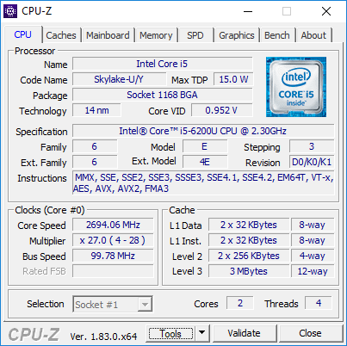

Information about phone cpu

|  |  |
| --- | --- |
| **Basic Properties** | |
| Device | iPhone 6 Plus |
| Dock Connector | Lightning |
| SIM Card Type | Nano-SIM |
| Device String | iPhone7,1 |
| Device Id | N56AP |
| Released | 19-Sep-2014 |
| **Capabilities** | |
| Cellular | Yes |
| GPS | Yes |
| NFC | Yes |
| Force Touch | No |
| **Bluetooth** | |
| Version | 4.0 |
| Controller | Broadcom BCM4345 |
| Bluetooth Smart (LE) | Yes |
| **Physical Properties** | |
| Width | 77.8 mm |
| Height | 158.1 mm |
| Depth | 7.1 mm |
| Weight | 172 g |
| **CPU Properties** | |
| CPU | Apple A8 |
| Speed | 1400 MHz |
| Manufacturer | TSMC |
| Instruction Set | 64-bit ARMv8-A |
| Microarchitecture | Cyclone 2 |
| Technology | 20 nm |
| Core Count | 2 |
| Active Core Count | 2 |
| **GPU Properties** | |
| GPU Type | PowerVR GX6450 |
| GPU Cores | 4 |
| **Co-processor Properties** | |
| Co-processor | Apple M8 |
| **Storage Information** | |
| Device Model | 128 GB |
| Total Storage | 119.20 GB |
| Available Storage | 1.85 GB |
| **RAM Information** | |
| Total RAM | 969 MB |
| Available RAM | 33 MB |
| **Screen Size** | |
| Screen Size | 5.5" |
| Aspect Ratio | 16:9 |
| Pixel Density | 401 PPI |
| **Screen Parameters** | |
| Vertical Resolution | 1920 Pixels |
| Horizontal Resolution | 1080 Pixels |
| Contrast | 1300:1 |
| Brightness | 500 cd/m² |
| Technology | IPS |
| Refresh Rate | 60Hz |
| Color Gamut | sRGB |
| **Back Camera** | |
| Resolution | 8 MegaPixels |
| Aperture | 2.2 |
| Max Video Resolution | 1080p @ 60fps |
| Max Video Speed | 240fps @ 720p |
| Optical Stabilization | Yes |
| Max Photo Resolution | 3264 x 2448 |
| Shortest Exposure Value | 1/166667 sec |
| Longest Exposure Value | 1/2 sec |
| **Front Camera** | |
| Resolution | 1.2 MegaPixels |
| Aperture | 2.2 |
| Max Video Resolution | 720p @ 30fps |
| Max Video Speed | 30fps @ 720p |
| Optical Stabilization | No |
| Max Photo Resolution | 1280 x 960 |
| Shortest Exposure Value | 1/76923 sec |
| Longest Exposure Value | 1/2 sec |
| **Cellular** | |
| Carrier Name | Jio |
| Current Connection | LTE |
| Capabilities | CDMA/UMTS/HSDPA/LTE |
| Baseband | Qualcomm MDM9625 |
| **Assigned IP Addresses** | |
| Wi-Fi (IPv4) | Not Available |
| Wi-Fi (IPv6) | Not Available |
| Cellular (IPv4) | 10.135.121.225 |
| Cellular (IPv6) | 2405:204:808e:96ab:bd33:304a:c04:4038 |
| **Wi-Fi Details** | |
| SSID | Not Connected |
| BSSID | Not Connected |
| Capabilities | 802.11 a/b/g/n/ac |
| Controller | Broadcom BCM4345 |
| **Battery** | |
| Status | Discharging |
| Level | 23 % |
| Voltage | 3.8 V |
| Capacity | 2915 mAh |
| Type | Li-Ion Polymer |
| **Battery Details** | |
| Charge | 506 / 2200 mAh (23 %) |
| Wear Level | 24.53 % |
| Voltage | 3.684 V |
| **Adapter Details** | |
| **Installed OS** | |
| Operating System | iOS |
| Version | 11.2.6 |
| Build Number | 15D100 |
| OS State | Stable |
| Multitasking | Yes |
| **Current Session** | |
| Active Time | 0d 3h 28m |
| Uptime | 0d 1h 57m |
| **OS Compatibility** | |
| Initial OS Version | iOS 8.0 |

**Practical 4**

**Aim : Study of Different types of Memory**

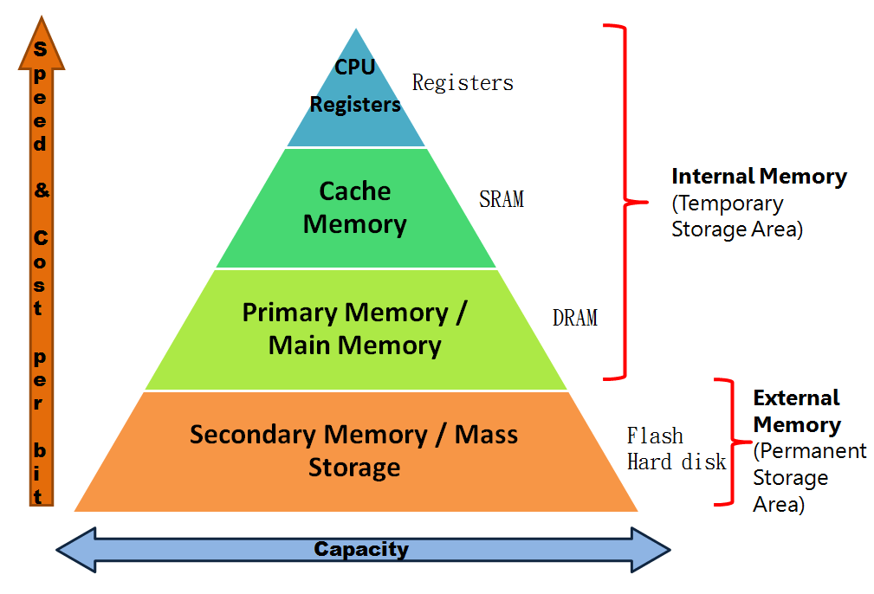

Memory Difference in speed & storage

TYPES OF MEMORY

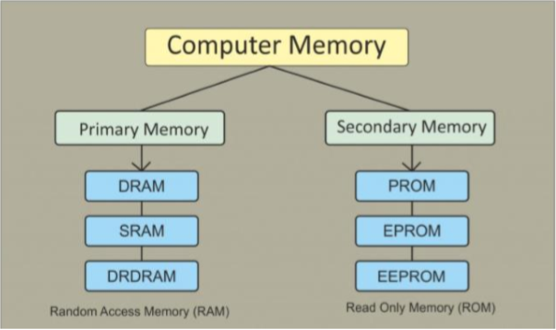

**COMPUTER MEMORY**

**Memory is major part of computers that categories into several types. Memory is best storage part to the computer users to save information, programs and etc, The computer memory offer several kinds of storage media some of them can store data temporarily and some them can store permanently. Memory consists of instructions and the data saved into computer through Central Processing Unit (CPU).**

CPU Register:

In computer architecture, a **processor register** is a quickly accessible location available to a computer's central processing unit (CPU). Registers usually consist of a small amount of fast storage, although some registers have specific hardware functions, and may be read-only or write-only. Registers are typically addressed by mechanisms other than main memory, but may in some cases be assigned a memory address e.g. DEC PDP-10, ICT 1900.

Almost all computers, whether load/store architecture or not, load data from a larger memory into registers where it is used for arithmetic operations and is manipulated or tested by machine instructions. Manipulated data is then often stored back to main memory, either by the same instruction or by a subsequent one. Modern processors use either static or dynamic RAM as main memory, with the latter usually accessed via one or more cache levels.

Processor registers are normally at the top of the memory hierarchy, and provide the fastest way to access data.

The number of registers available on a processor and the operations that can be performed using those registers has a significant impact on the [efficiency](https://en.wikipedia.org/wiki/Algorithmic_efficiency) of code generated by [optimizing compilers](https://en.wikipedia.org/wiki/Optimizing_compilers).

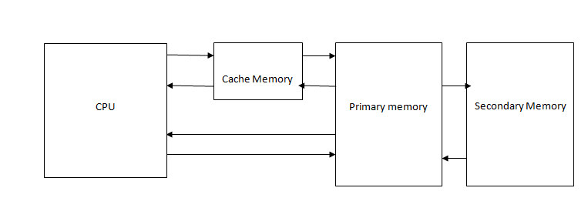

Relation Between Memory

Cache Memory:

Cache Memory: Cache memory is a small-sized type of volatile computer memory that provides high-speed data access to a processor and stores frequently used computer programs, applications and data. It is the fastest memory in a computer, and is typically integrated onto the motherboard and directly embedded in the processor or main random access memory (RAM).A **CPU cache**is a hardware cache used by the central processing unit (CPU) of a [computer](https://en.wikipedia.org/wiki/Computer) to reduce the average cost (time or energy) to access [data](https://en.wikipedia.org/wiki/Data_(computing)) from the main memory. A cache is a smaller, faster memory, closer to a [processor core](https://en.wikipedia.org/wiki/Processor_core), which stores copies of the data from frequently used main [memory locations](https://en.wikipedia.org/wiki/Memory_location). Most CPUs have different independent caches, including instruction and data caches, where the data cache is usually organized as a hierarchy of more cache levels (L1, L2, etc.).

Cache memory is fast and expensive. Traditionally, it is categorized as "levels" that describe its closeness and accessibility to the microprocessor:

**Level 1 (**[**L1**](http://whatis.techtarget.com/definition/L1-and-L2)**) cache** is extremely fast but relatively small, and is usually embedded in the processor chip (CPU).

**Level 2 (L2) cache** is often more capacious than L1; it may be located on the CPU or on a separate chip or coprocessor with a high-speed alternative system bus interconnecting the cache to the CPU, so as not to be slowed by traffic on the main system bus.

**Level 3 (L3) cache** is typically specialized memory that works to improve the performance of L1 and L2. It can be significantly slower than L1 or L2, but is usually double the speed of RAM. In the case of multicore processors, each core may have its own dedicated L1 and L2 cache, but share a common L3 cache. When an instruction is referenced in the L3 cache, it is typically elevated to a higher tier cache.

The three different types of mapping used for the purpose of cache memory are as follow,

1. Direct mapping
2. Associative mapping,
3. Set-Associative mapping.

**Types of Cache:**

1. **Primary Cache –** A primary cache is always located on the processor chip. This cache is small and its access time is comparable to that of processor registers.
2. **Secondary Cache –** secondary cache is placed between the primary cache and the rest of the memory. It is referred to as the level 2 (L2) cache. Often, the Level 2 cache is also housed on the processor chip.

Memory is the best essential element of a computer because computer can’t perform simple tasks. The performance of computer mainly based on memory and CPU. Memory is internal storage media of computer that has several names such as majorly categorized into two types, Main memory and Secondary memory.

1. Primary Memory / Volatile Memory.

2. Secondary Memory / Non Volatile Memory.

Primary Memory:

Primary Memory also called as volatile memory because the memory can’t store the data permanently. Primary memory select any part of memory when user want to save the data in memory but that may not be store permanently on that location. It also has another name i.e. RAM.

In computing, **memory** refers to the computer hardware integrated circuits that store information for immediate use in a computer; it is synonymous with the term "primary storage". Computer memory operates at a high speed, for example random-access memory (RAM), as a distinction from storage that provides slow-to-access information but offers higher capacities. If needed, contents of the computer memory can be transferred to secondary storage, through a memory management technique called "virtual memory".

The term "memory", meaning "primary storage" or "main memory", is often associated with addressable semiconductor memory, i.e. integrated circuits consisting of silicon-based transistors, used for example as primary storage but also other purposes in computers and other digital electronic devices. There are two main kinds of semiconductor memory, volatile and non-volatile. Examples of non-volatile memory are flash memory (used as secondary memory) and ROM, PROM, EPROM and EEPROM memory (used for storing firmware such as BIOS). Examples of volatile memory are primary storage, which is typically dynamic random-access memory (DRAM), and fast CPU cache memory, which is typically static random-access memory (SRAM) that is fast but energy-consuming, offering lower memory areal density than DRAM.

**Random Access Memory (RAM):**

RAM : Random-access memory (RAM) is a form of computer data storage that stores data and machine code currently being used. A random-access memory device allows data items to be read or written in almost the same amount of time irrespective of the physical location of data inside the memory. In contrast, with other direct-access data storage media such as hard disks, CD-RWs, DVD-RWs and the older magnetic tapes and drum memory, the time required to read and write data items varies significantly depending on their physical locations on the recording medium, due to mechanical limitations such as media rotation speeds and arm movement.

RAM contains multiplexing and demultiplexing circuitry, to connect the data lines to the addressed storage for reading or writing the entry. Usually more than one bit of storage is accessed by the same address, and RAM devices often have multiple data lines and are said to be "8-bit" or "16-bit", etc. devices.

RAM stands for Random Access Memory, and it gives computers the virtual space needed to manage information and solve problems in the moment. You can think of it like reusable scratch paper that you would write notes, numbers, or drawings on with a pencil. If you run out of room on the paper, you make more by erasing what you no longer need; RAM behaves similarly when it needs more space to deal with temporary information (i.e. running software/programs). Larger pieces of paper allow you to scribble out more (and bigger) ideas at a time before having to erase; more RAM inside of computers shares a similar effect.

RAM comes in a variety of shapes (i.e. the way it physically connects to or interfaces with computing systems), capacities (measured in MB or GB), speeds (measured in MHz or GHz), and architectures.

Nearly every computing-capable device needs RAM. Take a look at your favorite device (e.g. smartphones, tablets, desktops, laptops, graphing calculators, HDTVs, handheld gaming systems, etc.), and you should find some information about the RAM. Although all RAM basically serves the same purpose, there are a few different types commonly in use today:

• Static RAM (SRAM) • Dynamic RAM (DRAM) • Synchronous Dynamic RAM (SDRAM)

• Single Data Rate Synchronous Dynamic RAM (SDR SDRAM) • Double Data Rate Synchronous Dynamic RAM (DDR SDRAM, DDR2, DDR3, DDR4) • Graphics Double Data Rate Synchronous Dynamic RAM (GDDR SDRAM, GDDR2, GDDR3, GDDR4, GDDR5)

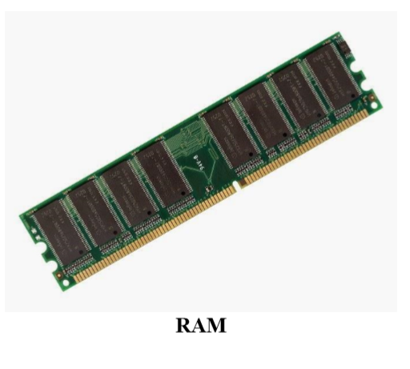

2. Secondary Memory / Non-Volatile Memory:

NV or Non-volatile memory is a term used to describe any memory or storage that is saved regardless if the power to the computer is on or off. The best example of non-volatile memory and storage is a computer hard drive, flash memory, and ROM.

ROM : Read-only memory (ROM) is a type of non-volatile memory used in computers and other electronic devices. Data stored in ROM can only be modified slowly, with difficulty, or not at all, so it is mainly used to store firmware (software that is closely tied to specific hardware, and unlikely to need frequent updates) or application software in plug-in cartridges. ROM is permanent memory location that offer huge types of standards to save data. But it work with read only operation. No data lose happen whenever power failure occur during the ROM memory work in computers.Strictly, *read-only memory* refers to memory that is hard-wired, such as diode matrix and the later mask ROM(MROM), which cannot be changed after manufacture. Although discrete circuits can be altered in principle, integrated circuits (ICs) cannot, and are useless if the data is bad or requires an update. That such memory can never be changed is a disadvantage in many applications, as bugs and security issues cannot be fixed, and new features cannot be added.

Types of ROM: There are five basic ROM types:

1. **Mask ROM** – It is also known as MROM. It is a static ROM which comes programmed into an integrated circuit by its manufacturer. The software mask is burned into the chip and that is why it is termed as Mask ROM. Network operating systems and server operating systems make use of this type of Mask ROM chips.
2. **PROM**–It stands for Programmable Read Only Memory. It was first developed in 70s by Texas Instruments. It is made as a blank memory. A PROM programmer or PROM burner is required in order to write data onto a PROM chip. The data stored in it cannot be modified and therefore it is also known as one time programmable device.
3. **EPROM** – It stands for Erasable Programmable ROM. It is different from PROM as unlike PROM the program can be written on it more than once. This comes as the solution to the problem faced by PROM. The bits of memory come back to 1, when ultra violet rays of some specific wavelength falls into its chip’s glass panel. The fuses are reconstituted and thus new things can be written on the memory.
4. **EEPROM** – It stands for Electrically Erasable Read Only Memory. These are also erasable like EPROM, but the same work of erasing is performed with electric current. Thus, it provides the ease of erasing it even if the memory is positioned in the computer. It stores computer system’s BIOS. Unlike EPROM, the entire chip does not have to be erased for changing some portion of it. Thus, it even gets rid of some biggest challenges faced by using EPROMs.
5. **FLASH ROM**– It is an updated version of EEPROM. In EEPROM, it is not possible to alter many memory locations at the same time. However, Flash memory provides this advantage over the EEPROM by enabling this feature of altering many locations simultaneously. It was invented by Toshiba and got its name from it capability of deleting a block of data in a flash.

Secondary Storage:

Secondary memory is computer memory that is non-volatile and persistent in nature and is not directly accessed by a computer/processor. It allows a user to store data that may be instantly and easily retrieved, transported and used by applications and services. Secondary memory is also known as secondary storage.

Secondary memory consists of all permanent or persistent storage devices, such as flash drives, hard disk drives (HDD), magnetic tapes and other types of internal/external storage media. In computing operations, secondary memory is accessed only by the primary or main memory and later transported to the processor.

Secondary memory is slower than primary memory but can store and retain data, even if the computer is not connected to electrical power. It also has substantial storage capacities, ranging from megabytes to several terabytes of storage space within single memory.

Some Secondary Storage:

1 Hard Disk Drive: A hard disk drive (HDD), hard disk, hard drive or fixed disk is a data storage device that uses magnetic storage to store and retrieve digital information using one or more rigid rapidly rotating disks (platters) coated with magnetic material. The platters are paired with [magnetic heads](https://en.wikipedia.org/wiki/Disk_read-and-write_head), usually arranged on a moving actuator arm, which read and write data to the platter surfaces. Data is accessed in a random-access manner, meaning that individual blocks of data can be stored or retrieved in any order and not only sequentially. HDDs are a type of non-volatile storage, retaining stored data even when powered off.

2 Optical Disk: In [computing](https://en.wikipedia.org/wiki/Computing) and [optical disc recording technologies](https://en.wikipedia.org/wiki/Optical_disc_recording_technologies), an optical disc (OD) is a flat, usually circular disc which encodes binary data ([bits](https://en.wikipedia.org/wiki/Bit)) in the form of [pits](https://en.wikipedia.org/wiki/Compact_disk#Physical_details) (binary value of 0 or off, due to lack of reflection when read) and lands (binary value of 1 or on, due to a reflection when read) on a special material (often aluminium ) on one of its flat surfaces. The encoding material sits atop a thicker substrate (usually polycarbonate) which makes up the bulk of the disc and forms a dust defocusing layer. The encoding pattern follows a continuous, spiral path covering the entire disc surface and extending from the innermost track to the outermost track. The data is stored on the disc with a [laser](https://en.wikipedia.org/wiki/Laser) or stamping machine, and can be accessed when the data path is illuminated with a [laser diode](https://en.wikipedia.org/wiki/Laser_diode) in an optical disc drive which spins the disc at speeds of about 200 to 4,000 RPM or more. An optical disc is designed to support one of three recording types: read-only (e.g.: CD and [CD-ROM](https://en.wikipedia.org/wiki/CD-ROM)), recordable (write-once, e.g. [CD-R](https://en.wikipedia.org/wiki/CD-R)), or re-recordable (rewritable, e.g. [CD-RW](https://en.wikipedia.org/wiki/CD-RW)).

3 USB Flash Drive: A USB flash drive, also variously known as a thumb drive, pen drive, jump drive, disk key, disk on key, flash-drive, memory stick or USB memory, is a data storage device that includes flash memory with an integrated USB interface. It is typically removable, rewritable and much smaller than an optical disc. Most weigh less than 30 g (1 ounce). Since first appearing on the market in late 2000, as with virtually all other computer memory devices, storage capacities have risen while prices have dropped.

USB flash drives are often used for the same purposes for which floppy disks or [CDs](https://en.wikipedia.org/wiki/CD-ROM) were once used; i.e. for storage, data back-up and transfer of computer files. They are smaller, faster, have thousands of times more capacity, and are more durable and reliable because they have no moving parts.

4 SD Card: Secure Digital (SD) is a [non-volatile](https://en.wikipedia.org/wiki/Non-volatile_memory) memory card format developed by the SD Card Association (SDA) for use in portable devices. Cards can protect their contents from erasure or modification, prevent access by non-authorized users, and protect copyrighted content using digital rights management.

5 Floppy Disk: A floppy disk, also called a floppy, diskette, or just disk, is a type of disk storage composed of a disk of thin and flexible [magnetic storage](https://en.wikipedia.org/wiki/Magnetic_storage) medium, sealed in a rectangular plastic enclosure lined with fabric that removes dust particles. Floppy disks are read and written by a floppy disk drive (FDD).

External Storage:

In computing, external storage comprises devices that store information outside a computer. Such devices may be permanently attached to the computer, may be removable or may use removable media.

Types of external storage :

1. Magnetic Storage
2. Optical Storage
3. Flash Memory Devices
4. External Hard Disk

**The ram I studied:**

Type:pc133 sdram sodimm module made by JEDEC

Clock frequency 133 mhz

Address bus:64 bit

Speed:1066 MB per sec

Voltage:3.3v

Synchronous dynamic access module

168 pin dim

Different types of ram:

Sdram->100mhz->168pins->2.5v

DDR1->400mhz->184 pins->2.5v

DDR2->533mhz->240pins->1.8v

DDR3->1333mhz->240pins notch not in middle->1.5v

Ecc ram:

Error correcting ram

**Error-correcting code memory** (**ECC memory**) is a type of [computer data storage](https://en.wikipedia.org/wiki/Computer_data_storage) that can detect and correct the most common kinds of internal [data corruption](https://en.wikipedia.org/wiki/Data_corruption). ECC memory is used in most computers where data corruption cannot be tolerated under any circumstances, such as for scientific or financial computing.

Typically, ECC memory maintains a memory system immune to single-bit errors: the data that is read from each [word](https://en.wikipedia.org/wiki/Word_(computer_architecture)) is always the same as the data that had been written to it, even if one or more bits actually stored have been flipped to the wrong state. Most non-ECC memory cannot detect errors although some non-ECC memory with parity support allows detection but not correction.

## Advantages and disadvantages

Ultimately, there is a [trade-off](https://en.wikipedia.org/wiki/Trade-off) between protection against unusual loss of data, and a higher cost.

ECC protects against undetected memory data corruption, and is used in computers where such corruption is unacceptable, for example in some scientific and financial computing applications, or in [file servers](https://en.wikipedia.org/wiki/Server_(hardware)). ECC also reduces the number of crashes, particularly unacceptable in multi-user server applications and maximum-availability systems. Most [motherboards](https://en.wikipedia.org/wiki/Motherboards) and processors for less critical application are not designed to support ECC so their prices can be kept lower. Some ECC-enabled boards and processors are able to support unbuffered (unregistered) ECC, but will also work with non-ECC memory; system firmware enables ECC functionality if ECC RAM is installed.

ECC memory usually involves a higher price when compared to non-ECC memory, due to additional hardware required for producing ECC memory modules, and due to lower production volumes of ECC memory and associated system hardware. Motherboards, [chipsets](https://en.wikipedia.org/wiki/Chipset) and processors that support ECC may also be more expensive.

ECC may lower memory performance by around 2–3 percent on some systems, depending on application and implementation, due to the additional time needed for ECC memory controllers to perform error checking..However, modern systems integrate ECC testing into the CPU, generating no additional delay to memory accesses

**HOW DDR WORKS:**

“DDR” refers to the interface of the RAM device. Double Data Rate; the data is transferred on both the rising and falling edges of the clock therefore two data bits in one clock cycle.

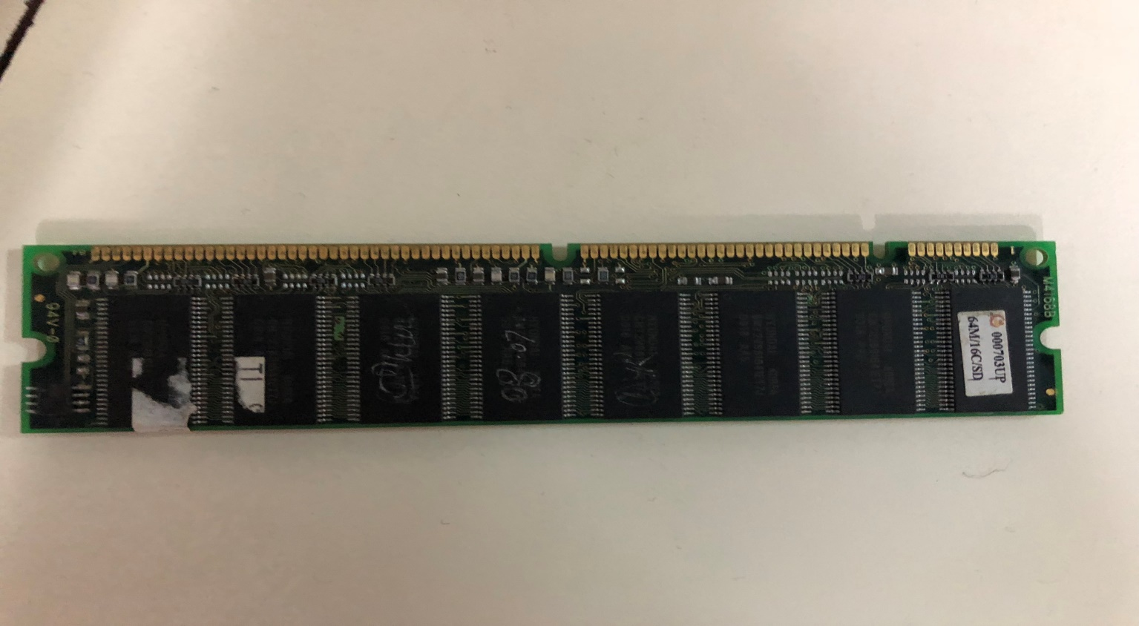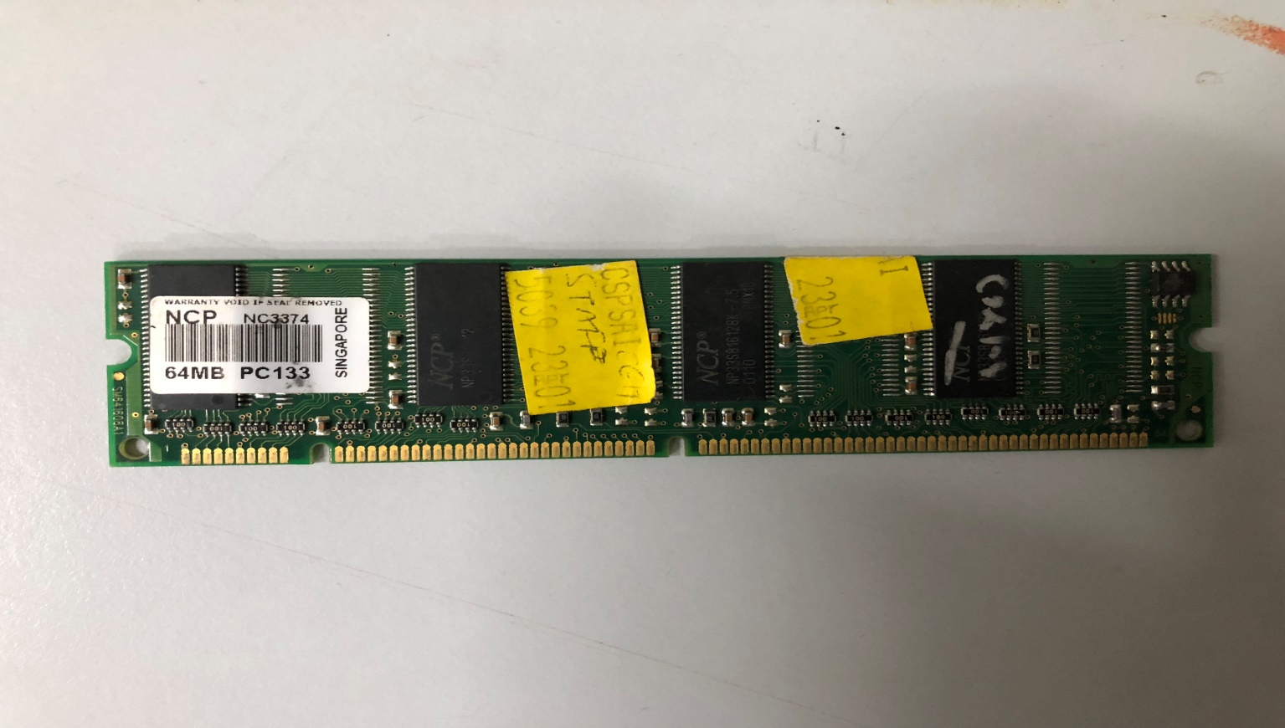

CONCLUSION :

Here we studied different types of memory used in computers.

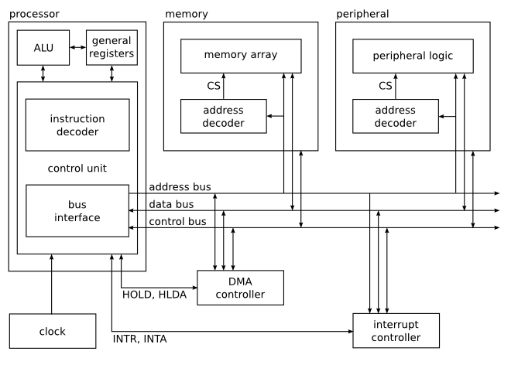

Figure Interconnection of RAM and CPU

**Practical 5**

**Aim : Study of other devices of computer**

The motherboard is a sheet of plastic that holds all the circuitry to connect the various components of a computer system. Learn how the motherboard functions to make all the other components work together.

## Motherboard: Definition

A motherboard is one of the most essential parts of a computer system. It holds together many of the crucial components of a computer, including the central processing unit (CPU), memory and connectors for input and output devices. The base of a motherboard consists of a very firm sheet of non-conductive material, typically some sort of rigid plastic. Thin layers of copper or aluminum foil, referred to as *traces*, are printed onto this sheet. These traces are very narrow and form the circuits between the various components. In addition to circuits, a motherboard contains a number of sockets and slots to connect the other components.

## Parts of a Motherboard

If you were to open up your computer and take out the motherboard, you would probably get pretty confused about all the different parts. Depending on the make and model of your computer, it might look something like this.

|  |
| --- |
| computer mother board |
| ***Photograph of a typical motherboard of a desktop computer*** |

To understand how computers work, you don't need to know every single part of the motherboard. However, it is good to know some of the more important parts and how the motherboard connects the various parts of a computer system together. Here are some of the typical parts:

* A CPU socket - the actual CPU is directly soldered onto the socket. Since high speed CPUs generate a lot of heat, there are heat sinks and mounting points for fans right next to the CPU socket.
* A power connector to distribute power to the CPU and other components.
* Slots for the system's main memory, typically in the form of DRAM chips.
* A chip forms an interface between the CPU, the main memory and other components. On many types of motherboards, this is referred to as the Northbridge. This chip also contains a large heat sink.
* A second chip controls the input and output (I/O) functions. It is not connected directly to the CPU but to the Northbridge. This I/O controller is referred to as the Southbridge. The Northbridge and Southbridge combined are referred to as the *chipset*.
* Several connectors, which provide the physical interface between input and output devices and the motherboard. The Southbridge handles these connections.
* Slots for one or more hard drives to store files. The most common types of connections are Integrated Drive Electronics (IDE) and Serial Advanced Technology Attachment (SATA).
* A read-only memory (ROM) chip, which contains the firmware, or startup instructions for the computer system. This is also called the BIOS.
* A slot for a video or graphics card. There are a number of different types of slots, including the Accelerated Graphics Port (AGP) and Peripheral Component Interconnect Express (PCIe).
* Additional slots to connect hardware in the form of Peripheral Component Interconnect (PCI) slots.

|  |
| --- |
| computer motherboard with labels |
| ***Photograph of a typical motherboard with the most important parts labeled*** |

**Computer Motherboard and its components:**

There are primarily two types of motherboards, AT motherboard, and ATX motherboard. AT motherboards are older, and not commonly used now a days. The AT and ATX motherboards differ in the form factor. Full AT is 12" wide x 13.8" deep, and Baby AT is 8.57" wide x 13.04" deep.  Full-ATX is 12" wide x 9.6" deep and Mini-ATX is 11.2" wide x 8.2" deep. Other major differences include power supply connector, and keyboard connector. AT has 5-pin large keyboard connector, where as ATX has 6-pin mini connector. Similarly, AT has single row two connectors +/-5V, and +/-12V, whereas ATX motherboard has double row single connector providing +/-5V, +/-12V, and +3.3V

A typical ATX PC motherboard with constituent components is given below:

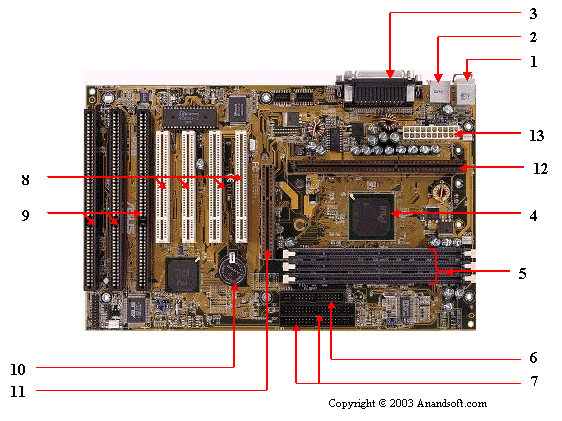

Figure 1 : Motherboard

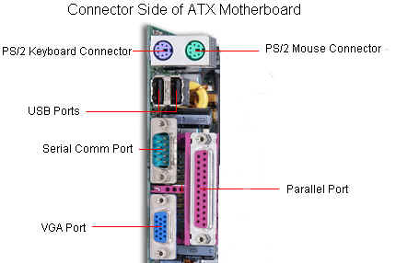

Figure 2 : Connector side of motherboard

The important constituent components of an ATX Motherboard are given below:

Mouse & keyboard

USB

Parallel port

CPU Chip

RAM slots

Floppy controller

IDE controller

PCI slot

ISA slot

CMOS Battery

AGP slot

CPU slot

Power supply plug in

1. Mouse & keyboard:  Keyboard Connectors are two types basically. All PCs have a Key board port connected directly to the motherboard. The oldest, but still quite common type, is a special DIN, and most PCs until recently retained this style connector. The AT-style keyboard connector is quickly disappearing, being replaced by the smaller mini DIN PS/2-style keyboard connector.

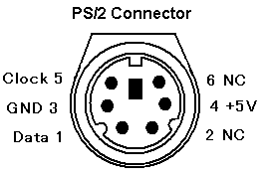

Figure 3 : PS/2 Connector

We can use an AT-style keyboard with a PS/2-style socket (or the other way around) by using a converter. Although the AT connector is unique in PCs, the PS/2-style mini-DIN is also used in more modern PCs for the mouse. Fortunately , most PCs that use the mini-DIN for both the keyboard and mouse clearly mark each mini-DIN socket as to its correct use. Some keyboards have a USB connection, but these are fairly rare compared to the PS/2 connection keyboards.    
  
2. USB (Universal serial bus): USB is the General-purpose connection for PC. You can find USB versions of many different devices, such as mice, keyboards, scanners, cameras, and even printers. a USB connector's distinctive rectangular shape makes it easily recognizable.

USB has a number of features that makes it particularly popular on PCs. First, USB devices are hot swappable. You can insert or remove them without restarting your system.

3. Parallel port: Most printers use a special connector called a parallel port. Parallel port carry data on more than one wire, as opposed to the serial port, which uses only one wire. Parallel ports use a 25-pin female DB connector. Parallel ports are directly supported by the motherboard through a direct connection or through a dangle.

4. CPU Chip : The *central processing unit,* also called the *microprocessor* performs all the calculations that take place inside a pc. CPUs come in Variety of shapes and sizes. Modern CPUs generate a lot of heat and thus require a cooling fan or heat sink. The cooling device (such as a cooling fan) is removable, although some CPU manufactures sell the CPU with a fan permanently attached.

5. RAM slots: Random-Access Memory (RAM) stores programs and data currently being used by the CPU. RAM is measured in units called bytes. RAM has been packaged in many different ways. The most current package is called a 168-pin DIMM (Dual Inline Memory module).

6. Floppy controller: The floppy drive connects to the computer via a 34-pin *ribbon cable,* which in turn connects to the motherboard. A *floppy controller* is one that is used to control the floppy drive.

7. IDE controller: Industry standards define two common types of hard drives: EIDE and SCSI.  Majority of the PCs use EIDE drives. SCSI drives show up in high end PCs such as network servers or graphical workstations. The EIDE drive connects to the hard drive via a 2-inch-wide, 40-pin ribbon cable,which in turn connects to the motherboard. *IDE controller* is responsible for controlling the hard drive.

8. PCI slot:  Intel introduced the *Peripheral component interconnect* bus protocol.  The PCI bus is used to connect I/O devices (such as NIC or RAID controllers) to the main logic of the computer. PCI bus has replaced the ISA bus.

9. ISA slot:  (Industry Standard Architecture) It is the standard architecture of the Expansion bus. Motherboard may contain some slots to connect ISA compatible cards.

10. CMOS Battery: To provide CMOS with the power when the computer is turned off all motherboards comes with a battery. These batteries mount on the motherboard in one of three ways: the obsolete external battery, the most common onboard battery, and built-in battery.    
  
11. AGP slot:  If you have a modern motherboard, you will almost certainly notice a single connector that looks like a PCI slot, but is slightly shorter and usually brown. You also probably have a video card inserted into this slot. This is an Advanced Graphics Port (AGP) slot.

12. CPU slot: To install the CPU, just slide it straight down into the slot. Special notches in the slot make it impossible to install them incorrectly. So remember if it does not go easily, it is probably not correct. Be sure to plug in the CPU fan's power.    
  
13. Power supply plug in:

The Power supply, as its name implies, provides the necessary electrical power to make the pc operate. the power supply takes standard 110-V AC power and converts into  +/-12-Volt, +/-5-Volt, and 3.3-Volt DC power.

The power supply connector has 20-pins, and the connector can go in only one direction.

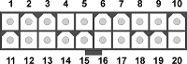

Figure 4 : Power supply plug in

**Expansion Slot**

Alternatively referred to as a bus slot or expansion port, an expansion slot is an opening located inside a computer on the motherboard or riser board that allows additional boards to be connected to it. For example, if you wanted to install a new video card in the computer you'd purchase a video expansion card and install that card into the compatible expansion slot. Below is a listing of some of the expansion slots commonly found in IBM compatible computers as well as other brands of computers and the devices commonly associated with those slots. Clicking on any of the links below give you additional details about each expansion slot.

Computer expansion slots

**AGP** - Video card, **AMR** - Modem, Sound card, **CNR** - Modem, Network card, Sound card, **EISA** - SCSI, Network card, Video card, **ISA** - Network card, Sound card, Video card, **PCI** - Network card, SCSI, Sound card, Video card, **PCIe** - Video card, **VESA** - Video card

Many of the above expansion card slots are obsolete. You're most likely only going to encounter AGP, PCI, and PCIe when working with computers today. In the picture below, is an example of what expansion slots may look like on a motherboard. In this picture, there are three different types of expansion slots; PCI Express, PCI, and AGP.

**PCI**

Short for Peripheral Component Interconnect, PCI was introduced by [Intel](http://www.computerhope.com/comp/intel.htm) in [1992](http://www.computerhope.com/history/1992.htm), revised in [1993](http://www.computerhope.com/history/1993.htm) to version 2.0, and later revised in [1995](http://www.computerhope.com/history/1995.htm) to PCI 2.1 and is as an expansion to the [ISA](http://www.computerhope.com/jargon/i/isa.htm) bus. The PCI bus is a [32-bit](http://www.computerhope.com/jargon/num/32bit.htm) (133MBps) computer bus that is also available as a [64-bit](http://www.computerhope.com/jargon/num/64bit.htm) bus and was the most commonly found and used computer bus in computers during the late 1990's and early 2000's. Unlike, ISA and earlier expansion cards, PCI follows the [PnP](http://www.computerhope.com/jargon/p/pnp.htm) specification and therefore does not require any type of [jumpers](http://www.computerhope.com/jargon/j/jumper.htm) or [dip switches](http://www.computerhope.com/jargon/d/dipswitc.htm). Below is an example of what the PCI slots looks like on a motherboard. In the picture, there are three PCI slots, PCI4, PCI5, and PCI6.

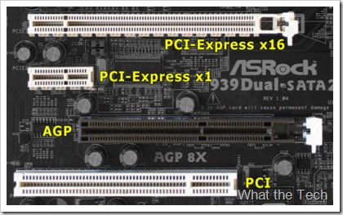

Figure 5 : Expansion slot

Today's computers and motherboards have replaced PCI with PCI Express (PCIe) slots.

Examples of PCI devices: Modem, Network card, Sound card, Video card

**Video card**

Alternatively referred to as a display adapter, graphics card, video adapter, video board, or a video controller, a video card is an internal circuit board that allows a display device such as a monitor to display images from the computer.

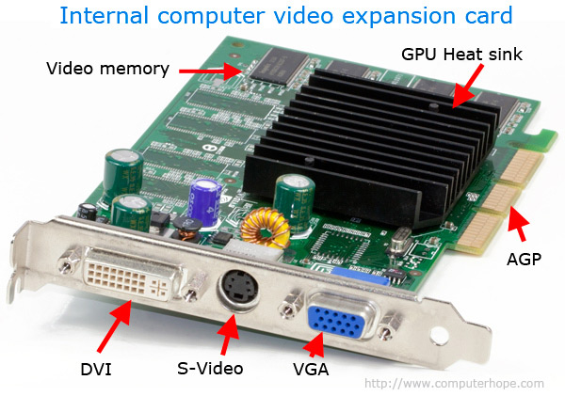

Figure6 : Video Card

In the picture above, is an example of a video card with three connections or video ports on the back, the standard VGA connector, S-Video connector, and the DVI connector. In this example, the card connects into the AGP slot on the computer motherboard.

**NIC**

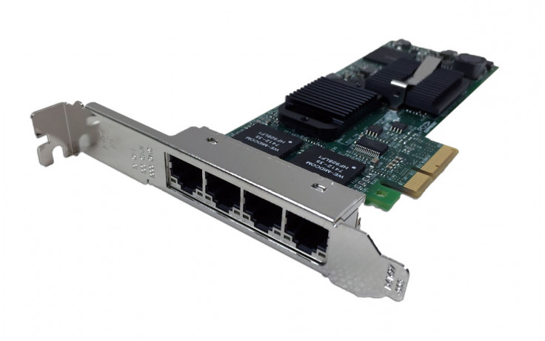

Figure 7 : NIC Card

Short for Network Interface Card, a NIC is also commonly referred to as an Ethernet card and network adapter and is an expansion card that enables a computer to connect to a network such as a home network or the Internet using an Ethernet cable with a RJ-45 connector. The picture is an example of a SMC EZ Card 10/100 PCI network card, a network card commonly found in most desktop computers today that do not already have an onboard network on their motherboard.

**AGP**

Short for Accelerated Graphics Port, AGP is an advanced port designed for Video cards and 3D accelerators. Designed by Intel and introduced in August of 1997, AGP introduces a dedicated point-to-point channel that allows the graphics controller direct access the system memory. Below is an illustration of what the AGP slot may look like on your motherboard.

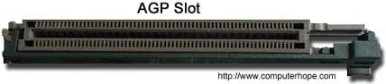

Figure 8 : AGP Slot

The AGP channel is 32-bits wide and runs at 66 MHz. This translates into a total bandwidth of 266 MBps, which is much greater than the PCI bandwidth of up to 133 MBps. AGP also supports two optional faster modes, with throughput of 533 MBps and 1.07 GBps. It also allows 3-D textures to be stored in main memory rather than video memory.

Each computer with AGP support will either have one AGP slot or on-board AGP video. If you needed more than one video card in the computer, you can have one AGP video card and one PCI video card or use a motherboard that supports SLI.

AGP is available in three different versions, the original AGP version mentioned above, AGP 2.0 that was introduced in May of 1998, and AGP 3.0 (AGP 8x) that was introduced in November of 2000. AGP 2.0 added 4x signaling and was capable of operating at 1.5V and AGP 3.0 was capable of double the transfer speeds.

**SMPS :**

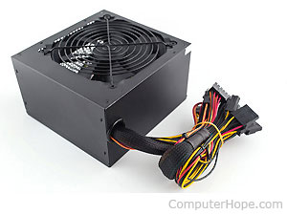

Figure 9 : SMPS

Figure 10 : SMPS Block diagram

Power supply (or power supply unit, PSU) is the device that transfers electric power from a source to a load using electronic circuits.

A typical application of power supplies is to convert utility's AC input power into regulated DC voltage(s) required for electronic equipment. Depending on the mode of operation of power semiconductors PSU can be linear or switching (SMPS).

What is SMPS? SMPS stands for switch mode power supply. In such a device power handling electronic components are continuously switching on and off with high frequency in order to provide the transfer of electric power via energy storage components (inductors and capacitors). By varying duty cycle, frequency or a relative phase of these transitions average value of output voltage or current is controlled . The frequency range of an SMPS is from 20 kHz to several MHz.

Below is the block diagram of a typical off-line switching power supply.

The AC input voltage first passes through fuses and a line filter and is rectified by a full-wave bridge rectifier. The rectified input voltage is next applied to PFC (power factor correction) pre-regulator followed by output DC-DC converter(s).

F1 and F2 shown on the left of the diagram are input fuses. Fuse is a safety device designed to physically open the circuit when the current being drawn through it exceeds its rating for a certain period of time. The fusing time depends on the degree of overload. Due to this time delay fuses will not always protect power supply circuit from a catastrophic failure caused by abnormal conditions. Their main purpose is to protect input line from overheating, prevent tripping of circuit breaker and prevent fire inside the PSU that may be triggered by failed components.

Lowpass EMI filter reduces high frequency currents getting from PSU into the AC line to an acceptable level.

It is necessary to prevent the PSU from causing interference on the mains wiring. There is a number of standards (such as EN55022 for Information technology equipment) that govern the maximum level of EMI caused by PSU.

The filter is followed by the bridge rectifier- the circuit that converts bipolar AC voltage to unipolar pulsating voltage. It uses four diodes in a bridge arrangement to provide the same polarity of output voltage for both polarities of input voltage.

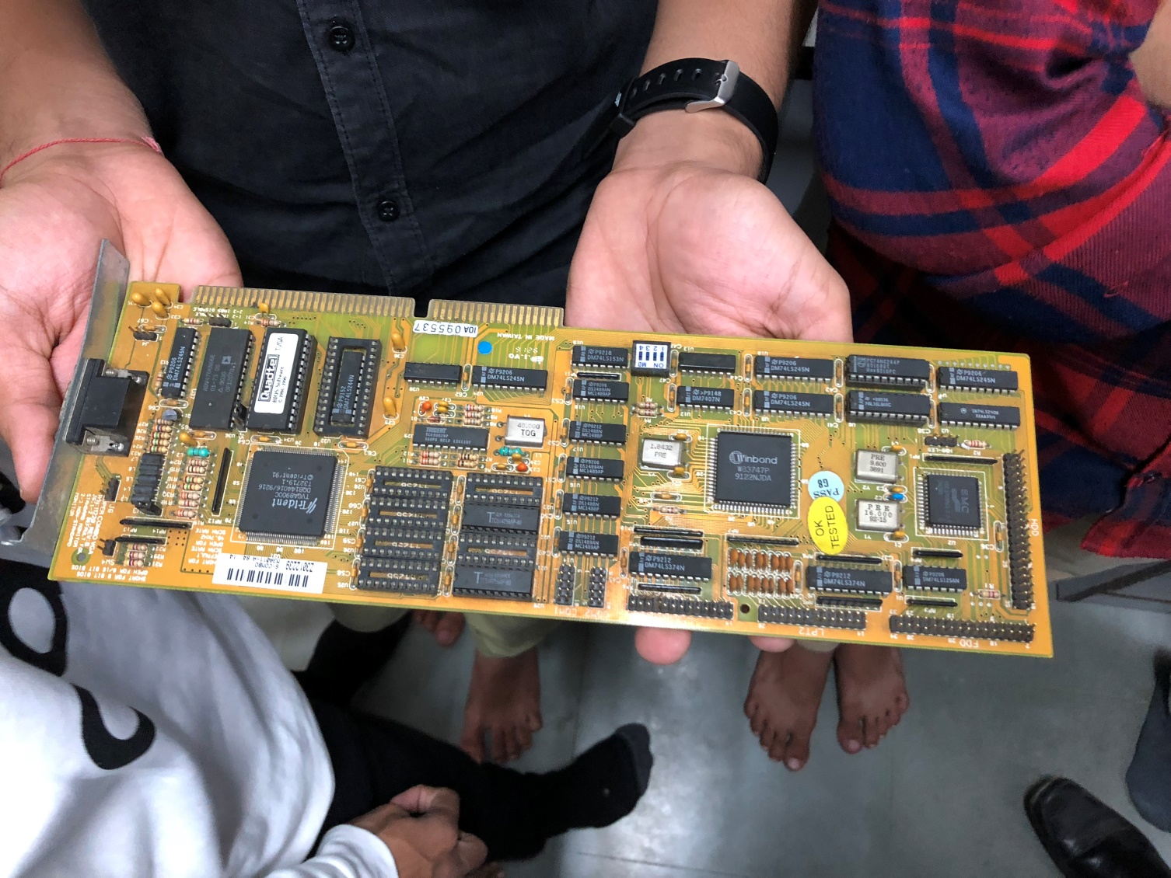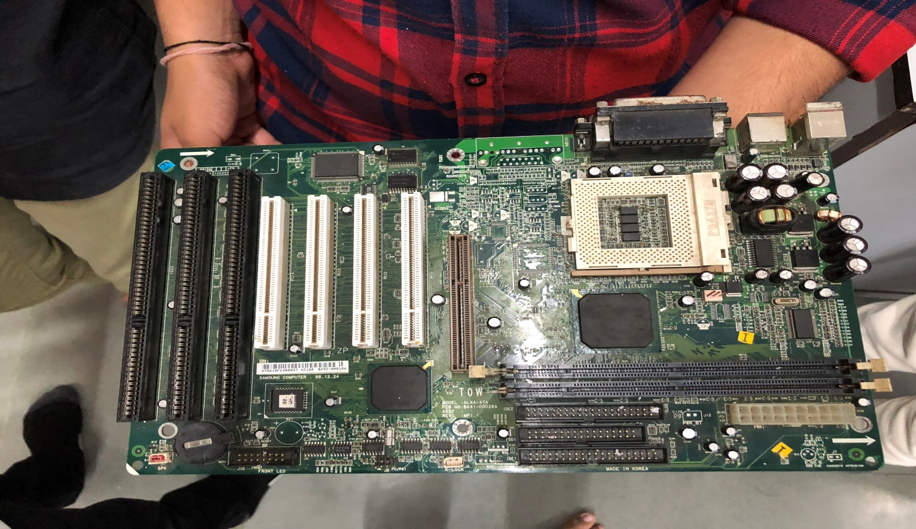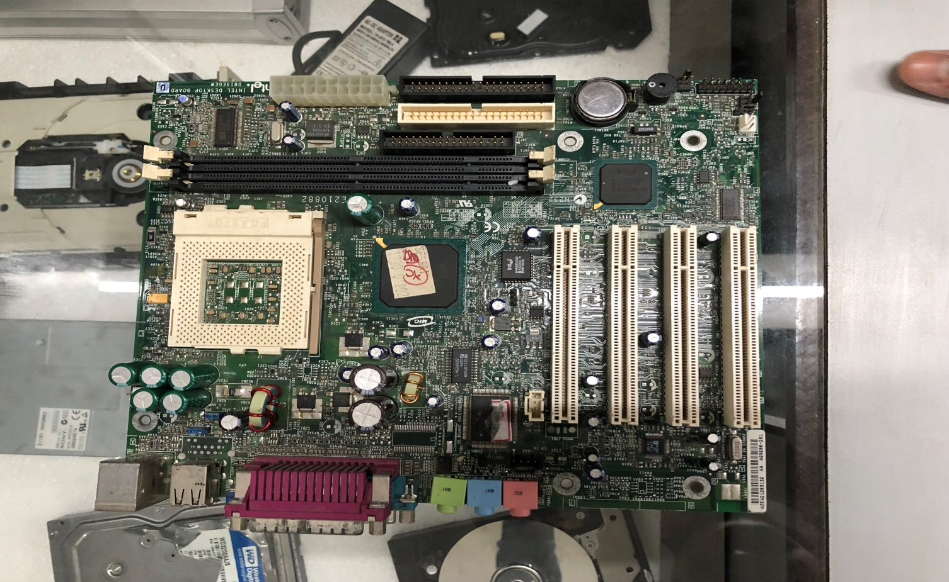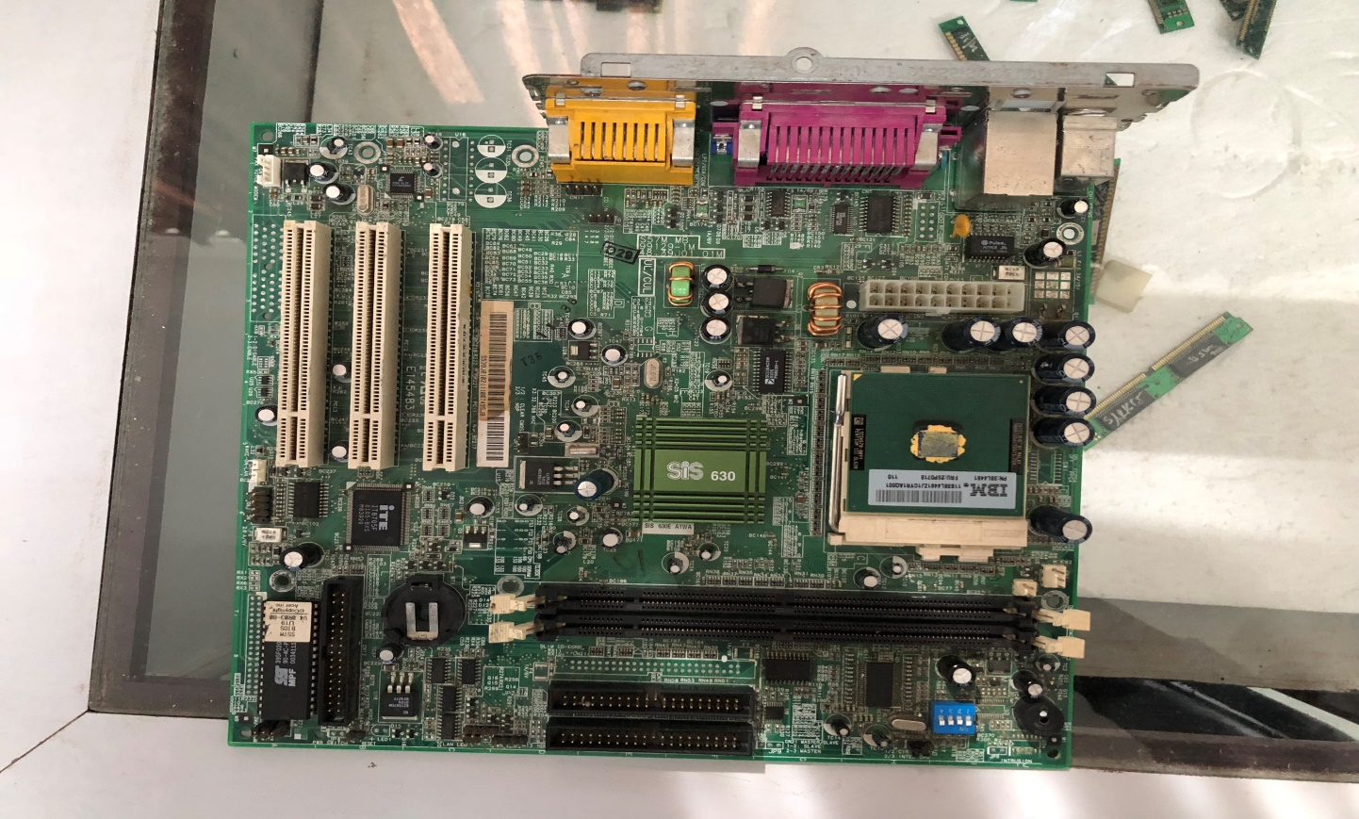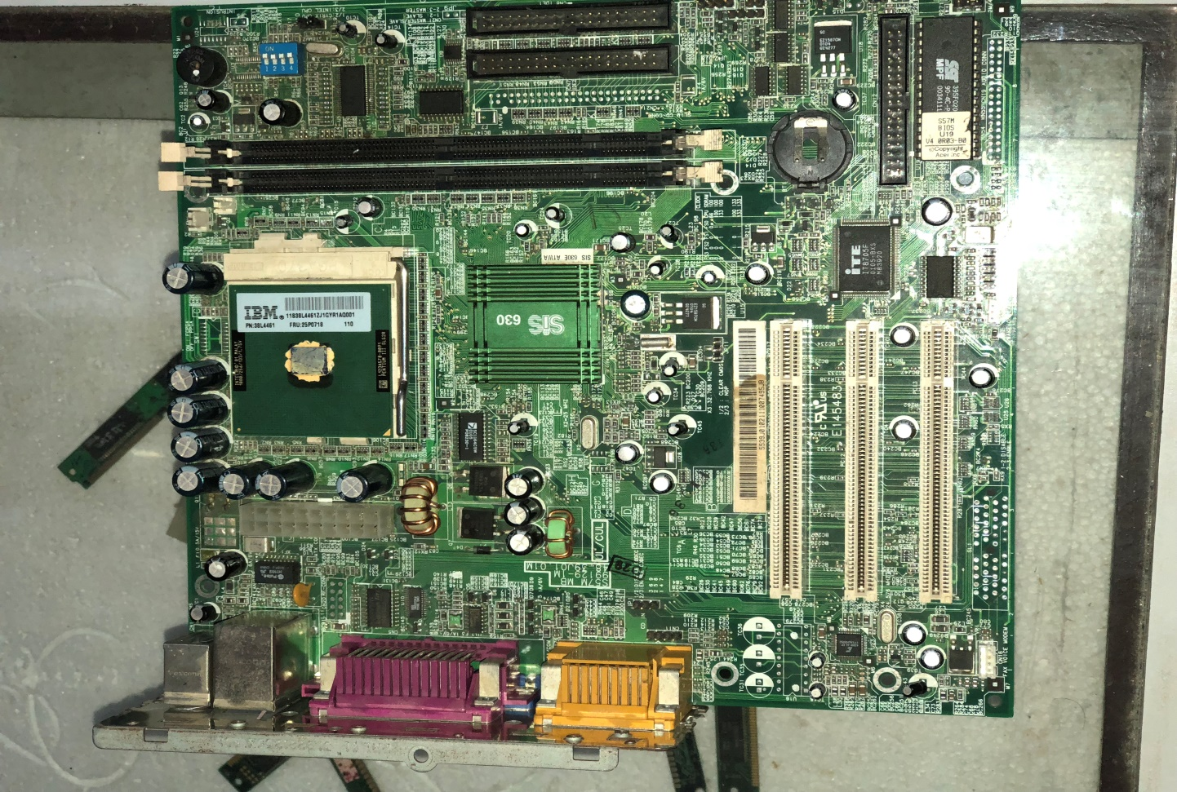

1. What form factor does the motherboard use?

### Motherboard Form Factor

There’s one important consideration we need to be aware of when choosing the case size and that is the size of the motherboard. They need to match. The size of the motherboard is often called the Form Factor and there are several standards. The form factor identifies the size of the circuit board, the location of the slots as well as the location of the faceplate that comes out the back of the computer. The form factor also identifies the location of the holes that are used to mount the motherboard into the system case. For example, the full tower has more than enough room to fit an ATX motherboard. Mid-tower case can also accommodate an ATX motherboard in most cases.

Example:

#### ATX Form Factor (Full ATX)

#### Mini ATX

#### Micro ATX

#### Flex ATX

#### Mini ITX

#### Em ITX

#### Nano ITX

#### Pico ITX

#### Mobile ITX

#### DTX Form Factor

#### Mini DTX

#### SSI CEB

#### SSI EEB (also called Extended ATX or E-ATX)

#### SSI MEB

#### BTX Form Factor

#### NLX Form Factor

1. Does the motherboard support the number and type of processor you plan to use (for example, Socket LGA 775 for the Intel Pentium 4 up to 3.3 GHz)?

The Pentium 4 replaced the Pentium III and ran at much higher clock speeds. Early versions used Socket 423, a socket used by no other Intel processor. Most Pentium 4 designs used Socket 478, while late-model Pentium 4 designs used Socket 775, which is also used by current Intel processors. The different sockets used by the Pentium 4 were necessary because of substantial design changes throughout the processor's lifespan, including the introduction of 64-bit extensions (x64).

No we have FCLGA-1156 slots for motherboard.

1. What are the supported frequencies of the system bus (for example, 1066/800/ 533 MHz)?

*Its the speed at which a CPU can read/write data from/to RAM which is processed and sent to respective components like GPU, DVD-ROM, Sound Card etc.*

1. What chipset does the board use?

In a computer system, a **chipset** is a set of electronic components in an [integrated circuit](https://en.wikipedia.org/wiki/Integrated_circuit) that manages the [data flow](https://en.wikipedia.org/wiki/Data_flow)between the [processor](https://en.wikipedia.org/wiki/Central_processing_unit), [memory](https://en.wikipedia.org/wiki/Computer_memory) and [peripherals](https://en.wikipedia.org/wiki/Peripheral). It is usually found on the [motherboard](https://en.wikipedia.org/wiki/Motherboard). Chipsets are usually designed to work with a specific family of [microprocessors](https://en.wikipedia.org/wiki/Microprocessor). Because it controls communications between the processor and external devices, the chipset plays a crucial role in determining system performance.

My motherboard uses intel skylane-U 8th revision chipset.

1. What type of memory does the board support (DDR or DDR2), and how much memory can the board hold?

My motherboard supports ddr3 ram.

1. What type and how many expansion slots are on the board (for example, PCI, PCI Express, and AGP)?

**PCI Express:**The best type of expansion slot to have in your PC is the PCI Express, also written as PCIe. Without boring you, the PCI Express type of expansion slot communicates with the motherboard, and therefore with the microprocessor, both quickly and efficiently.

**PCI:** The PCI slot is the most common form of internal expansion for a PC.

**GP:**This type of expansion slot was specifically designed to deal with graphics adapters. In fact, AGP stands for Accelerated Graphics Port. Older PCs may sport this expansion slot, but the best video cards use PCI Express.

**ISA:**The most ancient type of expansion slot is the ISA, which stands for (get this) Industry Standard Architecture. That’s because it never really had a name until another, better type of expansion slot came along. ISA slots hang around to be compatible with older expansion cards.

1. What hard drive controllers and connectors are on the board (for example, IDE, serial ATA, RAID, and SCSI)?

We have sata ports for hard drives.

1. What are the embedded devices on the board and what internal slots or connections does the board have? (For example, the board might provide a network port, wireless antenna port, FireWire port, two or more USB ports, modem port, and so forth.)

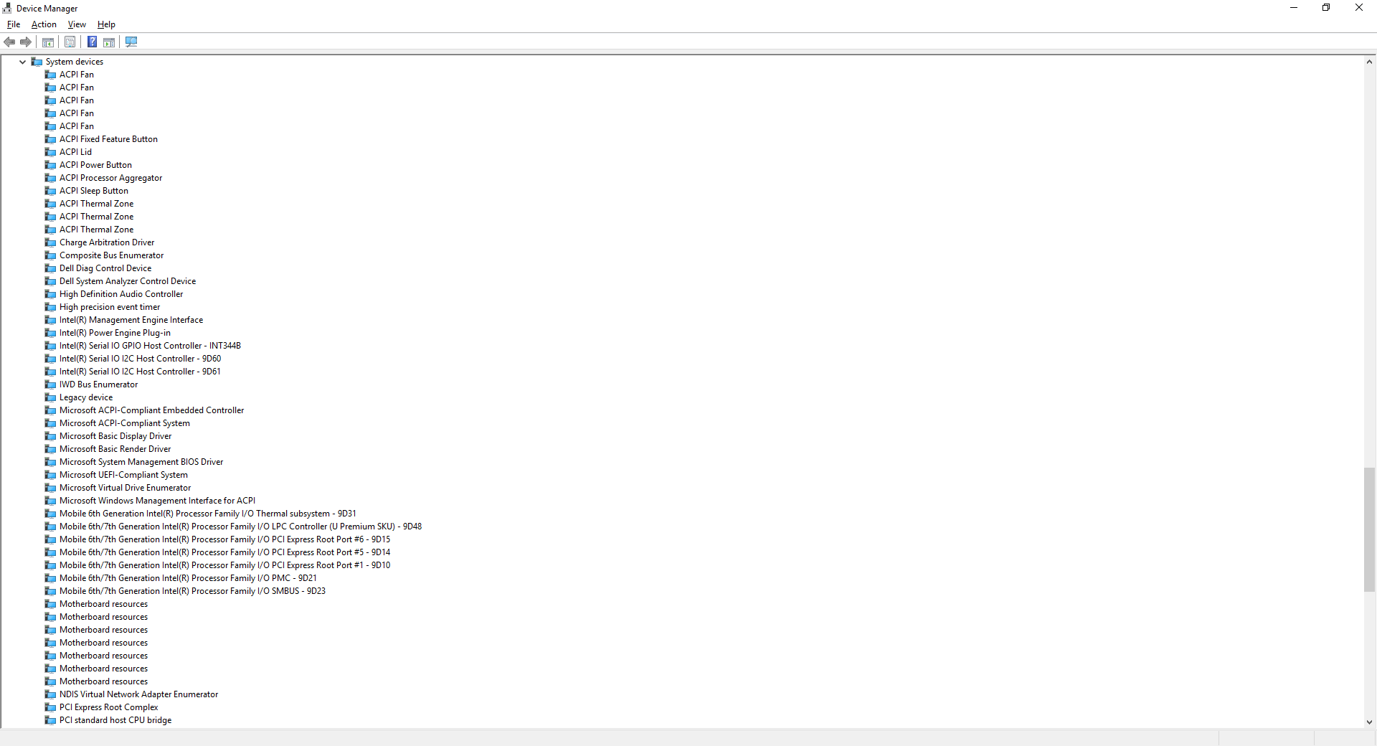

1. What type of BIOS does the motherboard use?

The BIOS in modern PCs initializes and tests the system hardware components, and loads a [boot loader](https://en.wikipedia.org/wiki/Boot_loader) or an [operating system](https://en.wikipedia.org/wiki/Operating_system) from a mass memory device. In the era of [MS-DOS](https://en.wikipedia.org/wiki/MS-DOS), the BIOS provided a [hardware abstraction layer](https://en.wikipedia.org/wiki/Hardware_abstraction_layer) for the keyboard, display, and other [input/output](https://en.wikipedia.org/wiki/Input/output) (I/O) devices that standardized an interface to application programs and the operating system. More recent operating systems do not use the BIOS after loading, instead accessing the hardware components directly.

My motherboard uses dell inc version 1.4.1 dated 12/08/2017.

**PRACTICAL 6**

**AIM:TO STUDY BLADE SERVER**

A blade server is a stripped down server computer with a modular design optimized to minimize the use of physical space and energy. Whereas a standard rack-mount server can function with (at least) a power cord and network cable, blade servers have many components removed to save space, minimize power consumption and other considerations, while still having all the functional components to be considered a computer. A blade enclosure, which can hold multiple blade servers, provides services such as power, cooling, networking, various interconnects and management. Together, blades and the blade enclosure form a blade system (although BladeSystem from Hewlett-Packard is a specific product name). Different blade providers have differing principles regarding what to include in the blade itself, and in the blade system altogether.

In a standard server-rack configuration, one rack unit or 1U—19 inches (480 mm) wide and 1.75 inches (44 mm) tall—defines the minimum possible size of any equipment. The principal benefit and justification of blade computing relates to lifting this restriction so as to reduce size requirements. The most common computer rack form-factor is 42U high, which limits the number of discrete computer devices directly mountable in a rack to 42 components. Blades do not have this limitation. As of 2014, densities of up to 180 servers per blade system (or 1440 servers per rack) are achievable with blade systems.

[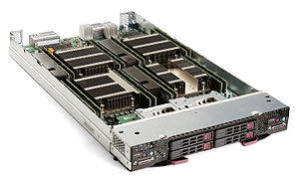](https://en.wikipedia.org/wiki/File:Supermicro_SBI-7228R-T2X_blade_server.jpg)

Supermicro SBI-7228R-T2X blade server, containing two dual-CPU server nodes

A **blade server** is a stripped-down [server computer](https://en.wikipedia.org/wiki/Server_computer) with a [modular design](https://en.wikipedia.org/wiki/Modular_design) optimized to minimize the use of physical space and energy. Blade servers have many components removed to save space, minimize power consumption and other considerations, while still having all the functional components to be considered a [computer](https://en.wikipedia.org/wiki/Computer). [[1]](https://en.wikipedia.org/wiki/Blade_server#cite_note-1) Unlike a rack-mount server, a blade server needs a **blade enclosure**, which can hold multiple blade servers, providing services such as power, cooling, networking, various interconnects and management. Together, blades and the blade enclosure, form a blade system. Different blade providers have differing principles regarding what to include in the blade itself, and in the blade system as a whole.

In a *standard* server-rack configuration, one rack unit or [1U](https://en.wikipedia.org/wiki/Rack_unit)—19 inches (480 mm) wide and 1.75 inches (44 mm) tall—defines the minimum possible size of any equipment. The principal benefit and justification of blade computing relates to lifting this restriction so as to reduce size requirements. The most common computer rack [form-factor](https://en.wikipedia.org/wiki/Motherboard_form_factor) is 42U high, which limits the number of discrete computer devices directly mountable in a rack to 42 components. Blades do not have this limitation. As of   2014, densities of up to 180 servers per blade system (or 1440 servers per rack) are achievable with blade systems.

BLADE SERVER USES:

[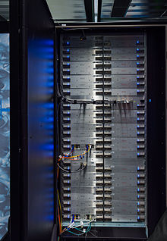](https://en.wikipedia.org/wiki/File:High_Performance_Computing_Center_Stuttgart_HLRS_2015_04_Cray_XC40_Hazel_Hen_blades.jpg)

[Cray XC40](https://en.wikipedia.org/wiki/Cray_XC40) supercomputer cabinet with 48 blades, each containing 4 nodes with 2 CPUs each

Blade servers function well for specific purposes such as [web hosting](https://en.wikipedia.org/wiki/Web_hosting), [virtualization](https://en.wikipedia.org/wiki/Hardware_virtualization), and [cluster computing](https://en.wikipedia.org/wiki/Cluster_computing). Individual blades are typically [hot-swappable](https://en.wikipedia.org/wiki/Hot_swap). As users deal with larger and more diverse workloads, they add more processing power, memory and I/O bandwidth to blade servers. Although blade server technology in theory allows for open, cross-vendor system, most users buy modules, enclosures, [racks](https://en.wikipedia.org/wiki/19-inch_rack) and management tools from the same vendor.

Eventual standardization of the technology might result in more choices for consumers;[[13]](https://en.wikipedia.org/wiki/Blade_server" \l "cite_note-techspot-13)[[14]](https://en.wikipedia.org/wiki/Blade_server#cite_note-cnet-14) as of 2009 increasing numbers of third-party software vendors have started to enter this growing field.[[15]](https://en.wikipedia.org/wiki/Blade_server#cite_note-theregister-15)

Blade servers do not, however, provide the answer to every computing problem. One can view them as a form of productized [server-farm](https://en.wikipedia.org/wiki/Server_farm) that borrows from [mainframe](https://en.wikipedia.org/wiki/Mainframe_computer) packaging, cooling, and power-supply technology. Very large computing tasks may still require server farms of blade servers, and because of blade servers' high power density, can suffer even more acutely from the [heating, ventilation, and air conditioning](https://en.wikipedia.org/wiki/Heating,_ventilation,_and_air_conditioning) problems that affect large conventional server farms.

What workloads are blade server’s best suited for?

* When compared to other traditional rack-mount servers, a blade server solution can be tasked and scaled virtually any workload from client to cloud:
* Server virtualization: with full support for Citrix XenServer, Microsoft Hyper-V, VMware vSphere
* Virtual Desktop: that can span all types of users from basic task workers all the way to power users who require high performance graphics
* Cloud infrastructure: both private and public with specialized solutions such as HP CloudSystem
* Big Data applications: such as database and transactional processing that support a wide range of solutions from SAP, Microsoft, SAS and Oracle
* IT Infrastructure solutions for collaboration: such as Microsoft Exchange and Lync
* Web page serving and caching
* SSL encrypting of Web communication
* Streaming audio and video content
* Supports all of the popular operating systems available today

***The emerging server blade architecture promises to alleviate many of the data center issues brought about by the shift to scale out architectures featuring standards-based, rack-dense servers. Server blades have the potential to increase server density, improve manageability, lower power consumption, and enhance deployment and serviceability, all resulting in lower total cost of ownership. Although the initial incarnation of blades is well suited for expansion into the front end of the IT infrastructure, the architecture is likely to evolve and play a significant role throughout the data center.***

Data center administrators and IT personnel have struggled with the infusion of rack-dense servers into their environments as they continue to shift from monolithic, proprietary architectures to more cost-effective, standards-based servers. Although the growth in rack-dense servers has been strong, vendors have not focused on issues of deployment, serviceability, cost, and management as much as improving density. Server blades, a new architecture for the next generation of servers, will alleviate many of the existing issues and will begin to change how vendors design standards-based servers.

**What is a server blade?**

Although vendors will likely create numerous incarnations of the server blade, it is basically a server on a card-a single motherboard that contains a full computer system, including processor(s), memory, network connections, and associated electronics (see **Figure 1** ). Most server blades initially will include some level of local disk storage with provisions to access external storage, as discussed later in this article.

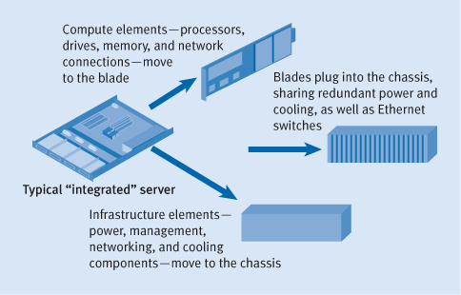

Figure 1. A shift in server design

Each blade runs its own instance of the operating system; consequently, administrators can designate individual blades for different applications or end users and can insert or remove (hot plug) them without affecting the operation of other blades. Multiple blades plug into the midplane of a chassis, or enclosure, that provides shared, redundant infrastructure components such as power, cooling, networking, and cabling.

**Why server blades?**

Essentially, blades allow system vendors to provide customers with solutions that improve efficiency in the data center, which ultimately reduces the total cost of ownership. Improving data center efficiency hinges on the following points.

**Reduce hardware costs**

Server blades are relatively inexpensive because each blade does not have a separate chassis and infrastructure like a traditional server. By leveraging power, cooling, management hardware, and cables over multiple systems, the per-server cost can be dramatically reduced, as shown in **Figure 2** .

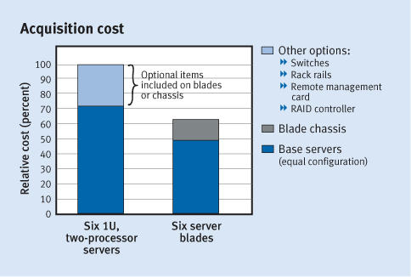

Figure 2. Blade economics

Vendors can now integrate components that customers would purchase separately—such as remote management cards, Ethernet switches, and even KVM (keyboard, video, and mouse) switches—into the chassis at a very low cost. Leveraging high-quality components over multiple servers also makes sense from a reliability standpoint, since the system has fewer components that could fail. Because of the initial investment cost associated with the chassis, blades are better suited for concentrated data center environments rather than distributed sites with small numbers of servers.

**Simplify deployment and service efforts**

Deploying multiple servers can be a time-consuming and resource-intensive process. An administrator installs each server in a rack, cables it to power and to the network, and provisions it with software. The cables, in particular, create one of the primary deployment headaches in high-density environments.

Using blades, an administrator installs and cables the chassis only; the individual server blades need no cabling. Adding new compute resources is as easy as plugging in a new blade, just like adding a hard drive today. The chassis minimizes the amount of cabling because redundant power supplies are leveraged across multiple blades. In addition, built-in switches consolidate Ethernet data and management networks, and even KVM connections (see **Figure 3** ).

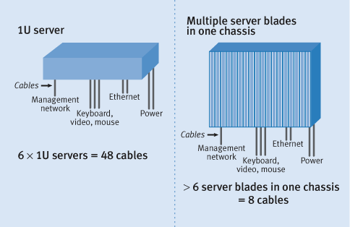

Figure 3. Cable consolidation by blade chassis

Automated software provisioning tools allow administrators to quickly and easily deploy software to one or many blades in a single operation over the network. After provisioning the blades, an administrator can manage them completely using remote-management tools. Customers should expect vendors to supply fully featured tools for remote software provisioning, hardware configuration, and systems management. These tools will allow customers to manage blades and traditional integrated servers from a single framework, lowering resource costs.

Servicing a failed blade involves removing the failed blade and plugging in a replacement while the failed blade waits for repair. An administrator also can easily implement a global hot-spare server, which can be remotely provisioned to take the attributes and tasks from a blade that requires service.

**Optimize use of space in data centers**

Because data center real estate is expensive, the market has witnessed a rapid movement toward dense rack-optimized servers during the last 24 months. Server blades can increase server density by 100 to 800 percent, depending on the design and vendor, when compared to today's 1U rack-optimized system (see **Figure 4** ). In addition, since each blade is an individual server, the chassis can be used to consolidate multiple applications in a single box. This consolidation further assists customers in centralizing their compute resources within the data center.

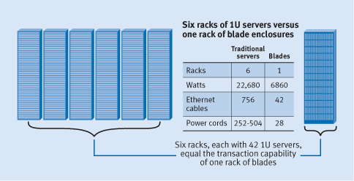

Figure 4. Density of traditional servers versus blades

**Increase resource utilization**

Data center managers must size the infrastructure of each client (whether an internal organization or external customer in the case of xSPs) for peak demand. Often, a significant portion of the hardware is underutilized while still generating heat and consuming capital, administrative resources, power, and space.

By migrating to a server blade architecture and using related improvements in workload management software, managers can size the data center infrastructure not on the peak demand of an individual client or group, but on the demand of the data center as a whole. Sizing is largely a function of management software, but blades can enhance software sizing capability with their low cost and ability to simplify the process of adding compute resources.

**Reduce power consumption**

To reduce the power consumption of blades, most vendors will use low-power processors in some of their blades. Even blades that do not use low-power processors will use less power than "integrated" servers, because blades have fewer power-consuming components. In addition, vendors can afford to use higher efficiency power supplies because they are leveraged over multiple servers. Blades that consume less power also produce less heat, which reduces the amount of electricity required by cooling systems.

**What are the challenges?**

The miniaturization and increased density of servers present challenges for storage, server management, standardization, and server-networking collision points.

**Limitations for storage expansion**

One concern about server blades is their ability to handle storage expansion. Although the first server blades on the market will have onboard disks, they will generally be limited in number. This limitation is fine for applications in the first and second tiers of the IT infrastructure, which are not generally storage intensive. These applications rely on back-end servers to connect to the storage infrastructure.

Storage cannot easily be internally expanded because most blade architectures prohibit traditional peripheral component interconnect (PCI) expansion slots. In addition, blades may not easily accommodate multiple external interface electronics and connectors, which forces vendors to choose between Ethernet and Fibre Channel for connectivity to external storage.

Ethernet will likely be the storage connection of choice for the first generation of high-density blades, because blades must have Ethernet connections to access a LAN (local area network) or WAN (wide area network). Because of its cost-effectiveness and pervasiveness in the data center, Ethernet is an optimal storage connection for blades. Using Ethernet, server blades can connect to network-attached storage (NAS) and Internet Protocol storage (IPS). Emerging IPS technologies like iSCSI (Internet SCSI) enable access to block-level storage resources over Ethernet. Fibre Channel connectivity will more likely be relegated to less dense, higher performance, modular products.

**Need for robust management tools**

Data centers are already struggling with the proliferation of equipment and its impact on resources; server blades can only exacerbate this issue. For blades to be successful, vendors will need to deliver robust tools that support not only standard management interfaces but also remote access, automated software provisioning, or hardware configuration tools. Data center managers should consider these new tools when planning their infrastructure so they may take full advantage of this new architecture's capabilities.

**Multiple hardware standards**

CompactPCI®  (cPCI) is currently the only standard that defines blade form factor and connectors. Blades and enclosures built to this standard can operate in a standard cPCI enclosure even if they come from a variety of vendors. This compatibility provides some investment protection for the customer, although servicing and supporting blades from multiple vendors may incur additional costs.

However, cPCI is not currently suited to high-performance, high-density, low-cost environments because of its architecture. The cPCI blades on the market are targeted primarily toward telecommunications and industrial applications instead of traditional data center computing; thus, access to an "ecosystem" of third-party blades provides little benefit for most data center customers.

Server blade vendors that do not use cPCI will build their solutions on standards-based chipsets, controllers, and processors, as well as standard protocols like Ethernet and Simple Network Management Protocol/Common Information Model (SNMP/CIM). However, the connectors and signal routing will differ depending on each vendor's implementation. Although customers will not be able to mix blades from multiple vendors in an enclosure, they will benefit from this implementation because it allows vendors to design products that offer better features at a lower cost, while occupying less rack space than products built on standards such as cPCI. As a result, in systems that do not use cPCI blades, server blades still will interact with each other and with "integrated" servers in a standard manner, run standard operating systems, and be managed using standard management tools.

**Network-server collision point**

Because Ethernet cables emerging from each blade would be unmanageable in a high-density environment, vendors are likely to integrate Ethernet switches into the enclosure. If an Ethernet switch is used as a cable consolidation point, the only Ethernet cables leaving the enclosure are the uplinks from the switches. Although this consolidation is elegant from a cabling perspective, it will cause administrators to change the way they think about server deployment. Network administrators and server administrators will need to work closely as they deploy and manage their server-network combination. Vendors also need to provide tools for managing these Ethernet switches.

**What lies in the future for blades?**

A new I/O architecture, InfiniBandTM  (IB), may drive the modular server landscape because it provides a universal interconnect fabric that is ideal in situations where space is limited and multiple fabrics such as Ethernet, Fibre Channel/SCSI, IPC (inter-process communication) are not possible (see **Figure 5** ). IB can offer the following benefits for server blades:

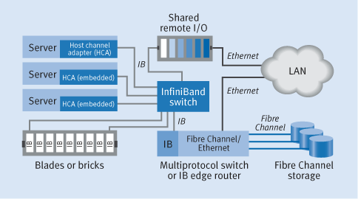

Figure 5. Sample InfiniBand fabric topology

|  |
| --- |
| * IB provides a high-performance, low-latency, blade-to-blade interconnect for high-performance computing and database clustering. * IB provides connectivity to external storage and Ethernet networks through IB-to-Fibre Channel or IB-to-Ethernet gateways or "edge routers." This architecture lets vendors use the capabilities of IB but does not force customers to re-cable the data center for IB. * IB allows multiple blades or multiple enclosures to share legacy PCI peripherals by providing connectivity to external PCI expansion modules. Not only does this approach save space, but it also allows customers to leverage devices over multiple servers. * Native IB storage, not yet available, will allow IB-enabled servers to connect directly into IB storage without changing protocols. |

IB interconnects and new management tools can provide the foundation for true "utility computing" models, where data center administrators have a pool of compute and storage resources that they can dynamically allocate as required. This technology fosters a dynamic and modular data center, whether it belongs to a service provider or a brick-and-click enterprise.

**A new IT infrastructure**

Early versions of server blades will be primarily high-density, low-power devices with relatively low performance. This type of blade is suited for first-tier applications such as static Web servers, security, network services, and streaming media because the applications can be easily and inexpensively load balanced. The performance of an application depends on the aggregate performance of the servers rather than the performance of an individual server.

Higher performance, less dense blade designs will help drive blade usage into more mainstream applications in the corporate data center. These designs can offer the individual performance characteristics and features available in today's rack-dense servers along with the cost, deployment, serviceability, and density benefits of server blades. The blades will be well suited to high-performance Web servers, dedicated application servers, server-based or thin-client computing, and high-performance computing (HPC) clusters.

The introduction of server blades and associated technology like IB will usher in a new IT infrastructure. IT managers should start planning now for server blade installations by evaluating IP-based storage solutions, remote software provisioning and management solutions, scale-out architectures, and load-balancing technologies.

**Components of Blade Server**

1. BLADE Chasis

HP c7000 enclosure was announced in June 2006. In 2007 there was a minor update including larger Onboard Administrator display (3" up from 2"). The next update was in 2009 and brought RoHS compatibility, increased backplane speed (5Tb/s up from 4Tb/s) and 1Gb/s Outboard Administrator connectivity. Fourth version - c7000 Platinum was announced in February 2013. It features location discovery services, thermal discovery services and redesigned backplane. The new backplane increased aggregate bandwidth 40% from 5 to 7 Tbit/s to allow use newest high-speed interconnect modules (such as 16Gbit/s FC and 56Gbit/s FDR InfiniBand). Also the new Platinum Plus rating power supplies were announced with higher efficiency than previous Gold Plus rating power supplies.

All versions of the enclosure occupy 10 rack units and can accommodate up to 16 half-height blade servers. It includes space for 6 power supplies (single-phase, three-phase or a -48V DC), 10 cooling fans, 8 single-wide (such as Gigabit Ethernet or FC) or 4 double-wide (such as 40Gb Ethernet or Infiniband) interconnect modules (that allows for up to 4 redundant interconnect fabrics)

**Networking**

Several networking options are available for the HP Bladesystem, these include but are not limited to :

* HP's propiatary Virtual Connect modules
* Cisco switches and fabric extenders
* Gigabit networks switches
* HP Procurve switches
* HP Comware based switches
* Passthrough modules
* Mellanox Infiniband
* Brocade SAN-switches
* Cisco SAN-switches

1. Blade 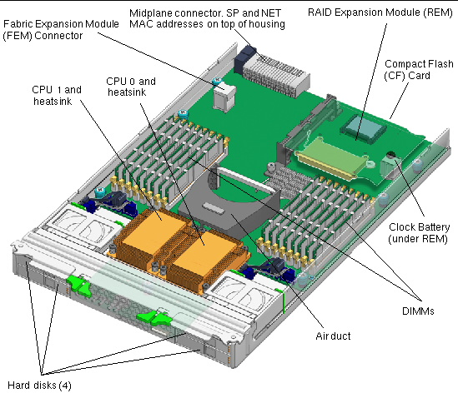
2. Storage

While computers typically use hard disks to store operating systems, applications and data, these are not necessarily required locally. Many storage connection methods (e.g. [FireWire](https://en.wikipedia.org/wiki/FireWire), [SATA](https://en.wikipedia.org/wiki/Serial_ATA), [E-SATA](https://en.wikipedia.org/wiki/ESATA), [SCSI](https://en.wikipedia.org/wiki/SCSI), [SAS](https://en.wikipedia.org/wiki/Serial_attached_SCSI) [DAS](https://en.wikipedia.org/wiki/Direct-attached_storage), [FC](https://en.wikipedia.org/wiki/Fibre_Channel) and [iSCSI](https://en.wikipedia.org/wiki/ISCSI" \o "ISCSI)) are readily moved outside the server, though not all are used in enterprise-level installations. Implementing these connection interfaces within the computer presents similar challenges to the networking interfaces (indeed iSCSI runs over the network interface), and similarly these can be removed from the blade and presented individually or aggregated either on the chassis or through [other blades](https://en.wikipedia.org/wiki/Blade_Server#Other_blades).

The ability to boot the blade from a [storage area network](https://en.wikipedia.org/wiki/Storage_area_network) (SAN) allows for an entirely disk-free blade, an example of which implementation is the [Intel Modular Server System](https://en.wikipedia.org/wiki/Intel_Modular_Server_System).

1. Networking

Blade servers generally include integrated or optional [network interface controllers](https://en.wikipedia.org/wiki/Network_interface_controller) for [Ethernet](https://en.wikipedia.org/wiki/Ethernet) or [host adapters](https://en.wikipedia.org/wiki/Host_adapter) for [Fibre Channel](https://en.wikipedia.org/wiki/Fibre_Channel" \o "Fibre Channel) storage systems or [converged network adapter](https://en.wikipedia.org/wiki/Converged_network_adapter) to combine storage and data via one [Fibre Channel over Ethernet](https://en.wikipedia.org/wiki/Fibre_Channel_over_Ethernet" \o "Fibre Channel over Ethernet) interface. In many blades at least one interface is embedded on the motherboard and extra interfaces can be added using [mezzanine cards](https://en.wikipedia.org/wiki/Mezzanine_card).

A blade enclosure can provide individual external ports to which each network interface on a blade will connect. Alternatively, a blade enclosure can aggregate network interfaces into interconnect devices (such as switches) built into the blade enclosure or in [networking blades](https://en.wikipedia.org/wiki/Blade_server#Other_blades).

**PRACTICAL 7:**

**AIM:LINUX OPERATING SYSTEM**

The Unix operating system was conceived and implemented in 1969 at AT&T's Bell Laboratories in the United States by Ken Thompson, Dennis Ritchie, Douglas McIlroy, and Joe Ossanna. It was first released in 1971, initially written entirely in assembly language as a common practice at the time. Later, in a key pioneering approach in 1973, Unix was re-written in the programming language C by Dennis Ritchie (with exceptions to the kernel and I/O). The availability of an operating system written in a high-level language allowed easier portability to different computer platforms.

With AT&T being required to license the operating system's source code to anyone who asked (due to an earlier antitrust case forbidding them from entering the computer business),[24] Unix grew quickly and became widely adopted by academic institutions and businesses. In 1984, AT&T divested itself of Bell Labs. Free of the legal obligation requiring free licensing, Bell Labs began selling Unix as a proprietary product.

The GNU Project, started in 1983 by Richard Stallman, had the goal of creating a "complete Unix-compatible software system" composed entirely of free software. Work began in 1984.[25] Later, in 1985, Stallman started the Free Software Foundation and wrote the GNU General Public License (GNU GPL) in 1989. By the early 1990s, many of the programs required in an operating system (such as libraries, compilers, text editors, a Unix shell, and a windowing system) were completed, although low-level elements such as device drivers, daemons, and the kernel were stalled and incomplete.[26]

Linus Torvalds has said that if the GNU kernel had been available at the time (1991), he would not have decided to write his own

**Advantages of Linux**

* Low cost: There is no need to spend time and huge amount money to obtain licenses since Linux and much of it's software come with the GNU General Public License. There is no need to worry about any software's that you use in Linux.
* Stability: Linux has high stability compared with other operating systems. There is no need to reboot the Linux system to maintain performance levels. Rarely it freeze up or slow down. It has a continuous up-times of hundreds of days or more.
* Performance: Linux provides high performance on various networks. It has the ability to handle large numbers of users simultaneously.
* Networking: Linux provides a strong support for network functionality; client and server systems can be easily set up on any computer running Linux. It can perform tasks like network backup more faster than other operating systems.
* Flexibility: Linux is very flexible. Linux can be used for high performance server applications, desktop applications, and embedded systems. You can install only the needed components for a particular use. You can also restrict the use of specific computers.
* Compatibility: It runs all common Unix software packages and can process all common file formats.
* Wider Choice: There is a large number of Linux distributions which gives you a wider choice. Each organization develop and support different distribution. You can pick the one you like best; the core function's are the same.
* Fast and easy installation: Linux distributions come with user-friendly installation.
* Better use of hard disk: Linux uses its resources well enough even when the hard disk is almost full.
* Multitasking: Linux is a multitasking operating system. It can handle many things at the same time.
* Security: Linux is one of the most secure operating systems. File ownership and permissions make linux more secure.
* Open source: Linux is an Open source operating systems. You can easily get the source code for linux and edit it to develop your personal operating system.

Today, Linux is widely used for both basic home and office uses. It is the main operating system used for high performance business and in web servers. Linux has made a high impact in this world

**Why use Linux?**

Why use Linux, instead of a well known, well tested, and well documented commercial operating system? We could give you a thousand reasons. One of the most important, however, is that Linux is an excellent choice for personal UNIX computing. If you're a UNIX software developer, why use MS-DOS at home? Linux allows you to develop and test UNIX software on your PC, including database and X Window System applications. If you're a student, chances are that your university computing systems run UNIX. You can run your own UNIX system and tailor it to your needs. Installing and running Linux is also an excellent way to learn UNIX if you don't have access to other UNIX machines.

But let's not lose sight. Linux isn't only for personal UNIX users. It is robust and complete enough to handle large tasks, as well as distributed computing needs. Many businesses--especially small ones--have moved their systems to Linux in lieu of other UNIX based, workstation environments. Universities have found that Linux is perfect for teaching courses in operating systems design. Large, commercial software vendors have started to realize the opportunities which a free operating system can provide.

**Linux vs. MS-DOS.**

It's not uncommon to run both Linux and MS-DOS on the same system. Many Linux users rely on MS-DOS for applications like word processing. Linux provides its own analogs for these applications, but you might have a good reason to run MS-DOS as well as Linux. If your dissertation is written using WordPerfect for MS-DOS, you may not be able to convert it easily to TeX or some other format. Many commercial applications for MS-DOS aren't available for Linux yet, but there's no reason that you can't use both.

MS-DOS does not fully utilize the functionality of 80386 and 80486 processors. On the other hand, Linux runs completely in the processor's protected mode, and utilizes all of its features. You can directly access all of your available memory (and beyond, with virtual RAM). Linux provides a complete UNIX interface which is not available under MS-DOS. You can easily develop and port UNIX applications to Linux, but under MS-DOS you are limited to a subset of UNIX functionality.

Linux and MS-DOS are different entities. MS-DOS is inexpensive compared to other commercial operating systems and has a strong foothold in the personal computer world. No other operating system for the personal computer has reached the level of popularity of MS-DOS, because justifying spending $1,000 for other operating systems alone is unrealistic for many users. Linux, however, is free, and you may finally have the chance to decide for yourself.

You can judge Linux vs. MS-DOS based on your expectations and needs. Linux is not for everybody. If you always wanted to run a complete UNIX system at home, without the high cost of other UNIX implementations for personal computers, Linux may be what you're looking for.

**Linux vs. The Other Guys.**

A number of other advanced operating systems have become popular in the PC world. Specifically, IBM's OS/2 and Microsoft Windows have become popular for users upgrading from MS-DOS.

Both OS/2 and Windows NT are full featured multitasking operating systems, like Linux. OS/2, Windows NT, and Linux support roughly the same user interface, networking, and security features. However, the real difference between Linux and The Other Guys is the fact that Linux is a version of UNIX, and benefits from contributions of the UNIX community at large.

What makes UNIX so important? Not only is it the most popular operating system for multiuser machines, it is a foundation of the free software world. Much of the free software available on the Internet is written specifically for UNIX systems.

There are many implementations of UNIX from many vendors. No single organization is responsible for its distribution. There is a large push in the UNIX community for standardization in the form of open systems, but no single group controls this design. Any vendor (or, as it turns out, any hacker) may develop a standard implementation of UNIX.

OS/2 and Microsoft operating systems, on the other hand, are proprietary. The interface and design are controlled by a single corporation, which develops the operating system code. In one sense, this kind of organization is beneficial because it sets strict standards for programming and user interface design, unlike those found even in the open systems community.

Several organizations have attempted the difficult task of standardizing the UNIX programming interface. Linux, in particular, is mostly compliant with the POSIX.1 standard. As time goes by, it is expected that the Linux system will adhere to other standards, but standardization is not the primary goal of Linux development.

**Linux vs. other implementations of UNIX.**

Several other implementations of UNIX exist for 80386 or better personal computers. The 80386 architecture lends itself to UNIX, and vendors have taken advantage of this.

Oher implementations of UNIX for the personal computer are similar to Linux. Almost all commercial versions of UNIX support roughly the same software, programming environment, and networking features. However, there are differences between Linux and commercial versions of UNIX.

Step-by-Step Installation of Linux OS

s the open source revolution grows around the world, more and more people are starting to switch over to the Linux Operating System and pre-eminent of all the Linux OS is the Red Hat Linux, owned and distributed by the Red Hat Inc. However, installation of Linux itself is seen as a rather arduous and herculean task among many beginners/inexperienced users. As a result this document has been formulated as a step-by-step guide to ensure that everybody can install and use Red Hat Linux seamlessly and with ease. So lets start the installation, here are the steps to easily install red hat linux :

**Step 1** – Insert the Red Hat Linux DVD into the DVD-drive of your computer. As soon as the following screen pops up, press ‘Enter’ to install Red Hat Enterprise Linux (RHEL) through GUI mode.

[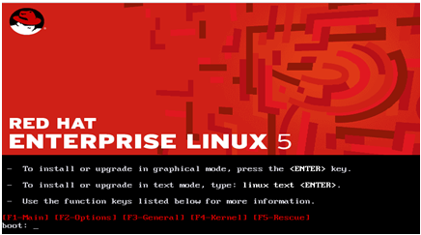](http://tutmaster.com/wp-content/uploads/2011/06/untitled.bmp)

**Step 2**- RHEL installer would then prompt you conduct a check as to whether the CD media from which you’re installing is functioning correctly or not. Choose ‘Skip’, press enter and the installation would begin.

[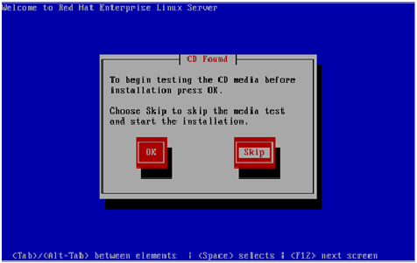](http://tutmaster.com/wp-content/uploads/2011/06/untitled1.bmp)

**Step 3**- Next, we need to select the language- English or any other language as per your preference, and then press ‘Next’ .

[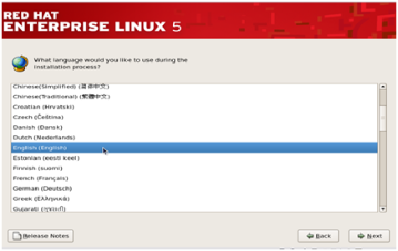](http://tutmaster.com/wp-content/uploads/2011/06/untitled2.bmp)

**Step 4**- In this step, the RHEL installer would ask you about the appropriate type of keyboard for the system. We take the ‘US English’ keyboard, you can pick any other option depending on the type of your keyboard. Then press ‘Next’ to move to the next step.

[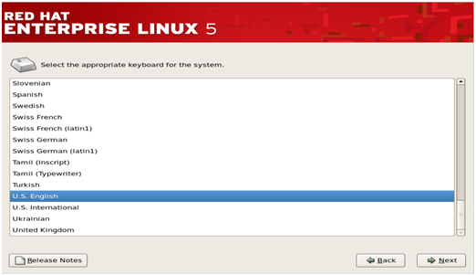](http://tutmaster.com/wp-content/uploads/2011/06/untitled3.bmp)

**Step 5**- Next, the installer would ask for an ‘installation number’ if you wish to install full set of Red Hat functionalities. Enter the installation number and press ‘OK’ if you have an officially licensed installation number(for corporate clients that buy Red Hat’s backup support and full features).

Others can select ‘Skip entering installation number’ and press ‘OK’ to proceed. RHEL would show a warning message, press ‘Skip’ in it to continue.

[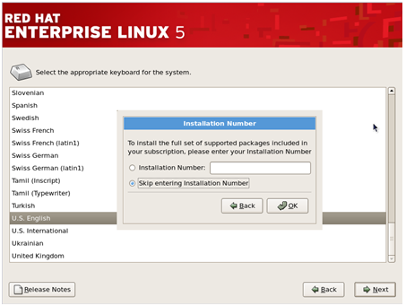](http://tutmaster.com/wp-content/uploads/2011/06/untitled4.bmp)

**Step 6**- The Red Hat installer would then require you to create partitions in your computer’s hard disk for the installation. You can do it in four ways but the simplest way is to select ‘Use free space on selected drives and create default layout’ as this option will not affect any other OS residing in your system.

Check the ‘review and modify portioning layout’ to create partitions and click next.

[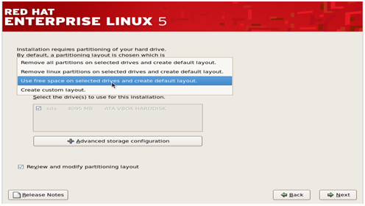](http://tutmaster.com/wp-content/uploads/2011/06/untitled5.bmp)

**Step 7**- In this step you must create the required system partitions and mount points such as ‘/boot’, ‘/home’, ‘swap’ etc which are required for the Linux’s proper functioning.

To create different partitions such as /home, /var etc, click on ‘New’ to create the partitions.

[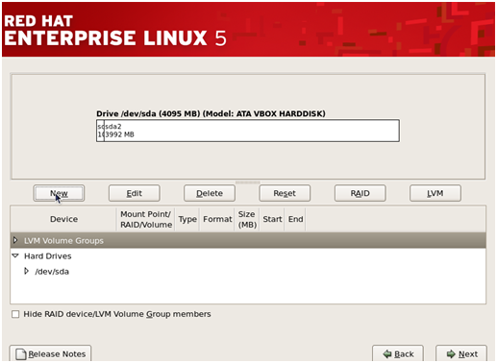](http://tutmaster.com/wp-content/uploads/2011/06/untitled6.bmp)

Then, select /home in the mount point and choose ‘ext3’ as the file system and give the desired size for it and then click ‘OK’. Similarly also create /boot and /var.

[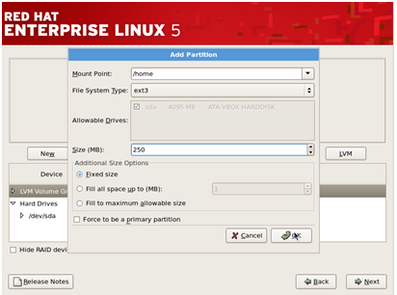](http://tutmaster.com/wp-content/uploads/2011/06/untitled7.bmp)

Also, create a swap partition by clicking on ‘New’ and then choosing the filesystem as ‘swap’ and also give the size of Swap partition.(Usually size of swap partition SHOULD BE twice the size of RAM available to the system but you can keep its size less than that too)

[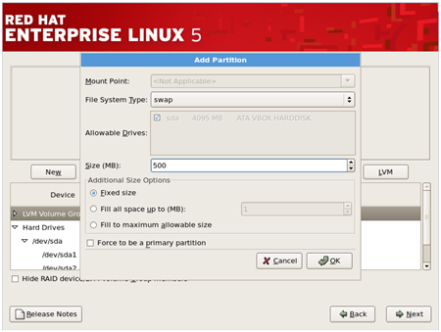](http://tutmaster.com/wp-content/uploads/2011/06/untitled8.bmp)

Once you have made all the desired partitions and given their mount points, click ‘Next’ to continue installation.

[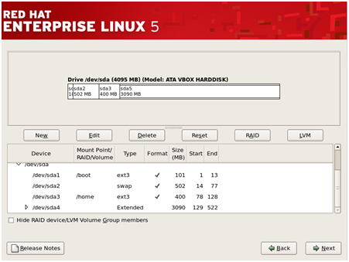](http://tutmaster.com/wp-content/uploads/2011/06/untitled9.bmp)

**Step 8**- This step pertains to the default OS that will be loaded by the GRUB loader

[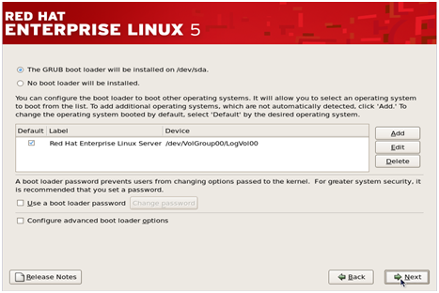](http://tutmaster.com/wp-content/uploads/2011/06/untitled10.bmp)

(Note- If you have multiple Operating Systems installed, you would see multiple options here and you have to check in front of the OS name that you want to be loaded by default when the system is started.)

Click ‘Next’ to continue.

**Step 9**- This step pertains to the network settings of the Linux system that you are going to install. You can select the Ethernet devices through which the system would communicate with other devices in the network.

You can also provide the hostname, Gateway address and DNS address to the system during this step. (However it’s better to adjust these settings once the system has been fully installed).

[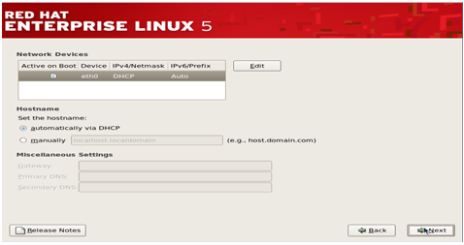](http://tutmaster.com/wp-content/uploads/2012/11/Untitled12.png)

**Step 10**- The next step is to adjust the system clock to your particular time zone. Select your time zone and then click ‘Next’.

[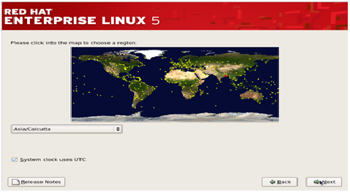](http://tutmaster.com/wp-content/uploads/2012/11/Untitled13.png)

**Step 11** – This is a very important step that deals with the root(super-user) password for the system . Type the password and confirm it and then click next.

[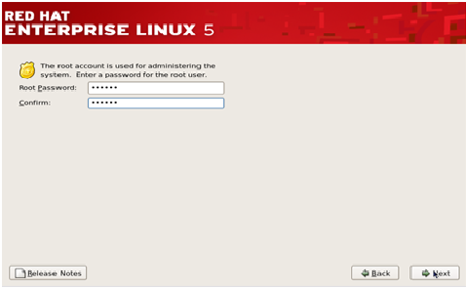](http://tutmaster.com/wp-content/uploads/2012/11/Untitled14.png)

**Step 12** – The RHEL installer would then prompt you about if you wish to install some extra ‘Software Development’ or ‘Web Server’ features. By default, keep it at ‘Customize later’ and press ‘Next’.

[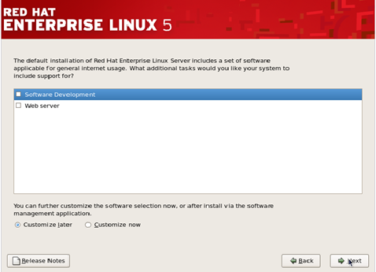](http://tutmaster.com/wp-content/uploads/2012/11/Untitled15.png)

**Step 13**- This next step will initiate the installation of Red Hat Linux, press ‘Next’ to begin the process.

[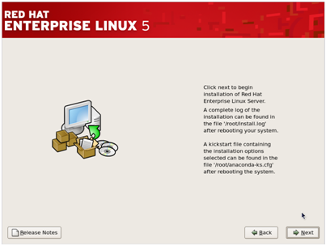](http://tutmaster.com/wp-content/uploads/2012/11/Untitled16.png)

**Step 14**- Upon the completion of installation you should the following screen. Press Reboot and you’d be ready to use your newly installed Red Hat Linux OS.

[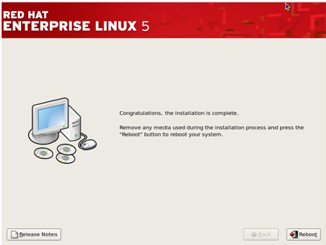](http://tutmaster.com/wp-content/uploads/2012/11/Untitled17.png)

**POST INSTALLATION CONFIGURATIONS**

1. Accept the Red Hat License agreement and click ‘Forward.

[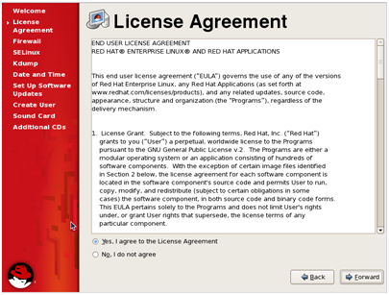](http://tutmaster.com/wp-content/uploads/2012/11/Untitled18.png)

2. The next step is regarding the configuration of the Firewall. You can Enable or Disable the firewall according to your preferences and then click ‘Forward’.

[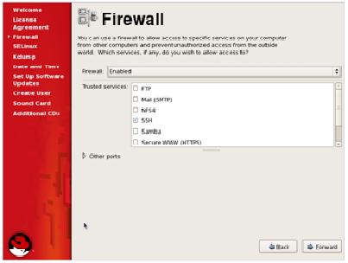](http://tutmaster.com/wp-content/uploads/2012/11/Untitled19.png)

3. Next step is about the configuration of another security tool- SE Linux. By default you should keep it ‘Disabled’ unless you’re working with very secure information.

[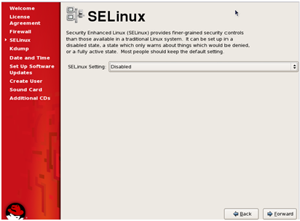](http://tutmaster.com/wp-content/uploads/2012/11/Untitled20.png)

4. You can also choose to configure the Kdump, that stores information about system crashes if your system fails but uses valuable disk space. By default don’t enable it.

[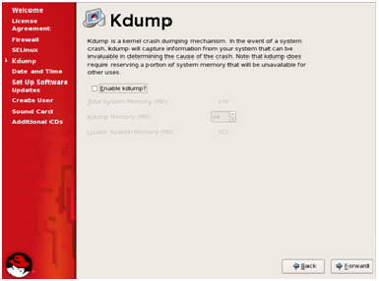](http://tutmaster.com/wp-content/uploads/2012/11/Untitled21.png)

5. Next, adjust the time and date settings, and then click ‘Forward’.

[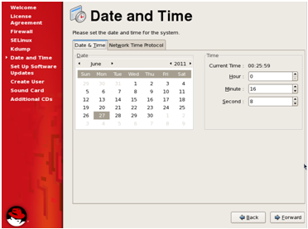](http://tutmaster.com/wp-content/uploads/2012/11/Untitled22.png)

6. The next step is for software updates from Red Hat, at this point you should skip the registration and register at a later time and then click ‘Forward’.

[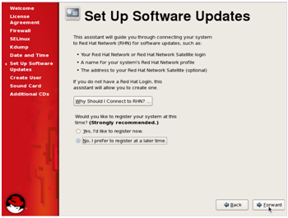](http://tutmaster.com/wp-content/uploads/2012/11/Untitled23.png)

7. This step is to create a non-admin user for the system. Enter the details and click ‘Forward’.

[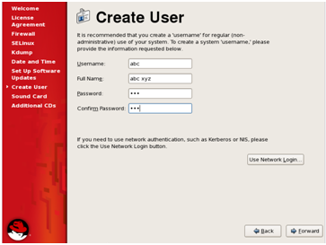](http://tutmaster.com/wp-content/uploads/2012/11/Untitled24.png)

8. This step is about configuration of your Sound Card, choose a sound device and then click ‘Forward’.

[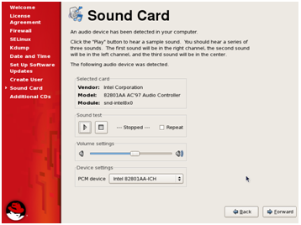](http://tutmaster.com/wp-content/uploads/2012/11/Untitled25.png)

9. Click ‘Forward’ to complete the configurations and start using your Red Hat Linux OS.

[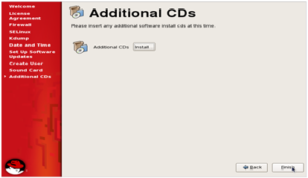](http://tutmaster.com/wp-content/uploads/2012/11/Untitled26.png)

(Note- On clicking ‘Finish’ the system would require a reboot if you have made changes to the configurations of Firewall or SE Linux.)

**Practical-8**

**Aim :** Introduction to Embedded Devices

**What is a Embedded System?**

An embeddedsystem is a computer system with a dedicated function within a larger mechanical or electrical system, often with real-time computing constraints. It is *embedded* as part of a complete device often including hardware and mechanical parts. Embedded systems control many devices in common use today. Ninety-eight percent of all microprocessors are manufactured as components of embedded systems.

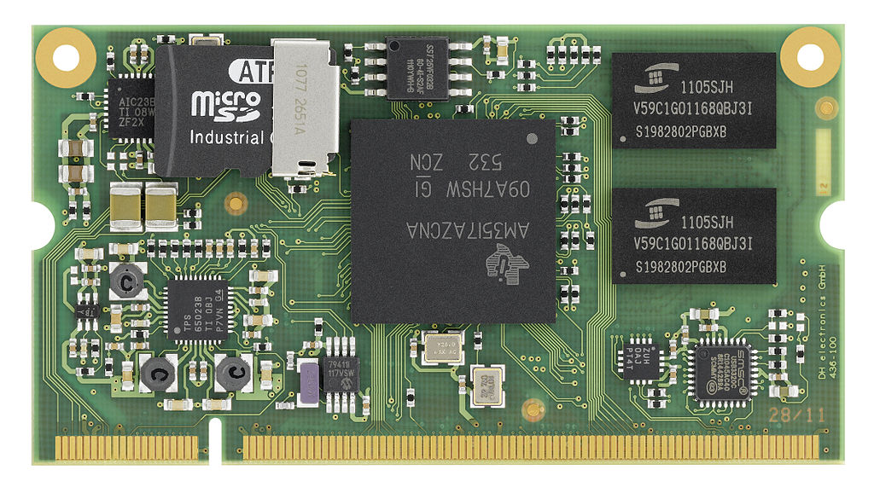

An *embedded system* on a plug-in card with processor, memory, power supply, and external interfaces

**An embedded system has three components −**

* It has hardware.
* It has application software.
* It has Real Time Operating system (RTOS) that supervises the application software and provide mechanism to let the processor run a process as per scheduling by following a plan to control the latencies. RTOS defines the way the system works. It sets the rules during the execution of application program. A small scale embedded system may not have RTOS.

So we can define an embedded system as a Microcontroller based, software driven, reliable, real-time control system.

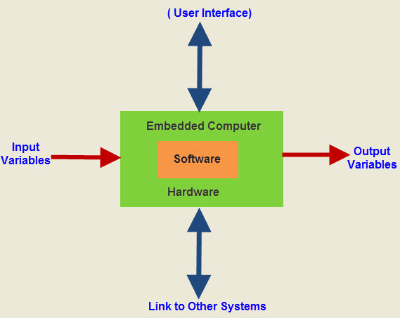

### EMBEDDED SYSTEMS HARDWARE

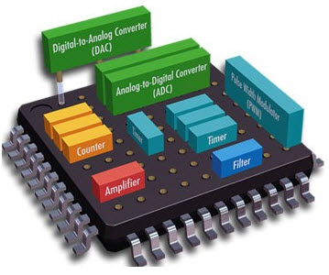As with every electronic device, an embedded device calls for a hardware platform in which it plays the operation. Embedded device hardware is built with a microprocessor or microcontroller. The embedded device hardware has factors like entering output (I/O) interfaces, consumer interface, reminiscence and the display. Usually, an embedded system consists of:

* Power supply
* Processor
* Timers
* Serial exchange ports
* Input/output circuits
* System service specific circuits

In some instances, customized chips may be feasible for a particular utility if quantities are sufficiently high. One common example of a popular elegance of devoted processor is the virtual signal processor, DSP. This type of processor is used for processing audio and photo files especially. Processing is required in no time as they may be utilized in packages which include mobile telephones and the like.

## EMBEDDED SYSTEM SOFTWARE

The embedded device software is written to carry out a selected feature. It is commonly written in a high degree format after which compiled right down to provide code that can be lodged inside a non-risky reminiscence within the hardware. An embedded gadget

software program is designed to keep in view of the 3 limits:

Availability of machine memory

Availability of processor’s speed

When the system runs continuously, there may be a want to limit power dissipation for events like prevent, run and wake up.

### Embedded System Classification

[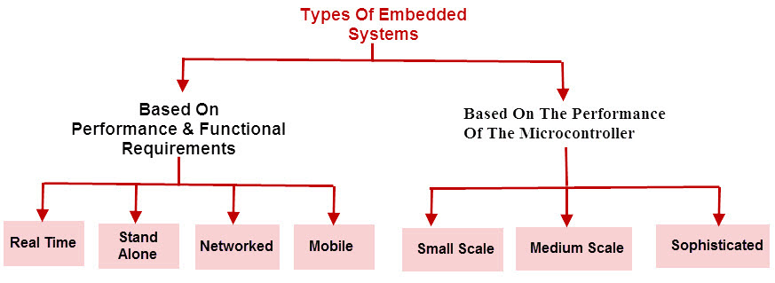](http://www.elprocus.com/wp-content/uploads/2015/03/Classification-of-Embedded-Systems.jpg)Classification of Embedded Systems

Embedded systems are primarily classified into different types based on complexity of hardware & software and microcontroller (8 or 16 or 32-bit). Thus, based on the performance of the microcontroller, embedded systems are classified into three types such as:

* Small scale embedded systems
* Medium scale embedded systems
* Sophisticated embedded systems

Further, based on performance and functional requirements of the system embedded system classified into four types such as:

* Real time embedded systems
* Stand alone embedded systems
* Networked embedded systems
* Mobile embedded systems

## Characteristics of an Embedded System

* **Single-functioned** − An embedded system usually performs a specialized operation and does the same repeatedly. For example: A pager always functions as a pager.
* **Tightly constrained** − All computing systems have constraints on design metrics, but those on an embedded system can be especially tight. Design metrics is a measure of an implementation's features such as its cost, size, power, and performance. It must be of a size to fit on a single chip, must perform fast enough to process data in real time and consume minimum power to extend battery life.
* **Reactive and Real time** − Many embedded systems must continually react to changes in the system's environment and must compute certain results in real time without any delay. Consider an example of a car cruise controller; it continually monitors and reacts to speed and brake sensors. It must compute acceleration or de-accelerations repeatedly within a limited time; a delayed computation can result in failure to control of the car.
* **Microprocessors based** − It must be microprocessor or microcontroller based.
* **Memory** − It must have a memory, as its software usually embeds in ROM. It does not need any secondary memories in the computer.
* **Connected** − It must have connected peripherals to connect input and output devices.
* **HW-SW systems** − Software is used for more features and flexibility. Hardware is used for performance and security.

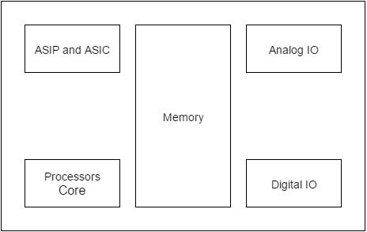

## Basic Structure of an Embedded System

The following illustration shows the basic structure of an embedded system

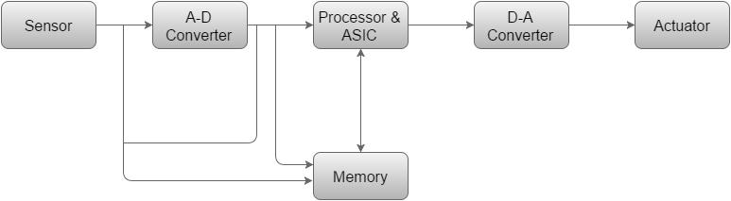

* **Sensor** − It measures the physical quantity and converts it to an electrical signal which can be read by an observer or by any electronic instrument like an A2D converter. A sensor stores the measured quantity to the memory.
* **A-D Converter** − An analog-to-digital converter converts the analog signal sent by the sensor into a digital signal.
* **Processor & ASICs** − Processors process the data to measure the output and store it to the memory.
* **D-A Converter** − A digital-to-analog converter converts the digital data fed by the processor to analog data
* **Actuator** − An actuator compares the output given by the D-A Converter to the actual (expected) output stored in it and stores the approved output.

**Types of embedded systems: -**



## EMBEDDED SYSTEM APPLICATIONS

The programs of an embedded system fundamentals consist of smart cards, PC networking, satellites, telecommunications, digital consumer electronics, missiles, etc.

* Embedded systems in cars include motor control, Cruise manipulates, frame safety, engine safety, robotics in a meeting line, automobile multimedia, automobile enjoyment, e-com get entry to, mobiles etc.
* Embedded structures in telecommunications consist of networking, mobile computing, and wireless communications, and so on.
* Embedded structures in smart playing cards consist of banking, smartphone and protection systems.
* Embedded systems in satellites and missiles include defense, conversation, and aerospace.
* Embedded structures in computer networking & peripherals consist of photo processing, networking systems, printers, community cards, monitors, and shows.
* Embedded structures in virtual patron electronics include set-pinnacle boxes, dads, high definition TVs and digital cameras.

### Advantages Of Embedded Systems

* Easily Customizable
* Low power consumption
* Low cost
* Enhanced performance

### Disadvantages Of Embedded Systems

* High development effort
* Larger time to market

An embedded system is a computer system with a dedicated function within a larger mechanical or electrical system, often with real-time computing constraints. It is embedded as part of a complete device often including hardware and mechanical parts. By contrast, a general-purpose computer, such as a personal computer (PC), is designed to be flexible and to meet a wide range of end-user needs. Embedded systems control many devices in common use today.

Modern embedded systems are often based on microcontrollers (i.e. CPUs with integrated memory or peripheral interfaces)[4] but ordinary microprocessors (using external chips for memory and peripheral interface circuits) are also still common, especially in more complex systems. In either case, the processor(s) used may be types ranging from rather general purpose to very specialised in certain class of computations, or even custom designed for the application at hand. A common standard class of dedicated processors is the digital signal processor (DSP).

The key characteristic, however, is being dedicated to handle a particular task. Since the embedded system is dedicated to specific tasks, design engineers can optimize it to reduce the size and cost of the product and increase the reliability and performance.

Embedded systems are commonly found in consumer, cooking, industrial, automotive, medical, commercial and military applications. Today, embedded systems are also found in cell phones, digital cameras, camcorders, portable video games, calculators, and personal digital assistants, microwave ovens, answering machines, home security systems, washing machines, lighting systems, fax machines, copiers, printers, and scanners, cash registers, alarm systems, automated teller machines, transmission control, cruise control, fuel injection, anti-lock brakes, active suspension and many other devices/ gadgets

Telecommunications systems employ numerous embedded systems from telephone switches for the network to cell phones at the end-user. Computer networking uses dedicated routers and network bridges to route data.

Consumer electronics include personal digital assistants (PDAs), mp3 players, mobile phones, videogame consoles, digital cameras, DVD players, GPS receivers, and printers. Household appliances, such as microwave ovens, washing machines and dishwashers, include embedded systems to provide flexibility, efficiency and features. Advanced HVAC systems use networked thermostats to more accurately and efficiently control temperature that can change by time of day and season. Home automation uses wired- and wireless-networking that can be used to control lights, climate, security, audio/visual, surveillance, etc., all of which use embedded devices for sensing and controlling.

A precise definition of embedded systems is not easy. Simply stated, all computing systems other than general purpose computer (with monitor, keyboard, etc.) are embedded systems.

System is a way of working, organizing or performing one or many tasks according to a fixed set of rules, program or plan. In other words, an arrangement in which all units assemble and work together according to a program or plan. An embedded system is a system that has software embedded into hardware, which makes a system dedicated for an application (s) or specific part of an application or product or part of a larger system. It processes a fixed set of pre-programmed instructions to control electromechanical equipment which may be part of an even larger system (not a computer with keyboard, display, etc).

A general-purpose definition of embedded systems is that they are devices used to control, monitor or assist the operation of equipment, machinery or plant. “Embedded” reflects the fact that they are an integral part of the system. In many cases, their “embeddedness” may be such that their presence is far from obvious to the casual observer. Block diagram of a typical embedded system is shown in fig.

Embedded System Architecture

An embedded system is an engineering artefact involving computation that is subject to physical constraints (reaction constraints and execution constraints) arising through interactions of computational processes with the physical world. Reaction constraints originate from the behavioural requirements & specify deadlines, throughput, and jitter whereas execution constraints originate from the implementation requirements & put bounds on available processor speeds, power, memory and hardware failure rates. The key to embedded systems design is to obtain desired functionality under both kinds of constraints.

CHARACTERISTICS

a) Embedded systems are application specific & single functioned; application is known apriori, the programs are executed repeatedly.

b) Efficiency is of paramount importance for embedded systems. They are optimized for energy, code size, execution time, weight & dimensions, and cost.

c) Embedded systems are typically designed to meet real time constraints; a real time system reacts to stimuli from the controlled object/ operator within the time interval dictated by the environment. For real time systems, right answers arriving too late (or even too early) are wrong.

d) Embedded systems often interact (sense, manipulate & communicate) with external world through sensors and actuators and hence are typically reactive systems; a reactive system is in continual interaction with the environment and executes at a pace determined by that environment.

e) They generally have minimal or no user interface.

**DESIGN METRICS FOR EMBEDDED SYSTEMS**

In addition to meeting the desired functionality of an embedded system, embedded system designer must optimize on the following design metrics

· Non Recurring Engineering (NRE) Cost: Money invested in R&D and developing first, functional and tested prototype.

· Unit Cost: Cost of producing one unit

· Electrical Power

· Performance - System Throughput, Computational Power, response time

· Functional Correctness

· Dependability; Fault Tolerance, Reliability, Maintainability, Availability

· Physical Size and Weight

· Time to prototype

· Time to market

· Safety: It should not cause harm to others.

· Maintenance, Ease of Use

These metrics compete amongst themselves; increasing one may affect others. Hence optimisation of these metrics is a challenge for an embedded system designer.

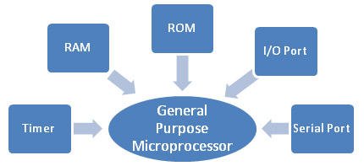

ELEMENTS OF EMBEDDED SYSTEMS

**. Hardware**

Core element of an embedded system is the processor or a computational unit. Processors can act as brain of the system. They can be programmed to do perform a task. This can be designed using variety of options.

**· General Purpose Microprocessors**

General purpose microprocessors are single chip semi conductor device which is a computer on chip, but not a complete computer. Its CPU contains an Arithmetic & Logic Unit(ALU), a Program Counter(PC), a Stack Pointer(SP), registers, a clock and interrupts circuit on a single chip. To make complete micro computer, one must add memory usually ROM and RAM, memory decoder, an oscillator, a number of serial and parallel ports

A general-purpose processor is designed to cater for large amount of applications and hence is produced in bulk. Using it in an embedded system offers various benefits. Design time is low as only software is to be developed, no digital design is involved. Typical characteristics of a general purpose processors are relatively high cost, high speeds, higher Power consumption, large architecture, large memory size, onboard flash and cache, an external bus interface for greater memory usage.

Examples: Motorola’s 680x0, Intel‘s x86

The Raspberry Pi is a credit card-sized single-board computer developed in the UK by the Raspberry Pi Foundation with the intention of promoting the teaching of basic computer science in schools.

The Raspberry Pi is manufactured in three board configurations through licensed manufacturing deals with Newark element14 (Premier Farnell), RS Components and Egoman. These companies sell the Raspberry Pi online. Egoman produces a version for distribution solely in China and Taiwan, which can be distinguished from other Pis by their red coloring and lack of FCC/CE marks. The hardware is the same across all manufacturers.

The Raspberry Pi has a Broadcom BCM2835 system on a chip (SoC), which includes an ARM1176JZF-S 700 MHz processor, VideoCore IV GPU, and was originally shipped with 256 megabytes of RAM, later upgraded (Model B & Model B+) to 512 MB. It does not include a built-in hard disk or solid-state drive, but it uses an SD card for booting and persistent storage, with the Model B+ using a MicroSD.

**Accessories**

* Camera – On 14 May 2013, the foundation and the distributors RS Components & Premier Farnell/Element 14 launched the Raspberry Pi camera board with a firmware update to accommodate it. The camera board is shipped with a flexible flat cable that plugs into the CSI connector located between the Ethernet and HDMI ports. In Raspbian, one enables the system to use the camera board by the installing or upgrading to the latest version of the OS and then running Raspi-config and selecting the camera option. The cost of the camera module is 20 EUR in Europe (9 September 2013). It can produce 1080p, 720p, 640x480p video. The footprint dimensions are 25 mm x 20 mm x 9 mm.
* Gertboard – A Raspberry Pi Foundation sanctioned device designed for educational purposes, and expands the Raspberry Pi's GPIO pins to allow interface with and control of LEDs, switches, analog signals, sensors and other devices. It also includes an optional Arduino compatible controller to interface with the Pi.
* Infrared Camera – in October 2013, the foundation announced that they would begin producing a camera module without an infrared filter, called the Pi NoIR.
* HAT (Hardware Attached on Top) expansion boards – Together with the model B+, inspired by the Arduino shield boards, were devised by the Raspberry PI Foundation.

**Conclusion :** Hence We have studied components, structure, types, characteristics and advantages and disadvantages of Embedded System.

**PRACTICAL 9**

**Aim :** Compiling Linux Kernel and Bootup Procedure of Embeeded Devices.

**Q. How to Compile Linux Kernel from Source to Build Custom Kernel?**

Linux kernel is the life force of all Linux family of operating systems including Ubuntu, CentOS, and Fedora.

For most part, you don’t need to compile the kernel, as it is installed by default when you install the OS. Also, when there is a critical update done to the kernel, you can use yum, or apt-get to update the kernel on your Linux system.  
  
However you might encounter certain situation, where you may have to compile kernel from source. The following are few situation where you may have to compile Kernel on your Linux system.

* To enable experimental features that are not part of the default kernel.
* To enable support for a new hardware that is not currently supported by the default kernel.
* To debug the kernel
* Or, just to learn how kernel works, you might want to explore the kernel source code, and compile it on your own.

### 1. Download the Latest Stable Kernel

The first step is to download the latest stable kernel from kernel.org.

### 2. Untar the Kernel Source

The second step is to [untar](https://www.thegeekstuff.com/2010/04/unix-tar-command-examples/) the kernel source file for compilation.

### 3. Configure the Kernel

# cd linux-3.9.3

# make menuconfig

The make menuconfig, will launch a text-based user interface with default configuration options as shown in the figure. You should have installed “libncurses and libncurses-devel” packages for this command to work.

### 4. Compile the Linux Kernel

Compile the main kernel:

# make

Compile the kernel modules:

# make modules

Install the kernel modules:

# make modules\_install

At this point, you should see a directory named /lib/modules/3.9.3/ in your system.

### 5. Install the New Kernel

Install the new kernel on the system:

# make install

### 6. Boot Linux to the new Kernel

To use the new kernel that you just compiled, reboot the system.

# reboot

Once the system is up, use [uname command](https://www.thegeekstuff.com/2012/09/uname-command-examples/) to verify that the new version of Linux kernel is installed.

$ uname -r

3.9.3

# Embedded Linux Booting Sequence

**Entire boot process can be divided into three parts**,

1.Firmware (Bootlaoder)  
2.Kernel  
3.user space

**Basic boot step are as follows,**

1. Power on
2. Firmware(bootloader start)
3. Kernel Decompression Start
4. User Space Start
5. RC script start
6. Application Start

**About Boot Loader:**

A boot loader, sometimes referred to as a boot monitor, is a small piece of software that executes soon after powering up a computer. On your desktop Linux PC you may be familiar with lilo or grub, which resides on the master boot record (MBR) of your hard drive. After the PC BIOS performs various system initializations it executes the boot loader located in the MBR. The boot loader then passes system information to the kernel and then executes the kernel. For instance, the boot loader tells the kernel which hard drive partition to mount as root.

In an embedded system the role of the boot loader is more complicated since these systems do not have a BIOS to perform the initial system configuration. The low level initialization of microprocessors, memory controllers, and other board specific hardware varies from board to board and CPU to CPU. These initializations must be performed before a Linux kernel image can execute.

**At a minimum an embedded loader provides the following features:**

* Initializing the hardware, especially the memory controller.
* Providing boot parameters for the Linux kernel.
* Starting the Linux kernel

**Additionally, most boot loaders also provide “convenience” features that simplify development:**

* Reading and writing arbitrary memory locations.
* Uploading new binary images to the board’s RAM via a serial line or Ethernet
* Copying binary images from RAM to FLASH memory
* Booting start with start\_kernel function in the file init/main.c.

**This function performs following steps to initialize the system:**

1. init architecture
2. init interrupts
3. init memory
4. start idle thread
5. rest\_init

**Conclusion :** We have learnt the process to compile linux kernel to build custom kernel.

**PRACTICAL 10**

**Aim:** Measurement of Kernel Parameters of Windows Operating System.

**Windows Tuning Parameters**

For Windows platforms, the default settings are usually sufficient. However, under sufficiently heavy loads it may be necessary to adjust the Max User Port and Tcp Timed Wait Delay. These parameters determine the availability of user ports requested by an application.

By default, ephemeral (that is, short-lived) ports are allocated between the values of 1024 and 5000 inclusive using the Max User Port parameter. The Tcp Timed Wait Delay parameter, which controls the amount of time the OS waits to reclaim a port after an application closes a TCP connection, has a default value of 4 minutes.

During a heavy load, these limits may be exceeded resulting in an address in use: connect exception. If you experience address in use: connect exceptions try setting the MaxUserPort and Tcp Timed Wait Delay registry values under the HKEY\_LOCAL\_MACHINE\SYSTEM\CurrentControlSet\Services\Tcpip\Parameterskey:

MaxUserPort = dword:00004e20 (20,000 decimal)  
   Tcp Timed Wait Delay = dword:0000001e (30 decimal)

Increase the value of the MaxUserPort parameter if the exception persists.

For more information about Windows 2000 tuning options, see:

* + The [Microsoft Windows 2000 TCP/IP Implementation Details](http://www.microsoft.com/windows2000/techinfo/howitworks/communications/networkbasics/tcpip_implement.asp).
  + The [Windows 2000 Performance Tuning](http://www.microsoft.com/technet/prodtechnol/windows2000serv/maintain/optimize/perftune.mspx) white paper.

**Passing Parameters to System Calls**

Parameters are passed to system calls in the same way that parameters are passed to other functions, but some additional calling conventions and limitations apply.

First, system calls cannot have floating-point parameters. In fact, the operating system does not preserve the contents of floating-point registers when a system call is preempted by another thread, so system calls cannot use any floating-point operations.

Second, because a system call runs on its own stack, the number of arguments that can be passed to a system call is limited. The operating system linkage conventions specify that up to eight general purpose registers are used for parameter passing. If more parameters exist than will fit in eight registers, the remaining parameters are passed in the stack. Because a system call does not have direct access to the application's stack, all parameters for system calls must fit in eight registers.

Third, some parameters are passed in multiple registers. For example, 32-bit applications pass **long long** parameters in two registers, and structures passed by value can require multiple registers, depending on the structure size. The writer of a system call should be familiar with the way parameters are passed by the compiler and ensure that the 8-register limit is not exceeded. For more information on parameter calling conventions, see [Subroutine Linkage Convention](https://www.ibm.com/support/knowledgecenter/ssw_aix_72/com.ibm.aix.alangref/idalangref_subrutine_link_conv.htm?view=kc) in *Assembler Language Reference*.

Finally, because 32-bit applications are supported by the 64-bit kernel, the data model used by the kernel does not always match the data model used by the application. When the data models do not match, the system call might have to perform extra processing before parameters can be used.

The [**IS64U**](https://www.ibm.com/support/knowledgecenter/ssw_aix_72/com.ibm.aix.ktechrf1/is64uks.htm?view=kc) macro can be used to determine if the caller of a system call is a 64-bit process. For more information on the IS64U macro, see [IS64U Kernel Service](https://www.ibm.com/support/knowledgecenter/ssw_aix_72/com.ibm.aix.ktechrf1/is64uks.htm?view=kc) in AIX® Version 6.1 Technical

The ILP32 and LP64 data models differ in the way that pointers and **long** and **long long** parameters are treated when used in structures or passed as functional parameters. The following tables summarize the differences.

| **Type** | **Size** | **Used as Parameter** |
| --- | --- | --- |
| **long** | 32 bits | One register |
| **pointer** | 32 bits | One register |
| **long long** | 64 bits | Two registers |

| **Type** | **Size** | **Used as Parameter** |
| --- | --- | --- |
| **long** | 64 bits | One register |
| **pointer** | 64 bits | One register |
| **long long** | 64 bits | One register |

System calls using these types must take the differing data models into account. The treatment of these types depends on whether they are used as parameters or in structures passed as parameters by value or by reference.

# Changing Boot Parameters

# To enable and configure boot-related operating system features, such as debugging, you must add boot parameters to a boot entry for the operating system.

To change boot parameters on a system running Windows, you can use BCDEdit.

### Using BCDEdit

To add a boot configuration parameter to a boot entry, use the BCDEdit boot entry options to change global settings, such as **/ems**, **/debug**, **/dbgsettings**, or set individual parameters using the **[BCDEdit /set](https://msdn.microsoft.com/library/windows/hardware/ff542202)** options. For a complete list of BCDEdit options, at a command prompt, type **BCDEdit /?** or **BCDEdit /?** <command> to find help about a specific command.

For example, the following command enables PAE for a specified boot entry:

bcdedit /set {802d5e32-0784-11da-bd33-000476eba25f} pae forceenable

To turn the kernel debugger on or off, use the **/debug** option with the following syntax:

bcdedit /debug <ID> [on | off]

The <ID> is the GUID that is associated with the boot entry. If you do not specify an <ID>, the command modifies the operating system that is currently active. The following command turns on the kernel debugger for a boot entry, called Debug Entry:

bcdedit /debug {49916baf-0e08-11db-9af4-000bdbd316a0} on

To view the current boot entries, type **bcdedit** at the command prompt. The boot entry for Debug Entry shows that the kernel debugger is turned on.

## Windows Boot Loader

-------------------

identifier {49916baf-0e08-11db-9af4-000bdbd316a0}

device partition=C:

path \Windows\system32\winload.exe

description DebugEntry

locale en-US

inherit {bootloadersettings}

osdevice partition=C:

systemroot \Windows

resumeobject {3e3a9f69-024a-11db-b5fc-a50a1ad8a70e}

nx OptIn

pae ForceEnable

debug Yes

# Boot Parameters to Manipulate Memory

You can simulate a low-memory environment for testing without changing the amount of physical memory on the computer. Instead, you can limit the memory available to the operating system by using **truncate memory** or **remove memory** options with the **[BCDedit /set](https://msdn.microsoft.com/library/windows/hardware/ff542202)** command.

The **/maxmem** parameter specifies the maximum amount of memory available to Windows. It is calibrated in megabytes (MB). Set the value to any amount less than the actual physical memory on the computer.

The **/maxmem** parameter actually determines the largest memory address available to Windows. Due to gaps in the mapping of physical memory, Windows might receive somewhat less memory than the value of **/maxmem**. For more precision, use **/burnmemory**.

The **truncate memory** or **remove memory** options are available in Windows 7 and later. The **truncate memory** option disregards all memory at or above the specified physical address. The **remove memory** option reduces memory available to Windows by the specified amount (measured in MB). Both options reduce memory, but the **remove memory** option is better at restricting the operating system to use the specified memory while accounting for memory gaps.

### Boot Parameters to Test in a Low-memory Environment in Windows

To simulate a low-memory environment, use the **[BCDedit /set](https://msdn.microsoft.com/library/windows/hardware/ff542202)** command and the **remove memory** option to modify a boot entry. Set the value of **remove memory** to the amount of physical memory on the system minus the desired memory size for this test.

For example, to limit the memory of a computer with 2 GB of physical memory to a maximum of 512 MB of available memory, set the value of the **remove memory** parameter to 1536 (2 GB (2048 MB) - 512 MB = 1536 MB).

The following example shows a BCDEdit command used to remove 1536 MB of memory from the total available to the system for the specified boot entry.

bcdedit /set {18b123cd-2bf6-11db-bfae-00e018e2b8db} removememory 1536

You can also use the **truncate memory** option with the **bcdedit /set** command to achieve the same result. When you use this option, Windows ignores all memory at or above the specified physical address. Specify the address in bytes. For example, the following command sets the physical address limit at 1 GB for the specified boot entry. You can specify the address in decimal (1073741824) or hexadecimal (0x40000000).

bcdedit /set {18b123cd-2bf6-11db-bfae-00e018e2b8db} truncatememory Ox40000000

Because the **removememory** option makes more efficient use of system memory, its use is recommended instead of **truncatememory**.

When you are finished testing, you can remove the **removememory** and **truncatememory** boot entry options using the **[BCDEdit /delete value](https://msdn.microsoft.com/library/windows/hardware/jj856916)** command.